# OBJECTIVE

1. **Study of various radar principles.**
2. **Benefit of photonic based implementation of radar is reviewed.**
3. **Various techniques of microwaves generation using MZM is simulated**
4. **Various techniques of frequency up and down conversion using polarization modulator is simulated**
5. **Transmission performance is measured by bit error rate performance and compared with BTB system.**

# Chapter-1

# Introduction

In this chapter, a general overview of the work is presented. The background is given in detail. We start with radar principles and then discuss the various measurement techniques in radar. Its limitation is highlighted and importance of microwave photonics is introduced. Basic principle of microwave generation using photonic techniques is presented. Finally a brief overview about the organization of the thesis is highlighted.

# 1.1 Review of RADAR technologies

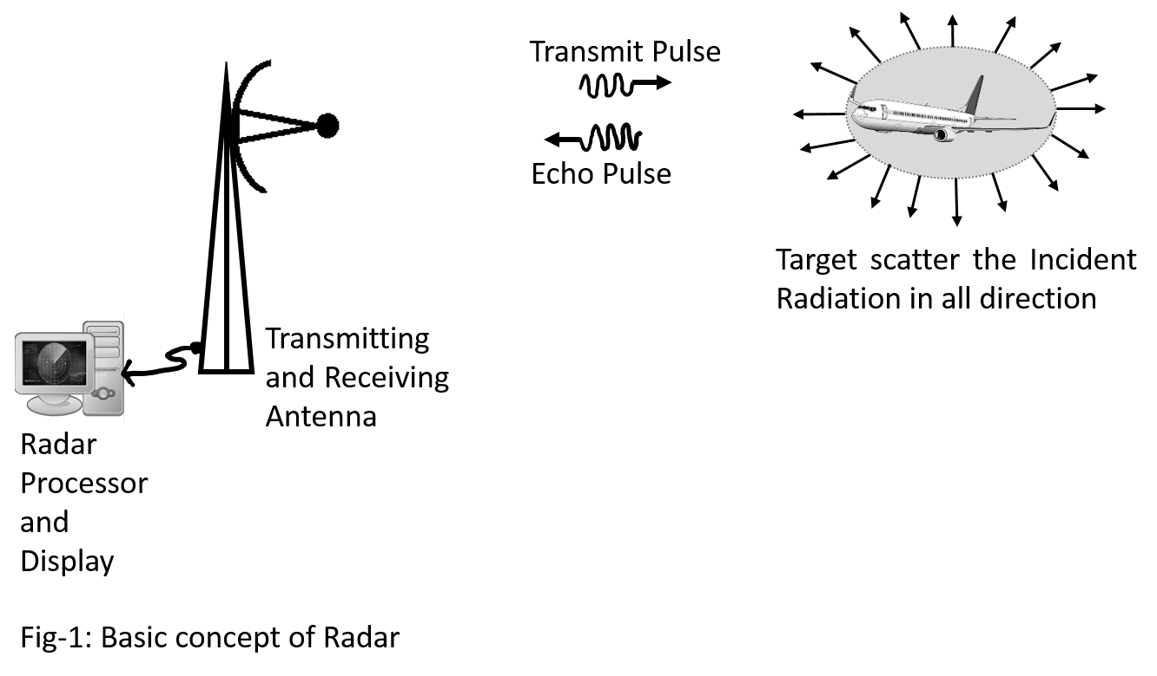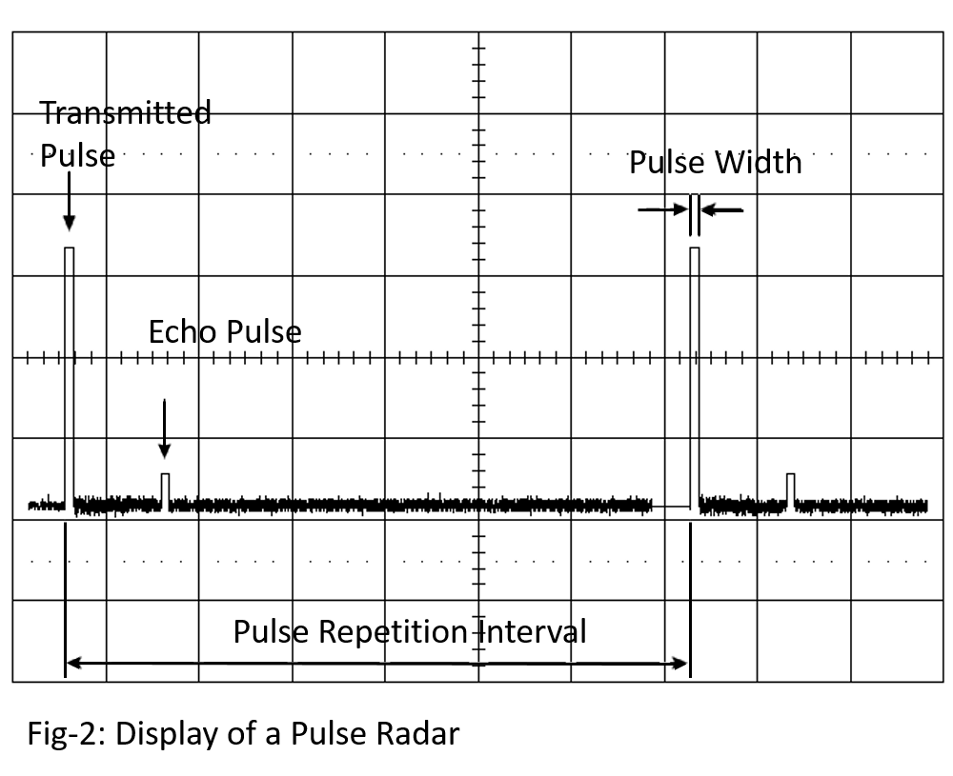

# 1.1.1 Target ranging using Pulse Radar

RADAR stands for Radio Detection and Ranging, which refers to a device that operated by illuminating the target with electromagnetic energy and extract useful information about it from the received echo. The returned echo can provide a lot of information about the target: the range or distance of the target from the Radar antenna, the angular location and its velocity. More advanced RADAR systems can even provide information of target shape and size.

The basic concept of a Radar is shown in Fig-1 and the radar display spectrum is shown in Fig-2. The radar antenna illuminates the target with a pulse of electromagnetic energy. The target scatters the incident pulse in all direction. But a very small portion of the incident pulse is scattered along the direction of the antenna. This echo pulse is received by the antenna and passed on to the radar signal processing unit. The signal processing unit can then process and extract the target distance from the antenna, which is called the range of the target. The range is detected from the time of flight of the echo, which is the time taken by the transmitted pulse from its launching time to echo reception time. Mathematically, the relation that connects the range and time of flight is given by:

$$R= \frac{c t}{2} \\ where c=speed of light in air=3 × {10}^{8}m/s, \\ t=time of flight in seconds,$$ $R=range of the target, which in Fig-1 is the distance of the aircraft to antenna$. The factor of 2 comes from the fact that the pulse has to travel twice the distance given by range.

The concept highlighted in Fig-1 and Fig-2 forms the basis for Pulse Radar. But there are several limitations of this method. First limitation is known as second time around echo. The transmit pulse are repeatedly sent after a time interval, which is known as Pulse Repetition Interval (PRI). The echo pulse must reach the antenna before the next pulse is transmitted in order to avoid error in detection. If the echo pulse come back after the next transmit pulse is sent out, then this echo is called second-time around echo. Therefore, the second time around echo limits the range of radar, which again is dependent on the selection of the pulse repetition interval. Thus, the maximum range called the unambiguous range of a pulse radar is obtained using the value of the pulse repetition interval and the following mathematical expression:

$$Unambiguous Range, R_{max}= \frac{c ×Pulse Repetition Interval}{2}$$

Therefore, in order to increase the Range of the radar, the Pulse Repetition Interval must be increased.

However, increasing the range arbitrarily has a caveat. The Radar receiver detects the target based on a very basic principle. Whenever the amplitude of the echo crosses a threshold, the radar would detect the echo as a target.Therefore, the target is separated from clutter and background noise based on the received echo power, whereby the unambiguous range is obtained by solving theRadar Equation [1]:

$${R_{max}}^{4}= \frac{P_{av} G A ρ_{a} σ n E_{i}\left(n\right){ F}^{4}e^{-2αR_{max}}}{{\left(4π\right)}^{2} k T_{0}F_{n}\left(Bτ\right)f_{p}{\left(S/N\right)}_{1}L_{f}L_{s}} \\ where R_{max}=maximum Radar Range \left(m\right), \\ P_{av}=Average Transmitted Power \left(W\right), \\ G=Antenna Gain, \\ A=Antenna Area \left(m^{2}\right), \\ ρ_{a}=Antenna Aperture Efficiency, \\ σ=Radar Cross-Section of the target \left(m^{2}\right), \\ n=Number of pulses that are received and integrated, \\ E_{i}\left(n\right)=Integration Efficiency, \\ F^{4}=Propagation Factor, \\ α=Attenuation Coefficient \left(Nepers per unit distance\right), \\ k=Boltzmann^{'}s constant=1.38 × {10}^{-23}J/{deg}, \\ T_{0}=standard temperature=290 K, \\ F_{n}=Receiver Noise Figure, \\ B=Receiver Bandwidth \left(Hz\right), \\ τ=Pulsewidth \left(s\right), \\ f_{p}=1/{Pulse Repetition Interval }=Pulse Repetition Frequency \left(Hz\right), \\ {\left(S/N\right)}_{1}=Signal-to-Noise ratio required as if the detection is based on only a single pulse, \\ L_{f}=Fluctuation loss \left(for a Swirling target model\right), \\ L_{s}=System Loss.$$

The above equation is valid for modern radar or classical radar systems. From the equation, it can be clearly seen that large ranges can be accounted if the average transmitted pulse power is increased, the noise figure is decreased, the number of pulses used for integration is increased, the receiver bandwidth is decreased, and finally, the loss factors are reduced. But all these factors cannot be simultaneously altered. Therefore, threshold power is selected by compromising the radar range such that, it is not too low or too high. Too low value of threshold power will trigger false detection due to noise spike or clutter. On the other hand, selecting a threshold power too high will result in missed detection. Thus a compromise is necessary.

Another limitation of the pulse radar is the selection of pulse width. If an echo is received when the transmitter is active, it will not be detected by the receiver. This is because the receiver is switched off when the transmitter is active. This fact marks the minimum detectable range or the range cell of the radar. The range cell is given by,

$$Range Cell= \frac{c ×Pulse Width in seconds}{2}$$

The range cell must be decreased so as to detect nearby targets. But since it is dependent on the pulse width, which itself depends on the switching time of the transmitter. Hence, the range cell cannot be arbitrarily reduced due to the limitation in electronic switching circuitry.

Further, even if the pulse width can be infinitesimally reduced, still the radar cannot detect anything more precisely than the distance equivalent of one wavelength. Therefore, increasing the frequency can increase the radar precision. But the frequency cannot be increased at will. This is limited by two factors. Electronics generator and receiver are not sensitive at all frequency, thus limiting them to a definite operating range of frequencies only. On the other hand, atmospheric attenuation may not allow all frequencies to travel equally due to the dependency of attenuation on the frequency. Therefore, a compromise is necessary to design such a radar, but to detect within one wavelength distance other advances are necessary.

# 1.1.2 Measurement of Velocity using FMCW Radar

Another factor of importance is the velocity. The velocity information is extracted from the Doppler frequency shift that occurs in the echo pulse. Whenever an electromagnetic pulse is scattered by a high speed moving object, the velocity of the scattered radiation will be modified by the velocity of the target. Therefore, considering the schematic in fig-1, the velocity of the echo pulse will increase or decrease depending on the relative direction of motion of the electromagnetic pulse and the target. However, the observed change in frequency will depend on the relative velocity of the target (the source is the radar antenna, which is assumed to be stationary compared to the target) and the frequency of the incident electromagnetic radiation. This change in frequency is called Doppler Shift. If we consider that the target is having a velocity $v$, and the radar is emitting a pulse with frequency $f$, then the observed Doppler Shift $f$ is given by:

$$f= \frac{v}{c}×f$$

Therefore, as the velocity of target increases, the Doppler shift observed will increase alongwith it. But to increase precisionthe frequency needs to be increases which is again limited by the electronics used and the atmospheric attenuation which may limit the radar operation.

A FMCW radar uses a frequency modulator to generate the output signal. Rather than sending out a pulse of one frequency, it would radiate a pulse whose frequency is increased with time, as shown in Fig-3. The ranging of target in this case is done by calculating the time of flight and using the relation,

$$R= \frac{c ∆t}{2}$$

The ranging can also be calculated by taking the frequency difference between the transmitted and received frequency, and using the relation:

$$R= \frac{c ∆f}{2 \left(\frac{df}{dt}\right)} \\ where ∆f=difference between the received and transmitted frequency, at that moment, \\ \frac{df}{dt}=the rate of variation of frequency with time, during transmission \\ =frequency modulation index.$$

The velocity is determined from the Doppler frequency shift, which is measured by taking the runtime frequency change in received waveform during the falling edge of the transmitted frequency sawtooth waveform. This is indicated in the figure as Doppler frequency $f_{D}$, which appears as an additional variation in frequency in the received waveform during the rising period of the sawtooth frequency waveform. If the target is approaching the radar antenna radially, the Doppler Shift $f_{D}$ is positive, so the echo signal frequency will appear to be reduced by this amount, and vice versa.

The FMCW radar is more precise in measuring range than Pulse Radar with additional capability to detect the velocity. But this Radar is still limited by two factors. First limitation is the rate at which the frequency is varies would limit the range resolution. Faster variation in FM frequency would reduce the Range whereas slower variation would increase the Range. But FM frequency variation rate cannot be arbitrarily modified and hence, limits the operation. Another limitation is that, for proper detection and target ranging, the target distance must be of order of one wavelength of frequency. Thus, precision of ranging is again limited.

# 1.1.3 Step Frequency CW (SFCW) Radar

A major drawback in frequency generation module of FMCW radar is the generation stage itself. It cannot provide smooth change in frequency, rather frequency changes are done in discrete steps. Thus, we come to the concept of SFCW Radar. SFCW radar is an FMCW radar where the frequency is changed in discrete state. Thus, each frequency component will stay ON for a finite amount of time determined by the pulse width and will repeat periodically after a time determined by the pulse repetition interval (PRI). Therefore, the number of frequency steps is finite and is determined by the ratio of PRI to pulse width. This radar system is more practical and can be designed with the help DDS (Direct Digital Synthesis) chipset and therefore, less complex than FMCW. The corresponding transmitted and received spectrum is shown in Fig-4.

# 1.1.4 Synthetic Aperture Radar (SAR)

The radiated power by a transmitting antenna depends on the antenna gain. The antenna gain depends on the antenna aperture size, which is related to the physical dimension of the antenna. Hence, an antenna with larger aperture will offer larger antenna gain. But on the other antenna, larger antenna is not feasible as it would occupy inconsiderable amount of space. Therefore, it is often required to reduce the antenna aperture size and with an aim that the antenna gain remains invariant. This can be done with the help of Synthetic Aperture. A synthetic aperture is a movable antenna, in which the overall physical dimension of the antenna is the product of total beam width and the amount of allowable mechanical displacement the antenna is allowed to have. Therefore, the synthesized aperture of a physically small antenna can be increased by using a moving mechanical rail over which the antenna is moved to enable scanning of a larger dimension of space. This forms the basis for Synthetic Aperture Radar.

A synthetic aperture radar can therefore scan azimuth by movement of the antenna in a horizontal plane and can also scan elevation by either vertical movement or by beam steering. Therefore, a SAR can cover a larger volume compared to physically larger antenna and also allow for more advanced ranging technique despite increase in processing capabilities.

# 1.2 Measurement of Displacement of Slow moving Target using RADAR

In this section, we will consider the case of slow moving target. By slow moving target, we refer to those objects which have very small velocity. Such targets prominently includes geo-technical activities like glacier shift, landmass movement, etc. For such target, we consider the expression of Doppler Shift written as:

$$f= \frac{v}{c}×f$$

From the above expression, we can infer that the slow moving targets will not produce enough Doppler Shift. Therefore, detection FMCW velocity measurement technique will be inefficient. Hence, a new technique based on interference of two waves is developed, which is named as Interferometry Technique, discussed in the following techniques.

# 1.2.1 Interferometry based RADAR

RF Interferometry is a more advanced and recent development in the Radar technology. It finds application non-destructive characterization of various materials and plasma diagnostics [2]. It is also recently been used in displacement measurement with high accuracy and fast operation with optical interferometers been able to have a resolution from micrometre to nanometre ranges [2].

To understand the concept of Interferometry, we first consider a target illuminated by an electromagnetic wave of frequency $f_{1}$. The target is at a range of $R$, which can be written in terms of integral number of wavelength and an additional displacement component as,

$$2R=N + 2D \\ where = \frac{c}{f_{1}}=operating wavelength, \\ N=some non-negative integer, \\ D=sub-wavelength distance$$

The phase advances that the electromagnetic radiation have undergone when traversing the wireless distance is given by,

$$∅_{1}= \frac{2π}{} ×2R=2πN+ \frac{2π}{}×2D$$

But due to the circular nature of the sinusoid, the phase term can be rewritten as:

$$∅_{1}=\frac{2π}{}×2D= \frac{2πf_{1}}{c} ×2D$$

Now, instead of single incident wave, if we now consider that the target is illuminated with two simultaneous waveforms, then for each of the echo received will have the respective phase depending on the frequency, which can be written as:

$$∅_{1}= \frac{2πf_{1}}{c} ×2D$$

$$∅_{2}= \frac{2πf_{2}}{c} ×2D$$

The interferometry technique now comes into play, whereby the waveforms are allowed to interfere destructively such that the difference of their phase are taken into account. Therefore, the phase difference that is observed can be written as:

$$∆∅ = \frac{2π(f_{2}-f_{1})}{c} ×2D= \frac{2π ∆f}{c} ×2D$$

The unambiguous displacement can now be written by setting $∆∅=2π$, and we get, $$D_{max}= \frac{c}{2 ∆f}$$

In order to sense small distances, the frequency difference must be increased. For example, sensing a sum-millimeter difference with frequency separation in GHz, we can write,

$$D_{max}= \frac{150}{f (GHz)} mm$$

Thus, with a frequency separation of 8 GHz, an unambiguous displacement of 18.75 mm can be achieved. This fact when combined with delay measurement increases not only the range resolution of radar but also makes the radar sensitive so as to be able to isolate small displacement.

# 1.2.2 Limitation of Interferometry technique

The interferometry radar works with the phase measurement to range target displacement. Therefore, the radar must be able to measure phase value accurately.However the phase measurement accuracy is limited by two factors. First factor is the SNR of the received signal as it is dependent on the propagation loss and atmospheric attenuation factor, independent of the quality of the radar system [3]. The SNR may can be improved by using SFCW along with interferometry to obtain differential phase over multiple frequency and then using averaging technique to obtain better phase value. The technique is detailed in [3], which is beyond the scope of this thesis.

The second factor is the intrinsic phase noise of the generated signal.The differential phase is obtained by comparing the phase component of two frequencies reflected by the target. Therefore, the phase noise in this case depends on the degree of coherence between the waveforms of two frequencies [3]. Photonics is a way out in this case, as photonics allows improved way to coherently generate multiple frequencies. Therefore, the phase noise due to incoherence is reduced to an appreciable value. The photonics approach to generate multiple frequencies simultaneously is discussed in details in the next session.

# 1.3 Review of various frequency generation using Microwave Photonics

Microwave photonics had proven to be an interdisciplinary area of studies connecting the domain of microwave applications with photonics signal processing. The discipline have found applications in radar, broadband access systems, instrumentation and warfare system design [4]. The introduction of photonics in microwave generation have enabled lot of new features. Among this the prominent feature of interest is low phase noise in generated signal [4], which enables designing of Radar systems where phase measurement can be done precisely. Further, simultaneous generation of multiple frequencies had also been made possible using microwave photonics. These simultaneously generated microwave signals are phase coherent which greatly improves the signal quality compared to the microwave signal generated by conventional electrical methods. The use of such a photonic system have allowed the development of coherent radar systems for better detection and ranging [3]. In this section, some of the generation techniques are discussed in details.

# 1.3.1 Optical Heterodyning for Microwave generation

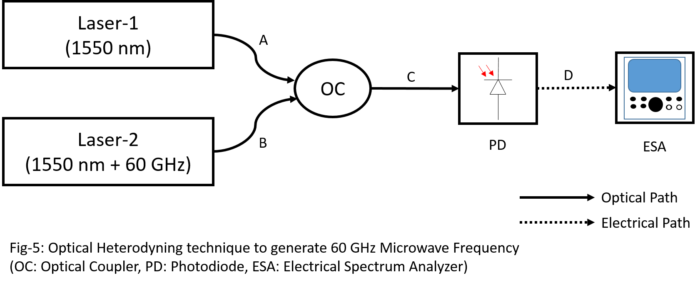

The simplest technique to generate high frequency microwave signal is through the use of optical heterodyning technique. In this technique two laser sources are used. The first laser source is set to the optical centre frequency of 1550 nm and the second laser source is detuned by the LO frequency of 60 GHz (say). The light from these individual laser sources are combined using an optical combiner, the output spectrum of which is shown in Fig-6 (C). The optical spectrum is the additive of the individual laser spectrum. The output light from the optical coupler is applied to the optical input of photodiode, where the light wave are made to heterodyne such that the output electrical spectrum from the photodiode consists of the difference frequency, which is 60 GHz as shown in Fig-6 (D).

Although this technique is the simplest, but it suffers from some limitations. Due to the usage of independent laser sources, the phase noise is very high. This can be seen in Fig-6 (D). The noise around 60 GHz is very high compared to the noise level far from it. Due to this, the phase measurement accuracy is limited. Several techniques like OPLL, OIL, OIPLL, [4] are already devised to reduce this noise, but they increase the complexity which can be easily simplified using the method that are discussed further.

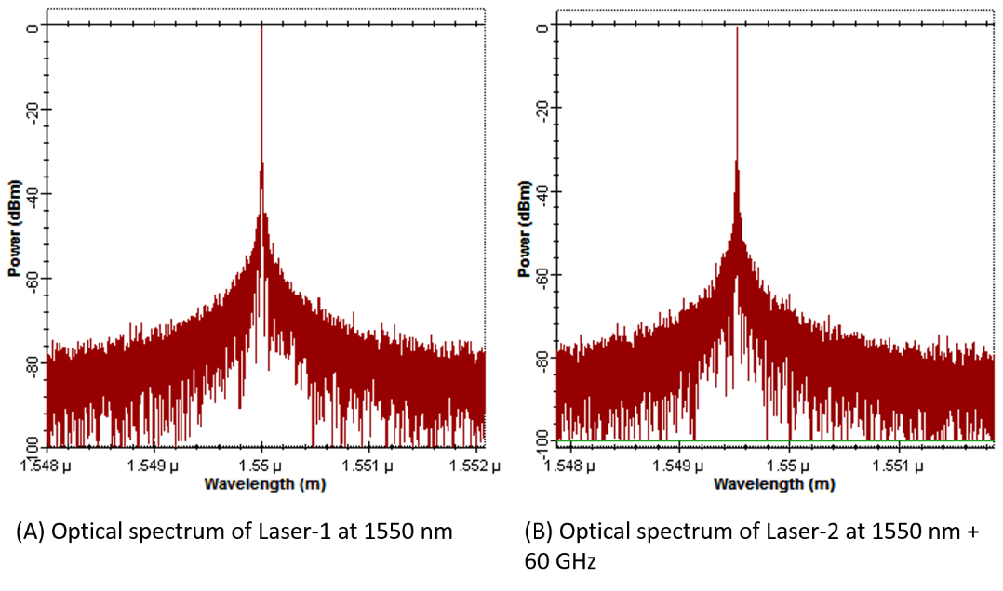

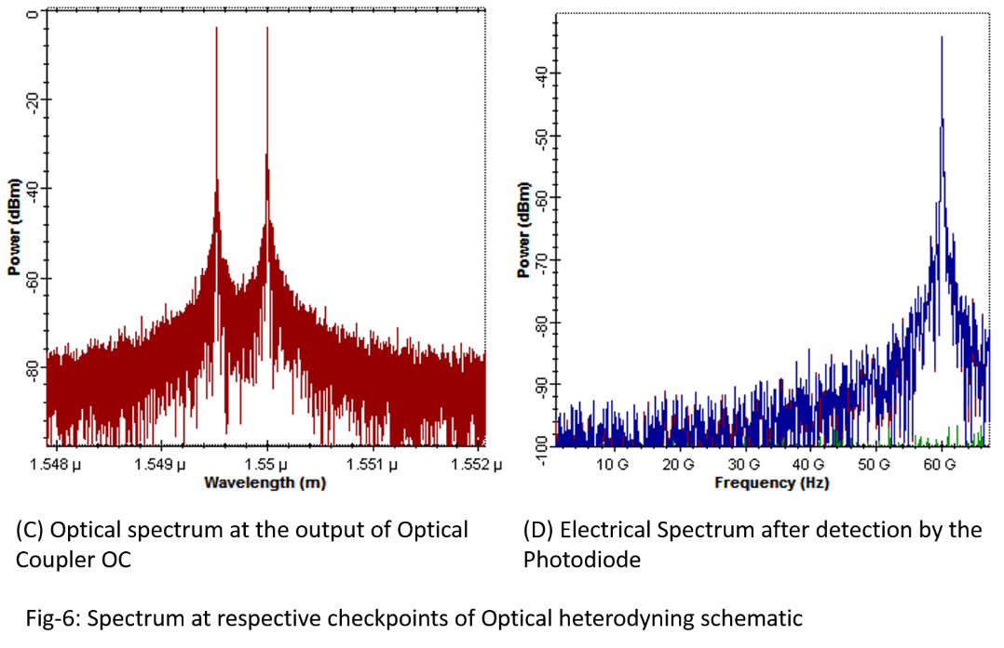

# 1.3.2 Microwave frequency generation using MZM based External Modulation

The concept behind generation of microwave frequency by external modulation is schematically shown in Fig-7. In this case, a single laser source is used. The light from the laser source is split along two path using an optical splitter. The light along one path is frequency shifted by using an electro-optical modulator, by an amount set by LO signal generator. Then the light waves are recombined using an Optical Combiner. The optical spectrum at the output of the optical combiner is will thus contain the laser wavelength and the detuned wavelength. After they are heterodyned using the photodiode, the difference between the detuned wavelength and the laser wavelength emerge as the required microwave signal at the electrical spectrum analyzer.

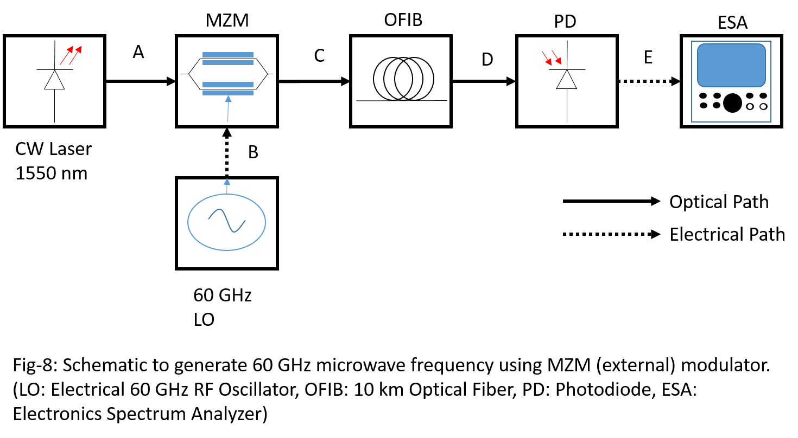

The MZM can be used to generate microwave, if it is used as shown in Fig-8. The CW laser and a 60 GHz RF is applied to the MZM biased at quadrature. As a consequence, the output light wave is modulated by the LO electrical waveform and a sideband of optical carrier is generated which are 60 GHz apart from the optical carrier. The optical spectrum in shown in Fig-9|(C). This modulated light is carried to a remote site using an optical fiber where the RF of 60 GHz is generated by heterodyning this optical sideband with the optical carrier using a Photodiode. The RF spectrum is shown in Fig-9 (E).

This technique produces a nearly clean RF spectrum and almost limits the phase noise to that exhibit by the laser source. Therefore, this method is implemented as the frequency generation stage for rest of the thesis. However, since all frequency generation methods rely on isolating a section of the spectrum and finally heterodyning them, their approach may be generalized using the schematic in Fig-8.

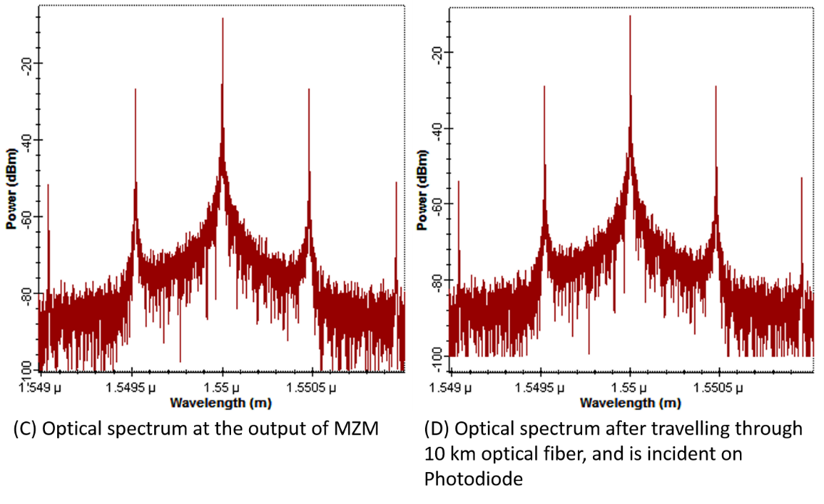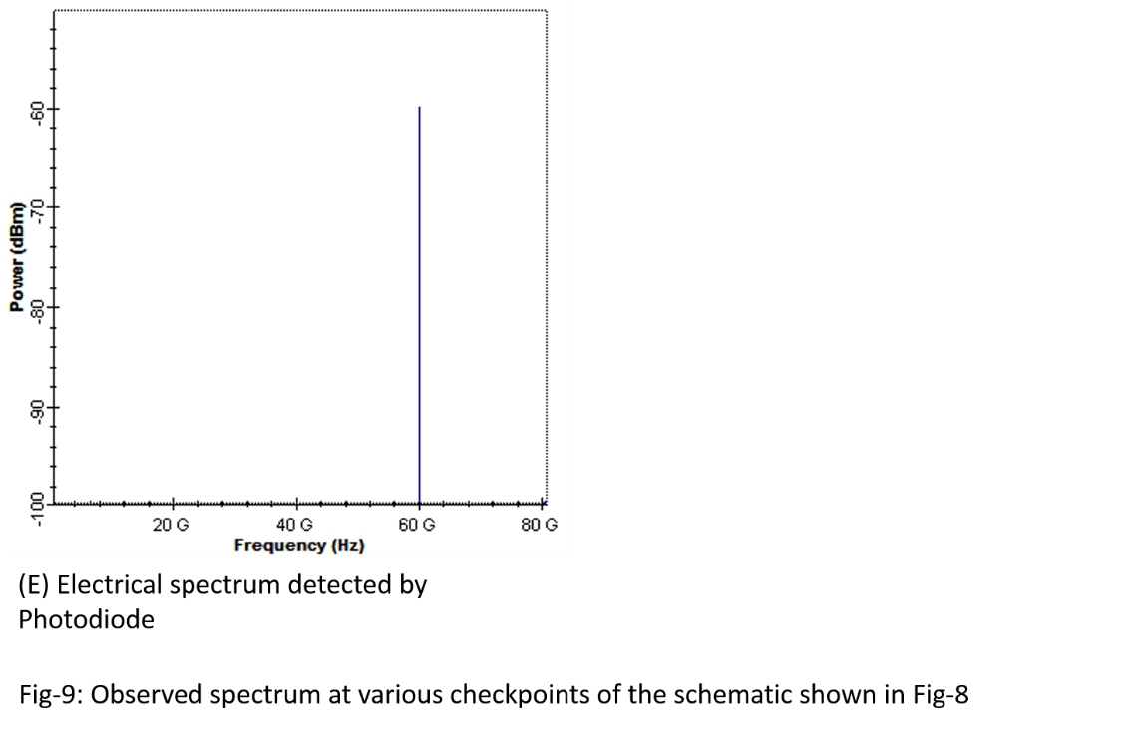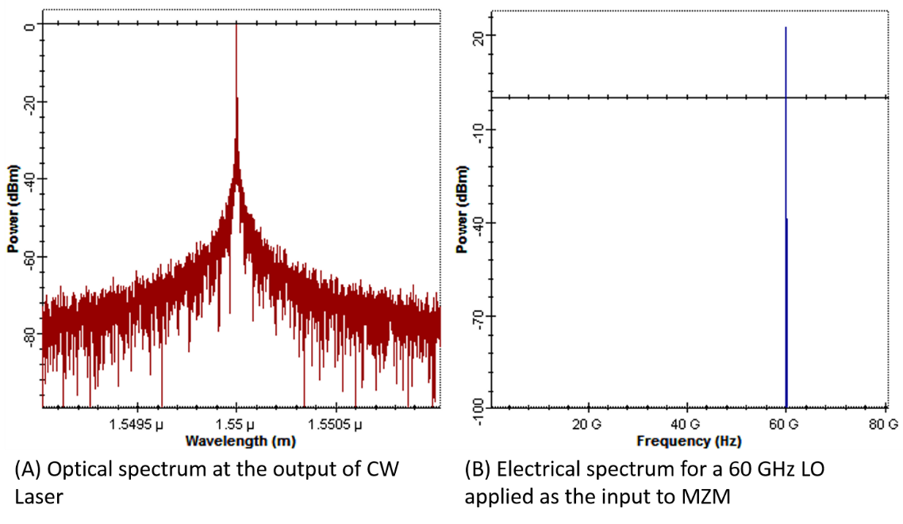

# 1.3.3 Microwave generation with Mode Locked Laser and Optical Comb sources

Mode locked laser and Optical Comb generators are good source for generating short optical pulses. By time to frequency domain conversion, the short pulses in time domain expands to frequency comb which occupies a large optical spectrum. The spectral bandwidth of the comb is equal to the inverse of the optical time domain pulse width and the frequency separation between each frequency of the comb is equal to the pulse repetition rate. These sources are therefore, efficient methods to generate required microwave frequencies.

However, there are two limitations with the usage of Mode Locked laser. There is a physical tendency for the mode locked laser to deviate out of its most stable state resulting in increase in spectral phase noise and leading to widening of pulses. As a consequence of which the pulse generation stops when the lasing condition is no more obeyed. At that instance, the laser needs to be restarted and carefully adjusted. The second limitation is that of the simulation software. OptiSystem version 7 does not contain in it any Mode Lock Laser component and hence mode locking must be explicitly done using discrete photonic components and wait for them to converge to a stable root. This design is beyond the scope of the thesis and hence a simulation for mode locking is not presented.

# 1.3.3.1 Optical Comb Source

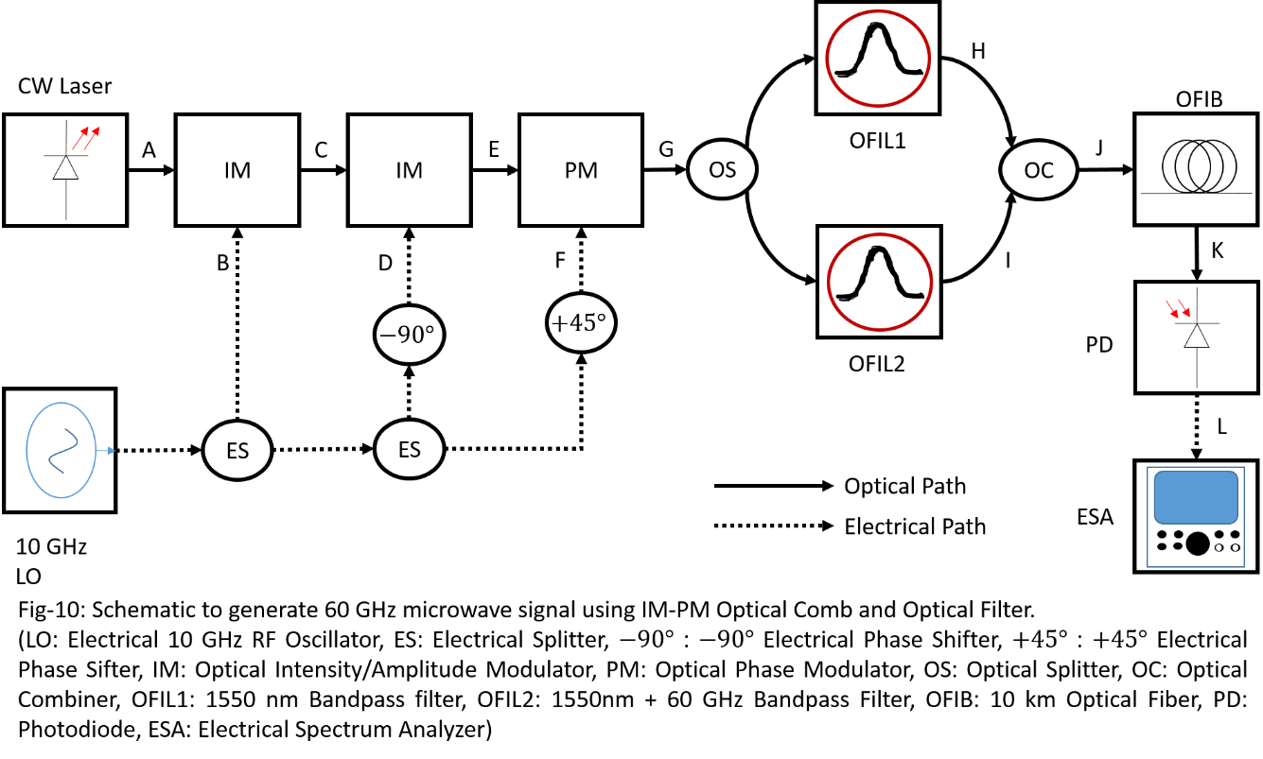

An optical comb generator can be designed using cascaded IM-PM connection as described in [5]. The schematic in Fig-10 shows the actual comb generation process. The comb generated have nearly flat amplitude over a wide number of harmonic, as shown in Fig-11 (G). The process of microwave generation involve heterodyning two harmonic among all that are generated in Fig-11 (G). By using two optical filter, two harmonic are separated as shown in Fig-11 (H) and (I). The selected harmonic are recombined using Optical Power Coupler and the spectrum is shown in Fig-11 (J) and (K). These optical harmonic are made to heterodyne at the photodiode generating the required LO frequency, as shown in Fig-11 (L). If the schematic is carefully noticed, it is similar to the optical heterodyning with a subtle difference. The difference here is that, here the RF generated is highly coherent because of the use of the single laser source. However, the technique can be studied similar to that in Section-1.3.2. Similar technique can be used to generate multiple frequency, although the treatment remains the same.

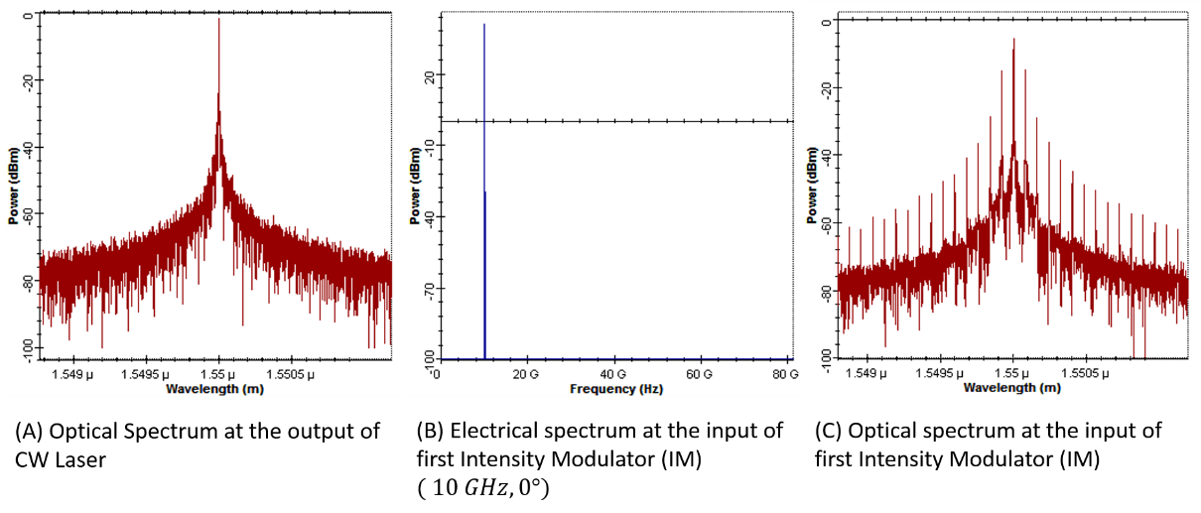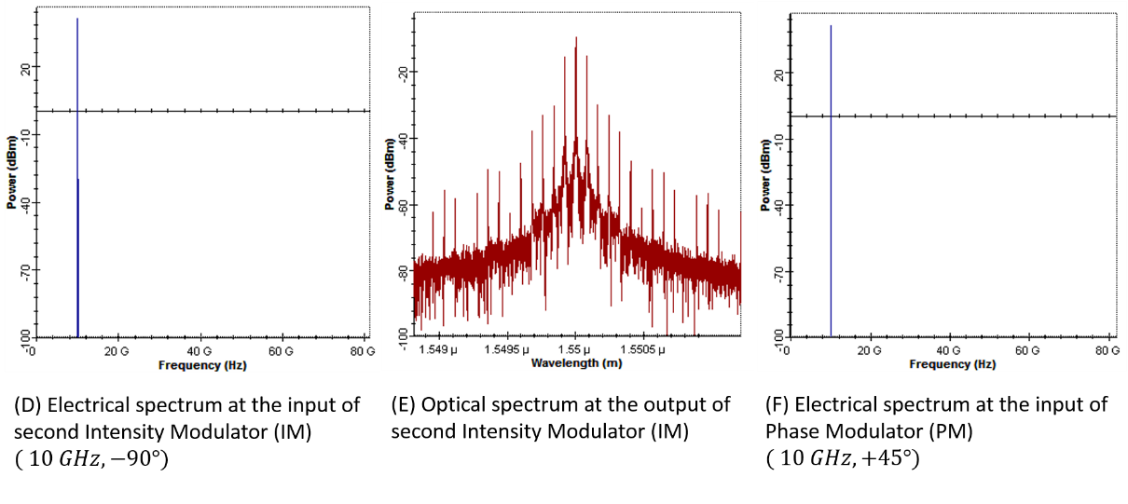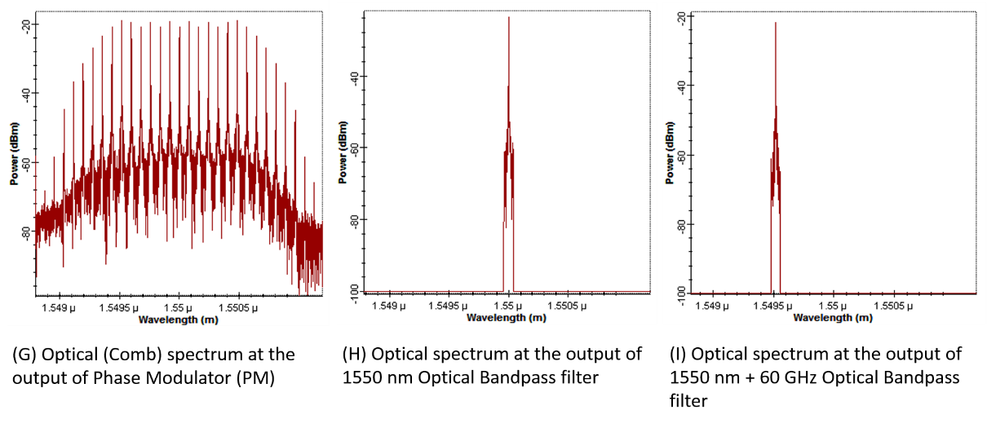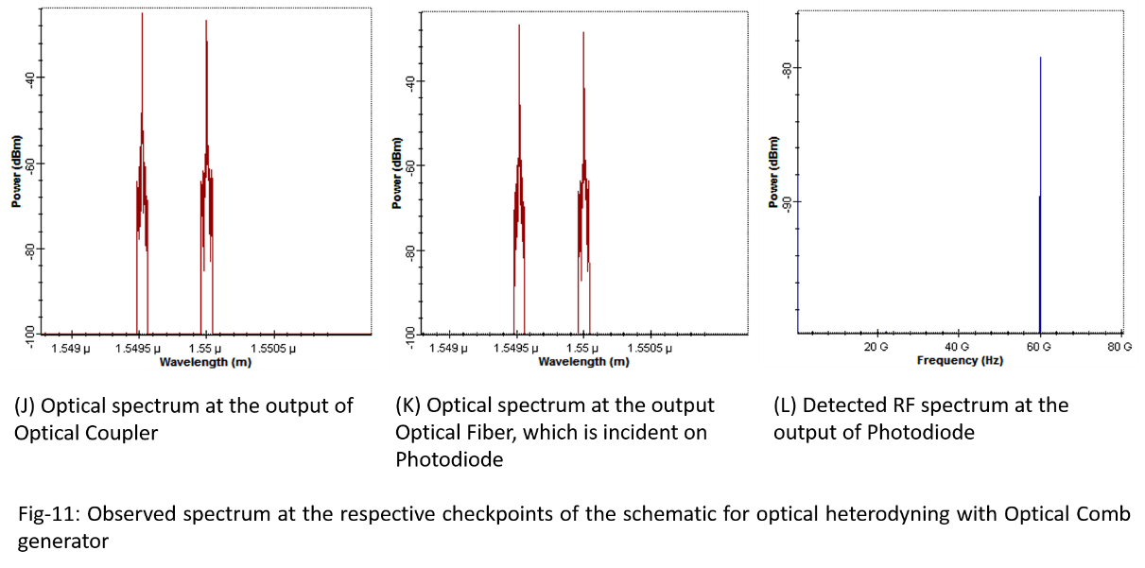

# 1.4 Organization of the Thesis

This chapter introduces motivation to build up photonic based up and down converter. It can be understood that, the schematic introduced in Section 1.3.2 is the most generic form of microwave frequency generation. In Chapter-2, the tunability of microwave generation technique is discussed. Further, we will also see how the tunability feature can achieve down-conversion as required by the Interferometry Radar. Also the characterization and performance assessment is done for the designed transceiver. In Chapter-3, the transceiver is redesigned using polarization modulator which overcomes the limitations of MZM based up and down converter. Then similar performance analysis is performed. Finally, the results obtained are summarized in Chapter-4, and conclusions regarding the same are drawn.

# REFERENCES

[1] M. Skolnik, “Introduction to Radar Systems”, MGH Publishers, India (2014).

[2] C. Nguyen, S. Kim, “Theory, Analysis and Design of Interferometric Sensors”, Springer (2012).

[3] S. Pinna, S. Melo, F. Laghezza, F. Scotti, E. Lazzeri, M. Scaffadi, P. Gelfi, A. Bogoni, “Photonics based radar for sub-mm displacement sensing”, IEEE Journal of Selected Topics in Quantum Mechanics (2016).

[4] J. Yao, “Microwave Photonics”, Vol. 27 (3), Journal of Lightwave Technology (2009).

[5] R. Yu, V. R. Supradeepa, C. M. Long, D. E. Leaird, A. M. Weiner, “Generation of very flat optical frequency combs from continuous-wave lasers using cascaded intensity and phase modulators driven by tailored radio frequency waveforms”, Optics Letters, Vol 35 (19) (2010).

# Chapter-2

# MZM based Photonic Transceiver

## 2.1 Introduction to Photonic Transceiver

An electrical RF transceiver, shown in Fig-1, the process of up or down-conversion is attained by beating the RF and LO to obtain IF frequency. During up conversion a band-pass filter is used to obtain the RF to be transmitted, whereas during down-conversion a low pass filter at the output can filter out the baseband data. Since, the circuit can up as well as down convert an input signal, it is called transceiver.

The photonic transceiver is a device for up-conversion and down-conversion using Photonics means. Since a photonics transceiver must be capable of converting RF to IF and vice versa, it is based on the same technique as used by the electronics transceiver design shown in Fig-1. The photonic way of transceiver eliminates the limitation suffered by the electrical design, and offers several advantages like RF/LO isolations, nonlinearity, scalability and efficiency [1].

In this chapter, techniques are devices to perform simultaneous up as well as down conversion without reconfiguration of the receiver architecture. Further, the system developed supports dynamic connectivity to existing optical link to achieve transceiver capability. The characterization of the performance of the receiver is done from theoretical as well as with simulations. The simulation is done using OptiSystem version 7 software from OptiWave Inc, which is a standard software for photonic simulations with a high degree of reliability and is popular among researchers and optical system designers, testers.

# 2.1.1 Review of the methods used for Photonic down-conversion

# 2.1.1.1 Direct Modulation of Photonic Link

In Fig-2, the laser is directly modulated and then optical to electrical conversion is used to obtain the required IF. This technique is the simplest among all. But the problem with this technique is the limited modulation bandwidth of lasers, relaxation oscillation which results in chirping at the output limits its application for long-haul communications despite the simplicity and low cost of link design exhibit by this technique [2]. These problems are eliminated by the use of external modulations, as opposed to direct modulation technique in Fig-2 because when external modulations are used the injection current is kept constant independent of the modulation being used or RF amplitude, which reduces chirping to a very low value[2].

# 2.1.1.2 External Modulation Link using Single Optical Modulator

In external modulation, the LO and RF signals are electrically combined and then applied to an optical external modulator. The optical external modulator modulates the light wave and finally frequency conversion is achieved at the output of optical-to-electrical conversion stage. This technique may seem simple and resembles that of external modulation for frequency generation shown in Chapter-1, but lacks electrical isolation which leads to unbalanced output due to impedance mismatch between LO, RF sources and the input of MZM. Hence, this technique is not preferred although it offers advantages like high speed of operation and scalability without adding more optical components.

# 2.1.1.3 External Modulation Link using Cascaded External Modulators

In Fig-4, cascaded external modulator EOM, EAM, etc. is used. In this design, the first stage is used for RF carrier frequency generation. This is referred to as LO stage, which requires a stableelectrical oscillator to improve the quality of the LO signal. After the light is modulated by a LO signal, the optical spectrum consists of the sidebands, which corresponds to the LO frequency.

The RF is applied to the second external optical modulator. The optical spectrum from the previous LO stage is applied to this modulator. The optical output of this stage contains, the optical sidebands from previous stage to be re-modulated by the applied RF signal applied to the second modulator. Finally, the sidebands generated by the second modulator are heterodyned during Optical-to-Electrical conversion by the photodiode, producing the required IF.

This method provides necessary isolation between LO, RF as well as IF and is also found to achieve better modulation efficiency as well as additional advantages, like wider bandwidth limited by MZM operational bandwidth, and much higher RF voltage swing [3].

# 2.1.1.4 External Modulation link using Single Optical Modulator and Multiple Laser Source

The Fig-5 is similar to Fig-4, in a way that LO stage is replaced by two laser sources. The RF inserted to the external optical modulator will modulate the optical output of the laser sources and produces respective sidebands. These modulated sidebands will heterodyne during Optical to Electrical conversion process and produce the required RF.

This technique can be used to achieve much higher LO frequencies, way into the mm-Wave range but also introduces much higher phase noise compared to the external modulation scenario, due to the incoherent nature of the free running laser sources [4]. This phase noise may be reduced by various optical synchronization techniques like Optical Injection Locking, OPLL, OIPLL, but also increases unnecessary complications in the link design. New and improved LO generations generally takes advantages of external modulations [4], optoelectronics oscillators [5-6], comb generators [7], frequency multiplication and mode-locked lasers, which provides much less phase noise and less design complexity than heterodyning techniques.

# 2.2 MZM for Up and Down-Conversion

A typical up or down conversion works as an analogous to a RF mixer circuit. An alternative representation of such circuit is a balanced amplitude modulator. The output spectrum in such balanced amplitude modulator consists of the sum and difference frequencies which are generated from the input RF and LO frequencies as is also observable in a RF mixer. However, in photonics, a MZM is a non-linear device which works on the principle of interferometry to convert phase modulation to intensity modulation.The working principle of MZM is that, the input light is split along two path using a Y-splitter. Along each path, the light is phase modulated with the help of an applied electric field across an electro-optic material through which the light passes. The applied electric field causes the refractive index of the material to change which changes the path length that the light takes to reach the Y-combiner. Finally, at the Y-combiner the phase modulated light interacts, resulting in constructive and destructive interferences. The constructive interference results in maximum light output whereas a destructive interference results in extinction of the input light. Thus the light wave become intensity modulated at the output. This can also be inferred as the non-linear amplitude modulation of optical mode with the application of the electric field.When phase modulation index or impressed electric field amplitudes are small, the intensity of output light become a linear function of the applied electric field, which makes MZM a suitable candidate fora typical RF up and down conversion.

# 2.2.1 The transfer function of a Dual-Drive Mach-Zehnder Modulator

In dual-drive MZM, the input optical power Ein is split along two paths using a Y splitter. Then a phase modulator made out of Lithium Niobate crystal of sufficient length is used to modulate the incident optical field in that arm with respect to the applied voltage. Finally, the modulated optical field are combined using a Y-coupler to provide output field Eout.

Consider a dual drive MZM, where an input optical electrical field Einwhich pass through a dual drive MZM whose arms are driven by two phasor voltages φ1 and φ2 respectively. These phasors will phase modulate the fields in the respective arms, thus resulting in a total output optical field Eout. The relation connecting input and output electric field by the relation:

$E_{out}= \frac{E_{in}}{{10}^{\frac{IL\left(dB\right)}{20}}}(γ e^{j ∅_{1}}+\left(1-γ\right)e^{j ∅_{2}})$.................... (1)

In the above relation, IL(dB) is the Insertion Loss, which can be defined as the ratio of the transmitted to the amount of incident power, expressed in dB. And γ represents the asymmetry of each MZM arms, which is again related to ER, the Extension Ratio. The Extinction Ratio is defined as the difference between the two optical power levels when the optical device is driven by a digital signal. If Extinction ratio ER is given in dB, the $ER= {10}^{\frac{ER(dB)}{10}}$, by the relation:

$γ= \frac{1}{2}\left(1-\frac{1}{\sqrt{ER}}\right)$.................... (2)

Therefore, $\left(1-γ\right)= \frac{1}{2}\left(1+\frac{1}{\sqrt{ER}}\right)$……………….. (3)

Substituting (2) and (3) in (1), we get,

$E_{out}= \frac{E_{in}}{{10}^{\frac{IL\left(dB\right)}{20}}}×\frac{1}{2}[\left(1-\frac{1}{\sqrt{ER}}\right)e^{j ∅_{1}}+\left(1+\frac{1}{\sqrt{ER}}\right)e^{j ∅_{2}}]$.................... (4)

Here it should be noted that the phases φ1 and φ2 are given by the following equations:

$∅_{1}= \frac{V_{bias1}}{V_{π}} π+ \frac{V_{rf1}(t)}{V_{π}} π= ∅_{bias1}+ \frac{V_{rf1}(t)}{V_{π}} π$……………….. (5)

$∅_{2}= \frac{V_{bias2}}{V_{π}} π+ \frac{V_{rf2}(t)}{V_{π}} π= ∅_{bias2}+ \frac{V_{rf2}(t)}{V_{π}} π$……………….. (6)

Where $V_{rf1}and V_{rf2}$ represents input RF instantaneous voltage, $V_{π}$ represents half-wave vthe oltage of the MZM, $V_{bias1}and V_{bias2}$ represents the DC bias applied to each arm.

# 2.2.2 Dual-Drive MZM with Single Input

In Dual-Drive MZM with Single Input, there is single input for DC bias and RF input. Consider one such MZM is biased with a DC input Vbias and RF instantaneous voltage of Vrf(t), then we can write the phasor voltage corresponding to this input as:

$∅_{1}={-∅}_{2}=∅= \frac{V_{bias1}}{V_{π}} π+ \frac{V_{rf}(t)}{V_{π}} π= ∅_{bias}+ \frac{V_{rf}(t)}{V_{π}} π$……………….. (7)

The above equation (7) represents that, the phasor applied to one arm is inverted and applied to the other arm such that, the MZM is operated under a push-pull arrangement. Substituting (7) in (4) we get,

$E_{out}= \frac{E_{in}}{{10}^{\frac{IL\left(dB\right)}{20}}}×\frac{1}{2}[\left(1-\frac{1}{\sqrt{ER}}\right)e^{j \frac{∅}{2}}+\left(1+\frac{1}{\sqrt{ER}}\right)e^{-j \frac{∅}{2}}]$.................... (8)

On rearranging and simplifying equation (8), we can write,

$E_{out}= \frac{E_{in}}{{10}^{\frac{IL\left(dB\right)}{20}}}×\frac{1}{2}[2\cos\left(\frac{∅}{2}\right)-\frac{j}{\sqrt{ER}} 2\sin\left(\frac{∅}{2}\right)]$

$E_{out}= \frac{E_{in}}{{10}^{\frac{IL\left(dB\right)}{20}}} [\cos\left(\frac{∅}{2}\right)-\frac{j}{\sqrt{ER}}\sin\left(\frac{∅}{2}\right)]$.................... (9)

The real part of the Eout represents the actual power transfer function of MZM whereas the imaginary part contributes to chirping when a pulsed input is applied to the MZM RF input. This input will reduce when the extinction ratio is increased. Hence, with the increase in the value of extinction ratio, the chirping reduces and consecutively reduces the contribution of the imaginary term in equation (9). For example, the Extinction ratio of 20 dB, reduces the contribution of the imaginary term to 0.1. For extinction ratio of 50 dB, this becomes 0.003. Finally, an extinction ratio of 100 dB, would reduce this to ${10}^{-5}$.

Therefore, we can conclude that an ideal and real chirp-free MZM should atleast possess an extinction ratio of 100 dB, which will make the contribution of the imaginary term to a negligible value for all calculation purposes. Under this condition, the equation (9) reduces to:

$E_{out}= \frac{E_{in}}{{10}^{\frac{IL\left(dB\right)}{20}}}\cos\left(\frac{∅}{2}\right)$.................... (10)

# 2.2.3 OptiSystem and its benefit in the design of MZM simulation model

OptiSystem is a software component of OptiWave Photonics Suite, which is specifically used to design a photonic transmission network using available photonics components, provided as a part of its component library. The software is designed with an aim of offering higher accuracy and modelling power with ease of use. The software provides an IDE (Integrated Development Environment) which acts as the paper on which the layout is drawn. The network is an interconnected set of blocks, where each block represents a component or subsystem of the real-world component. The interconnection between the components are done using “signal”, which is used to pass data from one component to another. The interconnected network in OptiSystem is a directed network, where the signal path interconnecting two components determine the direction of flow of the data. The data is represented by complex data structure and powerful numerical algorithms are used by the component models to solve the data and yield output.

The simulation engine uses block mode simulation algorithm. In this form of data processing, the entire block of data for a stipulated amount of time is generated or processed by a component model. Once the processing of the data is complete, the processed data is moved to another block, which performs the similar processing, conveying the data to the next. In this way, the data moves from generating node to the output or result node, getting transformed in between.The block mode is advantageous in optical domain simulation, whereby complex solution may be achieved such as split-step Fourier transform which is used in Non-Linear fiber. Further, it allows for immediate time-frequency conversion of data on the fly. Hence, the OptiSystem 7 always select the block simulation mode for simulation.Since, OptiSystem had already been established as an accurate and powerful simulation platform for Photonics Simulation, it will be used throughout the thesis for each and every simulation steps.

MZM is an essential component of the photonic transmission network, and also an essential component for the design of photonic up and down converter. Currently, there are two types of MZM available for use in network design categorized as Single-Drive MZM and Dual-Drive MZM. The Single-Drive MZM uses electric field induced phase modulation along one arm, whereas the other arm remains unaltered. This arrangement reduces extinction ratio and thus increases overall chirping. The chirping appears as unwanted harmonic and phase deviation in the output spectrum. However, the Dual-Drive MZM arrangement represents a balanced modulator, utilizing a Z-cut crystal. The balanced modulator arrangement is achieved with implementing two phase modulator, having one in each modulation arm. The modulators are driven by electric field which are complementary in phase. This arrangement allows us to yield high extinction ratio, which results in chirp free modulation.

The OptiSystem component library has an embedded single-drive MZM as well as dual-input dual-drive MZM. Single drive MZM is not used here because of its chirping nature. However, due to the absence of a single-input dual-drive MZM in the component library, a model for the same had been developed in the following section. The model implements a generic model for Single-Input Dual-Drive MZM with the Dual-Input Dual-Drive MZM. Further, a chirp free model for Single-Input Dual-Drive MZM is designed from this, by specifying a high extinction ratio. The design simplifies the network layout as it will be used wherever Single-Input Dual-Drive MZM is specified.

# 2.2.4 OptiSystem Model for a Single Input Dual Drive MZM

The transfer function of the Dual-Input Dual-Drive MZM component provided with the OptiSystem Simulation tool is written as:

$E_{out}= \frac{E_{in}}{{10}^{\frac{IL\left(dB\right)}{20}}}(γ e^{j ∅_{1}}+\left(1-γ\right)e^{j ∅_{2}})$....................(11)

When written in term of the extinction ratio, equation (11) reduces to (4):

$E_{out}= \frac{E_{in}}{{10}^{\frac{IL\left(dB\right)}{20}}}×\frac{1}{2}[\left(1-\frac{1}{\sqrt{ER}}\right)e^{j ∅_{1}}+\left(1+\frac{1}{\sqrt{ER}}\right)e^{j ∅_{2}}]$.................... (12)

It now the input phases to this component are scaled by an electrical amplifier to achieve a magnitude scale of 0.5, whereas the inputs are made to have opposite signs, then equation (12) would reduce to

$E_{out}= \frac{E_{in}}{{10}^{\frac{IL\left(dB\right)}{20}}} [\cos\left(\frac{∅}{2}\right)-\frac{j}{\sqrt{ER}}\sin\left(\frac{∅}{2}\right)]$.................... (13)

When extinction ratio is now made to be 100 dB, equation (13) reduces to equation (10):

$E_{out}= \frac{E_{in}}{{10}^{\frac{IL\left(dB\right)}{20}}}\cos\left(\frac{∅}{2}\right)$.................... (14)

Where the phase input represents:

$∅= \frac{V_{bias1}}{V_{π}} π+ \frac{V_{rf}(t)}{V_{π}} π= ∅_{bias}+ \frac{V_{rf}(t)}{V_{π}} π$……………….. (15)

The corresponding model to be used for simulation is shown in Fig-7 below. In Fig-7, a dual-input dual-drive MZM is used. One of its input is driven by the input RF scaled by 0.5 and another input of MZM is connected to the same RF scaled by -0.5. The combination will work as a single input but now will be a dual-drive MZM and implements the transfer function in equation (14), when its Extinction ratio is around 100 dB. The Fig-7b, the MZM is biased at MATP which represents a bias phase angle of φbias = 0o. Then Fig-7c, the MZM is biased at MITP, where the bias phase angle is φbias = 180o. For quadrature biasing, represented in Fig-7d, the bias angle will be φbias = 90o. Therefore, for obtaining the corresponding DC bias voltage to be used, from given bias angle, use the following formula:

$V_{bias}= V_{π}×\frac{φ_{bias}(radians)}{π}= V_{π}×\frac{φ_{bias}(degrees)}{180}$……………….. (16)

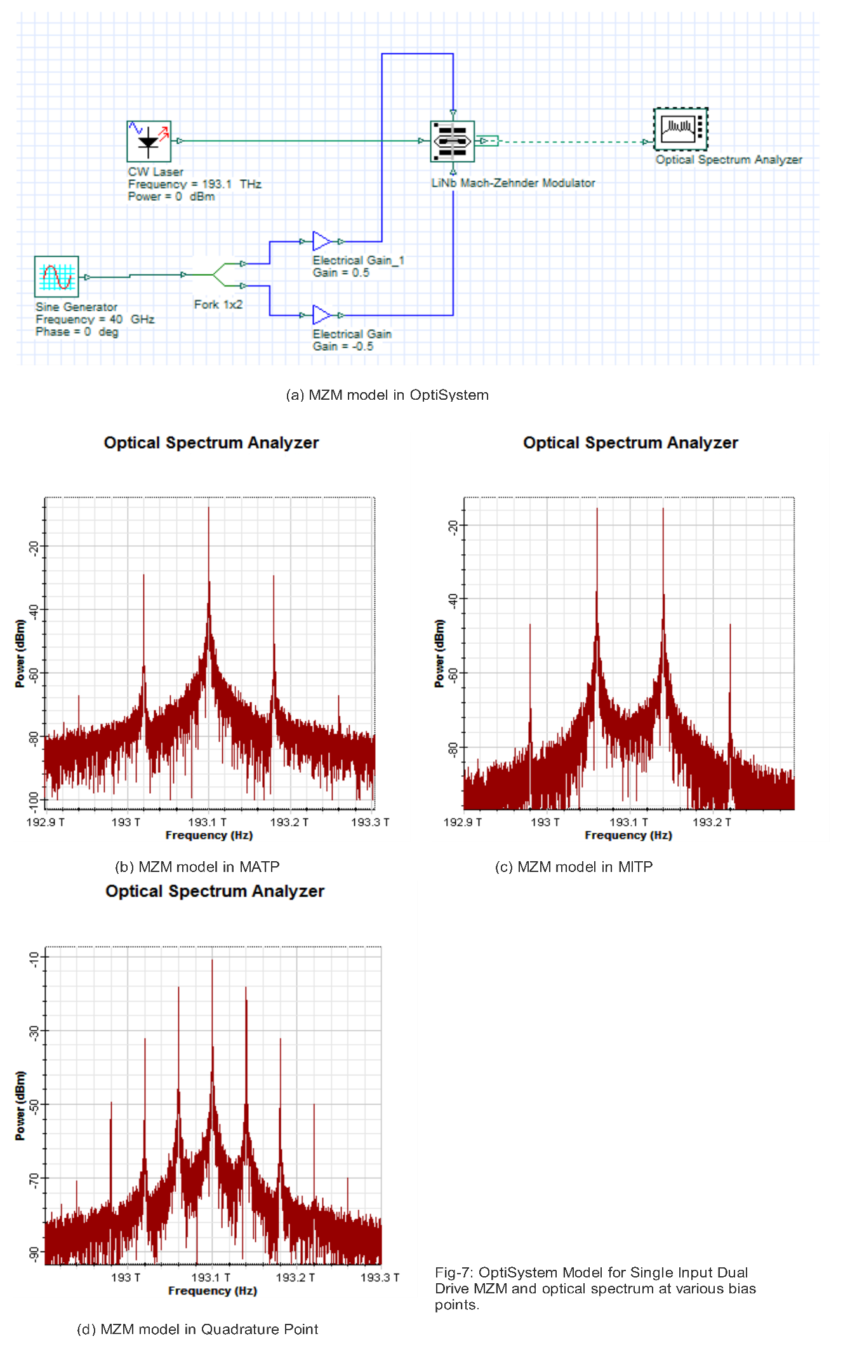

# 2.3 MZM for Frequency generation

In the previous section, an OptiSystem model for a chirp-free Single-Drive MZM is developed and the output under various bias conditions is pictorially shown in Fig-7. Further in chapter-1, a review of various generation techniques had been studied. Although all the techniques will work with the transceiver developing in the following section, we have taken the simplest technique for frequency generation. This technique takes advantage of the bias condition of MZM to obtain the desired (LO) frequency in optical domain. In this section, we will mathematically deduce the optical frequency that will appear depending on the LO frequency applied and the input bias.

Consider the schematic shown in Fig-7 (a). In the figure, an electrical sinusoid of form $V_{LO}\cos\left(ω_{LO}t\right)$ is applied. If the DC bias applied to the MZM is of form $\frac{∅_{DC}}{2}$, then the expression for output optical field is given by,

$$E_{out}= α E_{in}\cos\left\{\frac{∅_{DC}}{2}+A\cos\left(ω_{LO}t+ ∅_{LO}\right)\right\} \\ where E_{in}=optical input from Laser Source, \\ α= \frac{1}{{10}^{\frac{Insertion Loss in dB}{10}}}=a factor that accounts for the Insertion Loss,$$

$$A=\frac{\left|V_{LO}\right|}{V_{π}}\frac{π}{2}=modulation index due to impressed LO sinusoid, \\ ∅_{LO}=an angle that accounts for the phase mismatch between the RF and optical signal, \\ \left|V_{LO}\right|=peak voltage of the LO sinusoid, \\ V_{π}=half-wave voltage of the MZM.$$

When the MZM is biased at null point, then $\frac{∅_{DC}}{2}=0$. Under this condition, the path length remains same along both the arm of the MZM. Therefore, at the output, the light undergoes constructive interference, which results in maximum optical output. Along with the optical carrier, the above expression of output optical field can help in determining the other frequency component. The expression for output electric field can now be simply written as:

$$E_{out}= α E_{in}\cos\left\{A\cos\left(ω_{LO}t+ ∅_{LO}\right)\right\}$$ This expression can be expanded using Jacobi-Anger expansion as:

$$E_{out}= α E_{in} \{J_{0}\left(A\right)+2 \sum_{n=1}^{∝}{{(-1)}^{n}J_{2n}\left(A\right)\cos{2n \left(ω_{LO}t+ ∅_{LO}\right)}} \}$$ This expression indicates the presence of not only the optical carrier but also the even multiple of the input RF sinusoid. The spectrum is as indicated in Fig-7 (b). Although by controlling the modulation index of the input RF various even order harmonics can be generated, but since we are interested in the fundamental frequency corresponding to the input RF frequency, this bias condition is not satisfactory.

When the MZM is biased at half-wave voltage point, then $\frac{∅_{DC}}{2}=90°$. Under this condition, the path length elongates along one arm whereas equally shorten along the other, resulting in a total path difference of $180°$, which causes destructive interference at the output Y-combiner. This causes the output light intensity to reduce to a minimum value. In this case, the optical carrier is absent and the output optical field can be written as:

$$E_{out}= - α E_{in}\sin\left\{A\cos\left(ω_{LO}t+ ∅_{LO}\right)\right\}$$ This expression can be expanded using Jacobi-Anger expansion as:

$$E_{out}= α E_{in} \{2 \sum_{n=1}^{∝}{{(-1)}^{n}J_{2n-1}\left(A\right)\cos{(2n-1) \left(ω_{LO}t+ ∅_{LO}\right)}} \}$$ This expression indicates the absence of optical carrier but odd harmonics are present. The spectrum under this condition is shown in Fig-7 (c). But here fundamental frequency is present. But still this bias condition is unusable, because on detection by the photodiode the RF will not contain the fundamental LO frequency. But we want the fundamental LO frequency to be also the even multiple of the input RF sinusoid. Although by controlling the modulation index of the input RF various even order harmonics can be generated, but since we are interested in the fundamental frequency corresponding to the input RF frequency, this bias condition is not satisfactory.

The third option is to bias the MZM in quadrature, whereby $\frac{∅_{DC}}{2}=90°$. Under this condition, the total path length is such that neither it causes constructive or destructive interference. But in contradiction exhibit an in-between state of interference. Thus optical carrier is present although it will be partially extinguished. The output optical field can be written as:

$$E_{out}= \frac{α E_{in}}{\sqrt{2}}[\cos\left\{A\cos\left(ω_{LO}t+ ∅_{LO}\right)\right\}- \sin\left\{A\cos\left(ω_{LO}t+ ∅_{LO}\right)\right\} ]$$ This expression can be expanded using Jacobi-Anger expansion as:

$$E_{out}= α E_{in} \{J_{0}\left(A\right)+2 \sum_{n=1}^{∝}{{\left(-1\right)}^{n}J_{2n}\left(A\right)\cos{2n \left(ω_{LO}t+ ∅_{LO}\right)}} + 2 \sum_{n=1}^{∝}{{(-1)}^{n}J_{2n-1}\left(A\right)\cos{(2n-1) \left(ω_{LO}t+ ∅_{LO}\right)}}\}$$ The expression indicates that all harmonic would be present depending on the modulation index. The spectrum is depicted in Fig-7 (d). Now, if modulation index is small enough such that the second and higher order Bessel functions become negligible, then the above expression becomes:

$$E_{out}= α E_{in} \{J_{0}\left(A\right)- 2 J_{2n-1}\left(A\right)\cos{(2n-1) \left(ω_{LO}t+ ∅_{LO}\right)}\}$$ This expression indicates that the output optical spectrum would compose optical carrier and its first order sidebands. Which when detected using a photo detector would show fundamental LO frequency. Thus, as we require the LO frequency to be present in the output RF spectrum, therefore, the quadrature bias is the ideal bias condition to generate the required LO frequency. This bias condition is used throughout the thesis, as this not only produce the required frequency spectrum but is also the most stable region of the MZM bias curve.

# 2.4 Cascaded MZM based transceiver

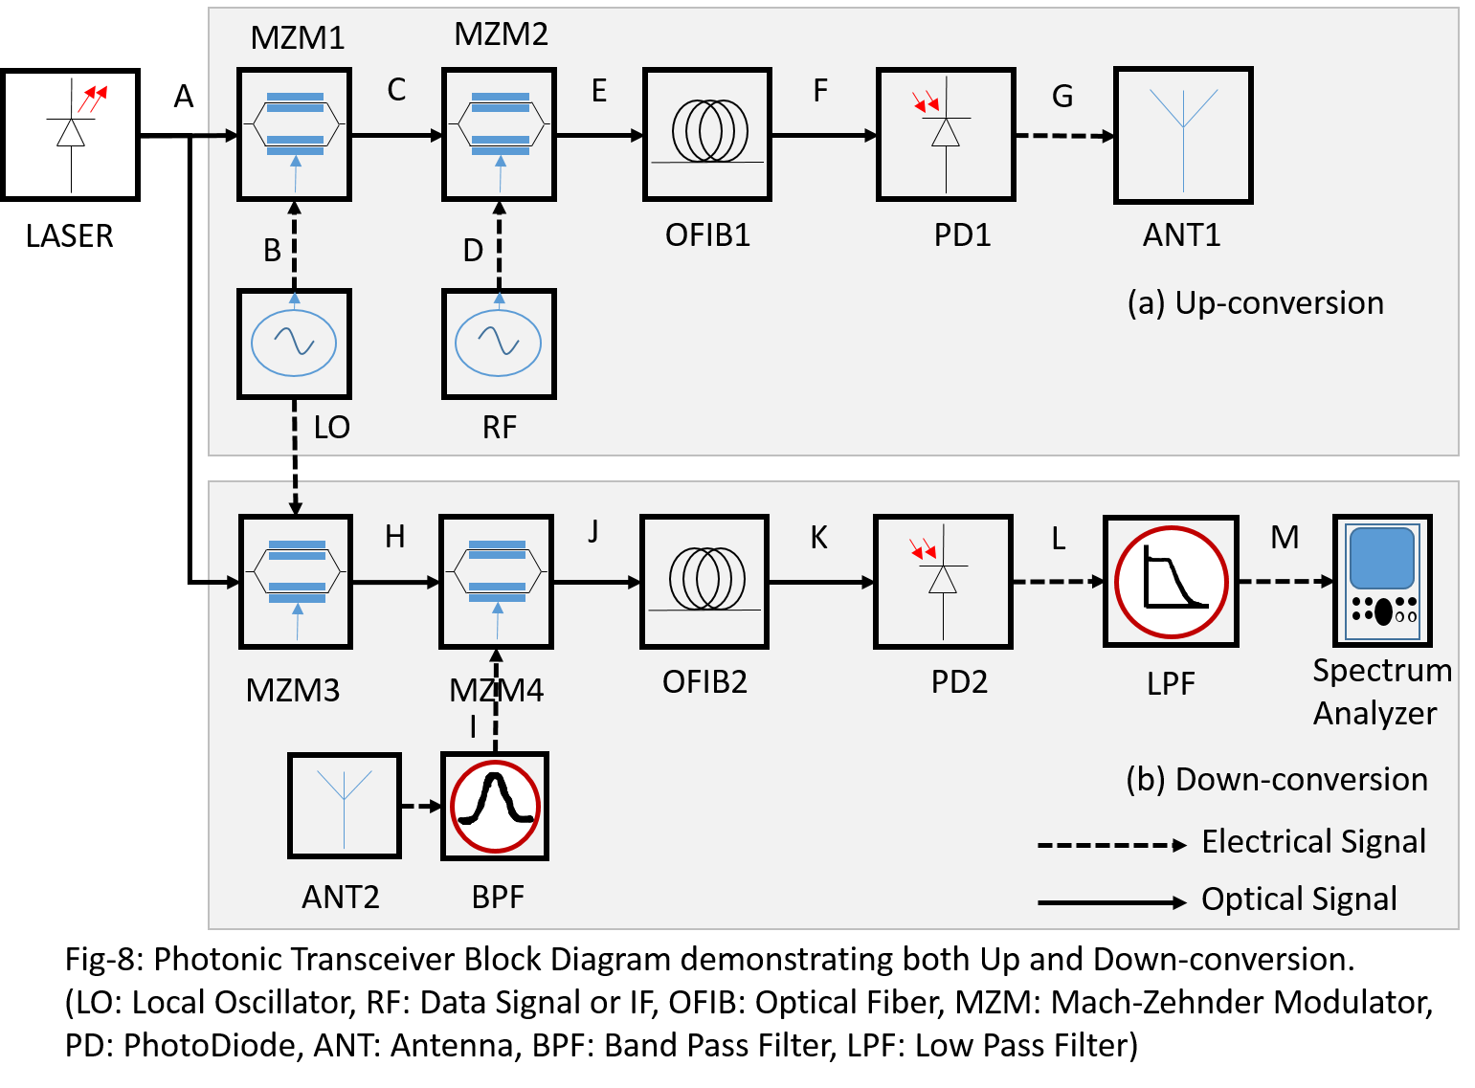

The most linear operating point of an MZM is when it is biased at quadrature. This linear operation can be used to implement an MZM based RF mixer and consecutively, an RF up and down-conversion system. To describe the operation, first, consider the circuit shown in Fig-8 above. A single laser source is used to drive up as well as down conversion path. In the upconversion route, MZM1 is driven by quadrature bias and an input reference signal is applied from a local oscillator (LO). This frequency will act as the carrier waveform for the following stage. The quadrature biasing ensures that all optical sidebands corresponding to the input LO frequency are generated by MZM1. But it should be kept in mind that the amplitude of the applied LO signal must be small enough to ensure that the second order side-band is negligibly small compared to the first order side-band. This assumption is necessary for eliminating the second order and consequently the higher order sidebands and also enables to simplify the calculations. The lightwave output from MZM1 thus contains optical sidebands of -fLO, 0 (representing the optical carrier) and +fLO, which is further modulated by MZM2. The MZM2 is biased at quadrature and a RF signal containing the modulated data is applied to it. The sidebands along with the optical carriers are simultaneously modulated by the RF signal applied at the input, which results in the further generation of first order sideband across each of the carriers or sidebands that appears across the input of the MZM2. This now the output of MZM2 contains the sidebands –fLO - fRF, -fLO, -fLO + fRF­, - fRF, 0, + fRF­, +fLO - fRF, +fLO, +fLO + fRF­. The output of MZM2 is connected to a photodiode through a fiber of specific length, say 10 km, where the resultant optical signals are made to heterodyne and produce upconverted RF signal across the LO frequency. Among all the heterodyning output the prominent output corresponds to the RF frequencies of fRF, fLO, fLO– fRF, fLO + fRF . The circuit thus seems to act as a mixer for RF input, which is now upconverted to the band governed by LO frequency. This upconverted signal at the photodiode is then radiated using an antenna. For simulation purposes ideal and noiseless optical amplifiers and electrical amplifiers are added to the design, wherever deemed necessary but eliminated from the diagram to ensure clarity without causing any change in the working principle. Fig-9 will show all the waveforms that appear at varies sections marked A-G in the diagram in Fig-8. The radiated RF, containing the injected RF along with upconverted RF can be used for multi-band transmission (like Microwave and Millimeter-wave), and if needed, an electrical band-pass filter can be used to extract the frequency of interest to be radiated.

For demonstrating the principle for downconversion, consider the shaded region-(b) of the figure-8. During down-conversion, the optical section as shown in region-(a) of Figure-8 remains unchanged. However, now the MZM4, which corresponds to MZM2 of Figure-8(a), is driven by the signal received from the antenna. The signal received by antenna must be filtered with a bandpass filter centered at fLOfrequency and exhibit the required bandwidth. The MZM4 is biased at quadrature and since it is driven by the optical frequencies -fLO, 0 (representing the optical carrier) and +fLO, and the RF input is now fLO+fRF (it can also befLO-fRF). Thus with RF input of MZM4 being fLO+fRF, the output of MZM4 is composed of the following sidebands –(2 fLO + fRF), -fLO, -fRF, 0, fRF, fLO, (2 fLO + fRF). These sidebands will heterodyne and after passing through an electrical low pass filter having bandwidth as the same as that of the RF signal will extract the RF spectrum composing of the modulated data signal. Therefore, during the down-conversion process, the high-frequency RF is converted to a low frequency or baseband modulated signal. Observe the waveforms as shown in Fig-10, which corresponds to the spectrum that would appear at various stages of the down-conversion schematic.

Therefore, the same schematic is acting as an upconversion during signal transmission and downconversion system during signal reception. Further, the use of same LASER source and LO source during up and down-conversion ensures that the overall design remains coherent throughout its operation time. A tight coherence between transmitter and receiver reduces electrical phase noise and also simplifies the signal processing overhead and hence, the complexity of the electrical section can be reduced.

In the following sections, we will analyze the transceiver performance in details and extract several operational parameters. The results obtained mathematically will be compared to the results from the simulations performed in OptiSystem.

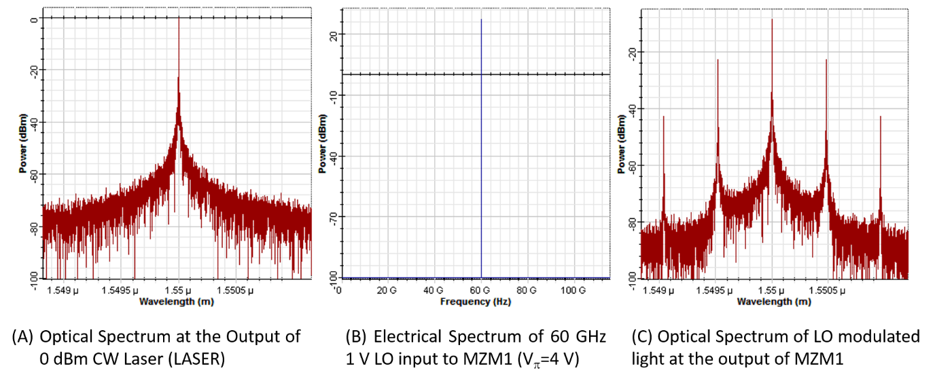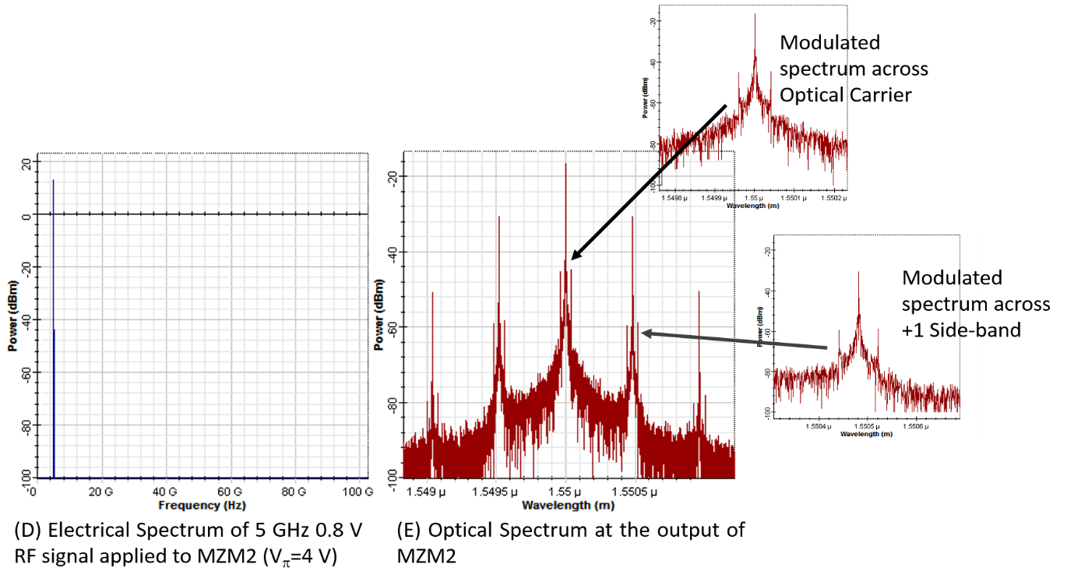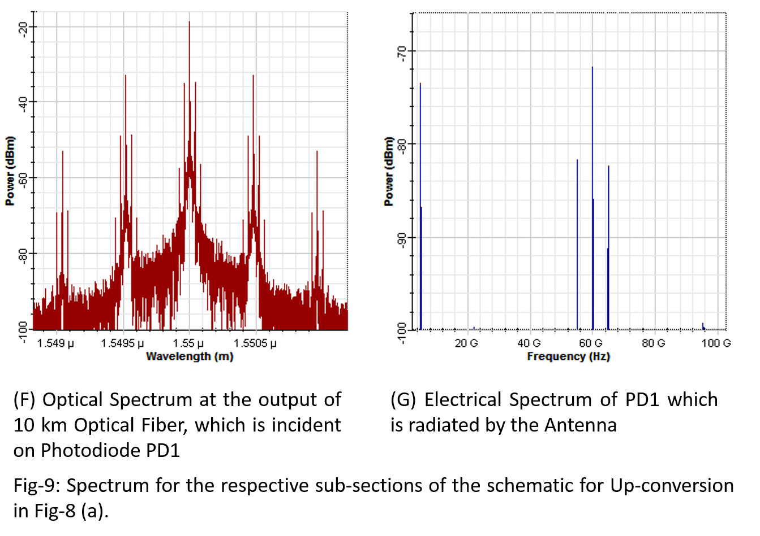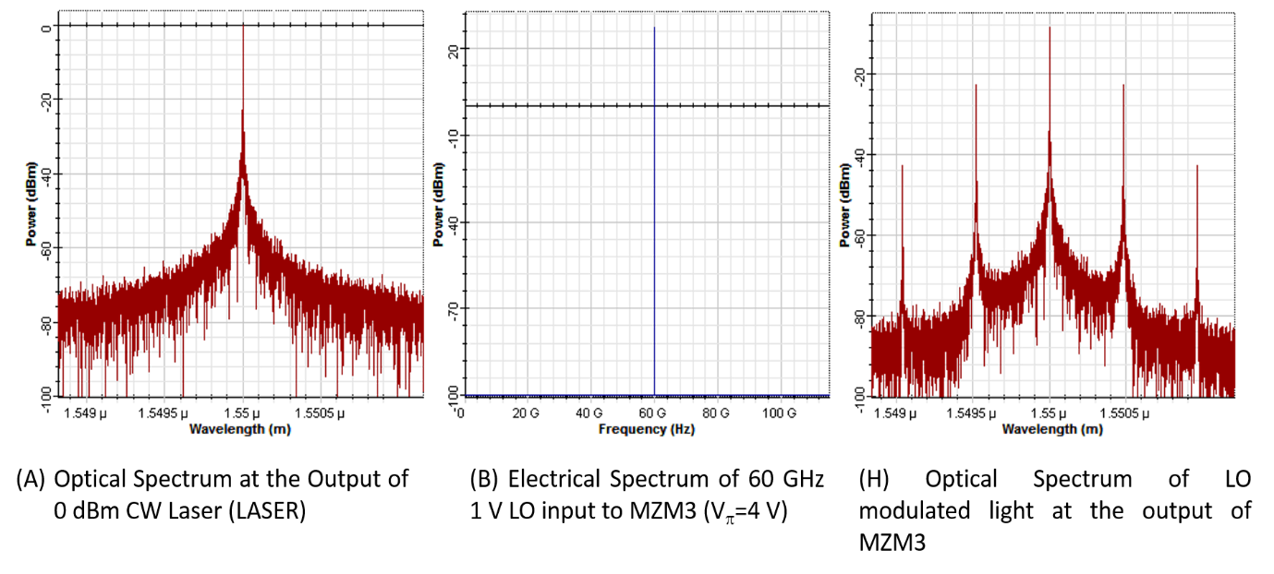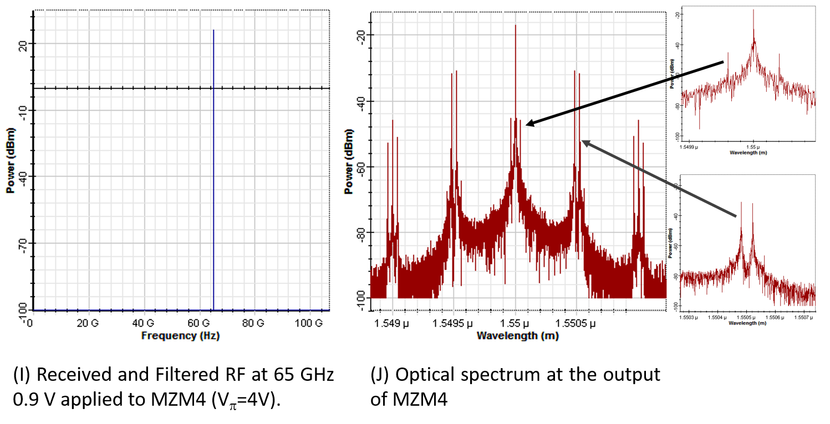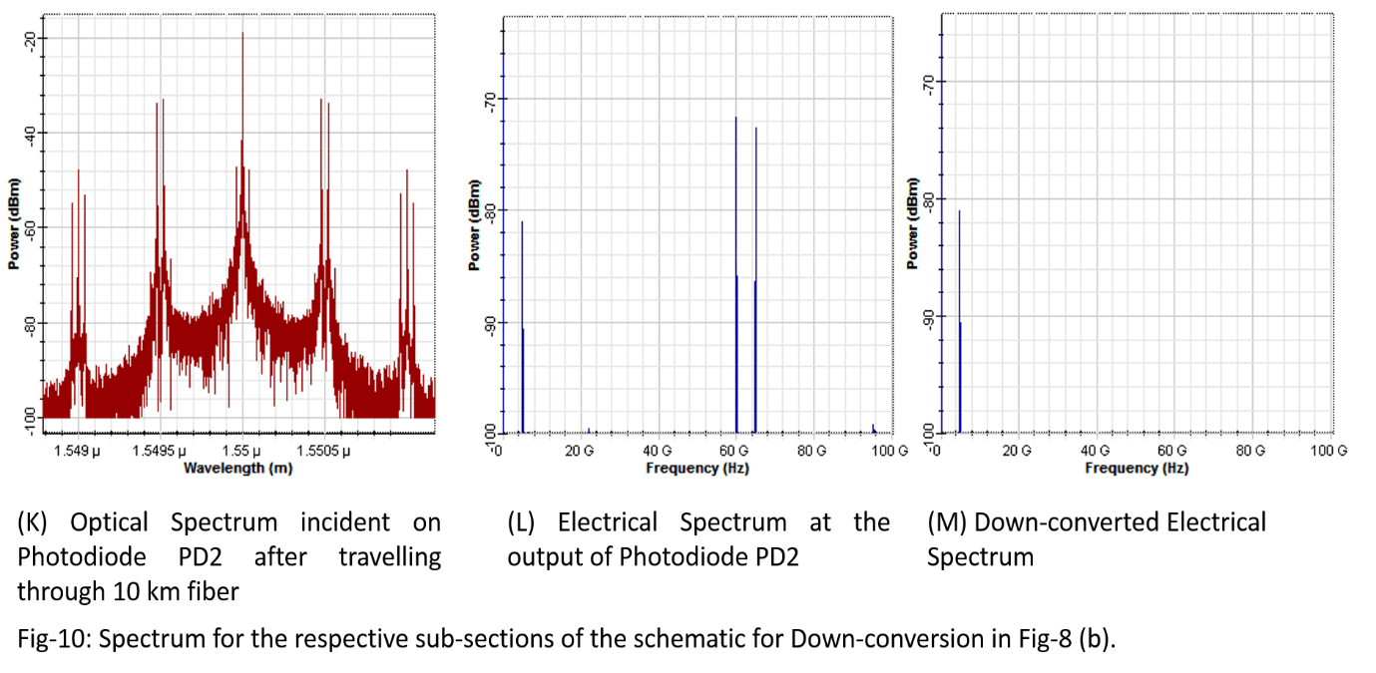

# 2.4.1 Theoretical Analysis of Cascaded MZM upconverter

Consider the schematic of a Photonic based up-converter block as shown in Fig-11 above. The first MZM1 is connected to a sinusoidal signal from a stable Local Oscillator (LO). Let us also consider that the stable local oscillator providesan LO signal in form of a sinusoid of frequency fLO, having am amplitude VLO, then the instantaneous sinusoidal voltage can be written as:

$V_{LO}\left(t\right)=V_{LO}cos⁡(ω_{LO}t)$……………….. (17)

$$where V_{LO} =peak amplitude of LO signal,$$ $ω_{LO}=angular frequency of the LO signal$.

Now consider the LASER in the schematic shown in Fig-11. Let the CW LASER emit an optical signal of power Pin whereby the magnitude of the optical field is Ein. Since the optical field output from the CW laser is incident on MZM1, the modulated output of MZM1 can be mathematically expressed as:

$$E_{1}= α_{1}E_{in}\cos\left[\frac{{90}^{0}}{2}+A\cos\left(ω_{LO}t+ φ_{LO}\right)\right] \\ = α_{1}E_{in}\cos\left[{45}^{0}+A\cos\left(ω_{LO}t+ φ_{LO}\right)\right]$$ $= α_{1}\frac{E_{in}}{\sqrt{2}}\left[\cos\left\{A\cos\left(ω_{LO}t+ φ_{LO}\right)\right\}-\sin\left\{A\cos\left(ω_{LO}t+ φ_{LO}\right)\right\}\right]$………………..(18) $$where α_{1}= \frac{1}{{10}^{\frac{Insertion Loss \left(dB\right)}{20}}}=a factor that accounts from the insertion loss in MZM1, \\ A= \frac{V_{LO}}{V_{π}}\frac{π}{2}=modulation index of MZM1 corresponding to amplitude of applied LO, \\ φ_{LO}=the phase mismatch arising from velocity mismatch between LO and optical field.$$

Expand equation (18) using Jacobi-Anger expansion and also assume that, the applied LO signal hasa sufficiently small amplitude such that only Bessel terms upto first order survive. Thus, the expansion of (18) becomes:

$E_{1}= \frac{α_{1}E_{in}}{\sqrt{2}}[ J_{0}\left(A\right)-2 J_{1}\left(A\right)cos⁡(ω_{LO} t+ φ_{LO}) ]$…………..…….(19)

From equation (19), we can conclude thatthe optical spectrum at the output of MZM1 is composed of the optical carrier itself along with the two first-order sidebands corresponding to the frequencies -ωLO and +ωLO, about the optical carrier, which can also be seen in Fig-9(c). Therefore, the optical power carried by each of these components can be written as:

$P_{1}\left(0\right)= \frac{{α_{1}}^{2}P_{in}}{2}{[ J_{0}\left(A\right)]}^{2}$………………..(20) $P_{1}\left(± ω_{LO}\right)= \frac{{α_{1}}^{2}P_{in}}{2}{[ J_{1}\left(A\right)]}^{2}$ 
 ……………….. (21)

Further, if the amplitude A of the LO is within 0.6, then by using the properties of Bessel function, we can write:

$$J_{0}\left(A\right)=1, J_{1}\left(A\right)=A/2$$

This will allow us to write equations (20) and (21) to be written as:

$$P_{1}\left(0\right)= \frac{{α_{1}}^{2}P_{in}}{2} \\ P_{1}\left(± ω_{LO}\right)= \frac{{α_{1}}^{2}P_{in}}{2}{[ \frac{A}{2}]}^{2}= P_{1}\left(0\right) ×0.25 A^{2}$$

In the next stage, the optical field from MZM1 is applied to the optical input of MZM2.Also, the RF/IF carrying the modulated data is applied to the MZM2, which like MZM1 should be biased in quadrature. Consider that the RF sinusoid applied to MZM2 be of the form:

$V_{RF}\left(t\right)=V_{RF}cos⁡(ω_{LO}t)$……………….. (22)

$$where V_{RF}=peak amplitude of RF signal,$$ $ω_{RF}=angular frequency of the RF signal$.

When this signal is applied to MZM2, the MZM will modulate the incident optical signal from MZM1 with the sinusoid from equation (22), the corresponding output from MZM2 will be:

$$E_{2}= α_{2}E_{1}\cos\left[\frac{{90}^{0}}{2}+B\cos\left(ω_{RF}t+ φ_{RF}\right)\right] \\ = α_{2}E_{1}\cos\left[{45}^{0}+B\cos\left(ω_{RF}t+ φ_{RF}\right)\right]$$ $= α_{2}\frac{E_{1}}{\sqrt{2}}\left[\cos\left\{B\cos\left(ω_{RF}t+ φ_{RF}\right)\right\}-\sin\left\{B\cos\left(ω_{RF}t+ φ_{RF}\right)\right\}\right]$………………..(23) $$where α_{2}= \frac{1}{{10}^{\frac{Insertion Loss \left(dB\right)}{20}}}=a factor that accounts from the insertion loss in MZM2, \\ B= \frac{V_{RF}}{V_{π}}\frac{π}{2}=modulation index of MZM2 corresponding to amplitude of applied RF, \\ φ_{RF}=the phase mismatch arising from velocity mismatch between RF and optical field.$$

Expand equation (23) using Jacobi-Anger expansion and also assume that, the applied RF signal hasa sufficiently small amplitude such that only Bessel terms upto first order survives. But here Bessel function upto second order is taken in orderto understand the optical spectrum at the output of MZM2. Thus, the expansion of (18) becomes:

$E_{2}= \frac{α_{2}E_{1}}{\sqrt{2}}[ J_{0}\left(B\right)-2J_{1}\left(B\right)\cos\left(ω_{RF} t+ φ_{RF}\right)-2 J_{2}\left(B\right)cos⁡({2ω}_{RF} t+ {2φ}_{RF}) ]$…….(24)

Substituting the values from equation (19) in equation (24), we have,

$$E_{2}= \frac{α_{2}}{\sqrt{2}}\frac{α_{1}E_{in}}{\sqrt{2}}\left[J_{0}\left(A\right)-2J_{1}\left(A\right)\cos\left(ω_{LO} t+ φ_{LO}\right)\right]\left[J_{0}\left(B\right)-2J_{1}\left(B\right)\cos\left(ω_{RF} t+ φ_{RF}\right)-2J_{2}\left(B\right)\cos\left({2ω}_{RF} t+ {2φ}_{RF}\right)\right]$$ $= \frac{α_{1}α_{2}E_{in}}{2} [ J_{0}\left(A\right)J_{0}\left(B\right)-2{J_{0}\left(A\right) J}_{1}\left(B\right)\cos\left(ω_{RF} t+ φ_{RF}\right)-2 J_{0}\left(A\right)J_{2}\left(B\right)\cos\left({2ω}_{RF} t+ {2φ}_{RF}\right)-2 J_{1}\left(A\right)J_{0}\left(B\right)\cos\left(ω_{LO} t+ φ_{LO}\right)+4J_{1}\left(A\right){ J}_{1}\left(B\right)\cos\left(ω_{LO} t+ φ_{LO}\right)\cos\left(ω_{RF} t+ φ_{RF}\right)+4 J_{1}\left(A\right)J_{2}\left(B\right)\cos\left(ω_{LO} t+ φ_{LO}\right)cos⁡({2ω}_{RF} t+ {2φ}_{RF}) ]$

$= \frac{α_{1}α_{2}E_{in}}{2} [ J_{0}\left(A\right)J_{0}\left(B\right)-2{J_{0}\left(A\right) J}_{1}\left(B\right)\cos\left(ω_{RF} t+ φ_{RF}\right)-2 J_{0}\left(A\right)J_{2}\left(B\right)\cos\left({2ω}_{RF} t+ {2φ}_{RF}\right)-2 J_{1}\left(A\right)J_{0}\left(B\right)\cos\left(ω_{LO} t+ φ_{LO}\right)+2 J_{1}\left(A\right){ J}_{1}\left(B\right)\cos\left\{\left(ω_{LO}+ω_{RF}\right)t+\left(φ_{LO}+ φ_{RF}\right)\right\} +2 J_{1}\left(A\right){ J}_{1}\left(B\right)\cos\left\{\left(ω_{LO}-ω_{RF}\right)t+\left(φ_{LO}- φ_{RF}\right)\right\} +2 J_{1}\left(A\right){ J}_{2}\left(B\right)\cos{ \{\left(ω_{LO}+{2 ω}_{RF}\right)t+(φ_{LO}+ {2 φ}_{RF})\}} +2 J_{1}\left(A\right){ J}_{2}\left(B\right)\cos{ \{\left(ω_{LO}-{2 ω}_{RF}\right)t+(φ_{LO}- {2 φ}_{RF})\}} ]$………………. (25)

From equation (25), we can see that the optical spectrum at the output of MZM2 consists of the positive frequencies: 0 (corresponding to optical carrier), ωRF, 2 ωRF, ωLO, (ωLO - ωRF), (ωLO + ωRF), (ωLO – 2 ωRF), (ωLO + 2 ωRF), which can also be seen in Fig. 9 (E) and (F). The second order frequencies 2 ωRF, (ωLO – 2 ωRF), (ωLO + 2 ωRF) bears a very low power and hence cannot be distinguished from their corresponding first-order frequencies. Therefore, the respective optical powers that are carried by these optical sidebands are obtained from equation (25), and are given below:

$P_{2}\left(0\right)={\left|E_{2}\left(0\right)\right|}^{2}={\left|\frac{α_{1}α_{2}E_{in}}{2}\right|}^{2}{\left[J_{0}\left(A\right)J_{0}\left(B\right)\right]}^{2} = \frac{T_{D}P_{in}}{2}{\left[J_{0}\left(A\right)J_{0}\left(B\right)\right]}^{2}$………………... (26)

$P_{2}\left(ω_{RF}\right)= \frac{T_{D}P_{in}}{2}{\left[-2 J_{0}\left(A\right)J_{1}\left(B\right)\right]}^{2}$………………… (27)

$P_{2}\left(2 ω_{RF}\right)= \frac{T_{D}P_{in}}{2}{\left[-2 J_{0}\left(A\right)J_{2}\left(B\right)\right]}^{2}$………………… (28)

$P_{2}\left(ω_{LO}\right)= \frac{T_{D}P_{in}}{2}{\left[-2 J_{1}\left(A\right)J_{0}\left(B\right)\right]}^{2}$…………………. (29)

$P_{2}\left(ω_{LO}± ω_{RF}\right)= \frac{T_{D}P_{in}}{2}{\left[2 J_{1}\left(A\right)J_{1}\left(B\right)\right]}^{2}$……………….. (30)

$P_{2}\left(ω_{LO}± 2 ω_{RF}\right)= \frac{T_{D}P_{in}}{2}{\left[2 J_{1}\left(A\right)J_{2}\left(B\right)\right]}^{2}$……………….. (31)

In equation (26) – (31), TD represents the total power loss due to insertion losses, fiber attenuation and power leakage or reflections, in the optical spectrum. This factor will allow us to correlate the theoretical result with that obtained experimentally or with simulations. TD can be measured by turning off LO and RF and measure the laser power that is received by an optical power meter at the photodiode end. Then TD is the ratio of this received power and the incident laser power Pin. Here, Pin represents the input Laser power in Watts. Therefore, the link loss factor TDis unitless. Another noteworthy point to mention is that TD may be a function of frequency if the spectrum spans over ultra-wideband, then again respective values corresponding to the band of measurement is similarly measured and inserted into the above equations to obtain their respective power.

The electrical spectrum is important in accordance with Radio-Over-Fiber concept. Hence, the next step in the theoretical calculation is the expression for electrical spectrum that will be observed with the optical signal in equation (25) when made incident on a photodiode. For obtaining the expression for optical spectrum we will not use the expression in equation (25), but rather use the equations (18) and (23), to increase the accuracy of the analysis, along with the assumptions that were used to obtain equation (25).

First, square the first equation in the equation in (18), we then have,

$${{|E}_{1}|}^{2}= {α_{1}}^{2}{|E_{in}|}^{2}\cos^{2}\left[\frac{{90}^{0}}{2}+A\cos\left(ω_{LO}t+ φ_{LO}\right)\right]$$

$${{|E}_{1}|}^{2}= {α_{1}}^{2}\frac{P_{in}}{2}[1+ \cos{\{{90}^{0}+2 A\cos\left(ω_{LO}t+ φ_{LO}\right)\}]}$$

${{|E}_{1}|}^{2}= {α_{1}}^{2}\frac{P_{in}}{2}[1-\sin\left\{ 2 A\cos\left(ω_{LO}t+ φ_{LO}\right)\right\}]$………………(32)

Similarly, squaring first equation in (23), we have,

$${{|E}_{2}|}^{2}= {α_{2}}^{2}{|E_{1}|}^{2}\cos^{2}\left[\frac{{90}^{0}}{2}+B\cos\left(ω_{RF}t+ φ_{RF}\right)\right]$$

$${{|E}_{2}|}^{2}= {α_{2}}^{2}\frac{{|E_{1}|}^{2}}{2}[1+ \cos{\{{90}^{0}+2 B\cos\left(ω_{RF}t+ φ_{RF}\right)\}]}$$

${{|E}_{2}|}^{2}= {α_{2}}^{2}\frac{{|E_{1}|}^{2}}{2}[1-\sin\left\{ 2 B\cos\left(ω_{RF}t+ φ_{RF}\right)\right\}]$………………(33)

Substitute the values from equation (32) to equation (33), we have,

${{|E}_{2}|}^{2}= {α_{1}}^{2}{α_{2}}^{2}\frac{P_{in}}{4} [1-\sin\left\{ 2 A\cos\left(ω_{LO}t+ φ_{LO}\right)\right\}] [1-\sin\left\{ 2 B\cos\left(ω_{RF}t+ φ_{RF}\right)\right\}]$………………(34)

Expand equation (34) with Jacobi-Anger expansion. The assumption here is that for the terms relating to A, all Bessel function terms above first order would be neglected. And for the terms relating to B, keep only Bessel function terms upto third order. Therefore, after applying the stated assumptions, the expansion of equation (34) becomes,

${{|E}_{2}|}^{2}= {α_{1}}^{2}{α_{2}}^{2}\frac{P_{in}}{4} [1-2 J_{1}\left(2 A\right)\cos\left(ω_{LO}t+ φ_{LO}\right)] [1-2 J_{1}\left(2 B\right)\cos\left(ω_{RF}t+ φ_{RF}\right)+2 J_{3}\left(2 B\right)\cos\left({3 ω}_{RF}t+ {3 φ}_{RF}\right) ]$

$${{|E}_{2}|}^{2}= {α_{1}}^{2}{α_{2}}^{2}\frac{P_{in}}{4} [1-2 J_{1}\left(2 B\right)\cos\left(ω_{RF}t+ φ_{RF}\right) +2 J_{3}\left(2 B\right)\cos\left({3 ω}_{RF}t+ {3 φ}_{RF}\right) -2 J_{1}\left(2 A\right)\cos\left(ω_{LO}t+ φ_{LO}\right)+4 J_{1}\left(2 A\right)J_{1}\left(2 B\right)\cos\left(ω_{LO}t+ φ_{LO}\right)\cos\left(ω_{RF}t+ φ_{RF}\right)-4 J_{1}\left(2 A\right)J_{3}\left(2 B\right)\cos\left(ω_{LO}t+ φ_{LO}\right)\cos\left({3 ω}_{RF}t+ {3 φ}_{RF}\right) ]$$

Further simplifying the above relation yield the following:

$${{|E}_{2}|}^{2}= {α_{1}}^{2}{α_{2}}^{2}\frac{P_{in}}{4}\left[1-2 J_{1}\left(2 B\right)\cos\left(ω_{RF}t+ φ_{RF}\right) +2 J_{3}\left(2 B\right)\cos\left({3 ω}_{RF}t+ {3 φ}_{RF}\right) -2 J_{1}\left(2 A\right)\cos\left(ω_{LO}t+ φ_{LO}\right)+2 J_{1}\left(2 A\right)J_{1}\left(2 B\right)\cos{\{\left(ω_{LO}-ω_{RF})t+(φ_{LO}-φ_{RF}\right)}\right\}+2 J_{1}\left(2 A\right)J_{1}\left(2 B\right)\cos{\{\left(ω_{LO}+ω_{RF})t+(φ_{LO}+φ_{RF}\right)}\}-2 J_{1}\left(2 A\right)J_{3}\left(2 B\right)\cos{\{\left(ω_{LO}-{3 ω}_{RF})t+(φ_{LO}-{3 φ}_{RF}\right)}\} -2 J_{1}\left(2 A\right)J_{3}\left(2 B\right)\cos{\{\left(ω_{LO}+{3 ω}_{RF})t+(φ_{LO}+{3 φ}_{RF}\right)}\} ]$$

………………… (35)

The electrical spectrum is,therefore, composed of a DC component which results in a photocurrent given by,

$I_{DC}= R {α_{1}}^{2}{α_{2}}^{2}\frac{P_{in}}{4}= \sqrt{L} R \frac{P_{in}}{4}$…………………. (36)

In equation (36), we have assumed that the photodiode has responsivity R and L is the overall optical link loss from the laser to the ammeter that measures the DC current that flows out of the photodiode. The factor L allows for necessary corrections that may be required for correlating simulation with the experimental values, due to losses arising from the non-ideal character of the laboratory devices. Further, the factor L is dependent on the frequency where it is measured and therefore, L may take up values which may be different for different frequencies. Thus values of L should be obtained experimentally before the actual experiment takes place, and necessary correction to the formulas presented must be done.

Since electrical power measurement is readily available through the use of spectrum analyzer, it is fairly easy to express equation (36) using electrical power rather than current. For calculating power, we assume that an ideal 50 Ω resistive load is connected across the photodiode. The current delivered by the photodiode, represented in equation (36) will flow through this resistance and result in power dissipation across this resistance. This power can be mathematically written from equation (36) as:

$P_{DC}= L R^{2}\frac{{P_{in}}^{2}}{16} ×50$…………………. (37)

Therefore, from equation (35), we can see that along with a DC current, there are several other frequency components also present viz., ωRF, 3 ωRF, ωLO, ωLO - ωRF, ωLO + ωRF, ωLO – 3 ωRF, ωLO + 3 ωRF, which are also verifiable from the plot in Fig-9 (G). The respective electrical powers written in term of the observed DC power takes the mathematical form:

$P\left(ω_{RF}\right)=L\left(ω_{RF}\right)\frac{P_{DC}}{2}{\{ 2 J_{1} (2 B)\}}^{2}$………………… (38)

$P\left(3 ω_{RF}\right)=L\left({3 ω}_{RF}\right)\frac{P_{DC}}{2}{\{ 2 J_{3} (2 B)\}}^{2}$………………… (39)

$P\left(ω_{LO}\right)=L\left(ω_{LO}\right)\frac{P_{DC}}{2}{\{ 2 J_{1} (2 A)\}}^{2}$………………… (40)

$P\left(ω_{LO} ± ω_{RF}\right)=L\left(ω_{LO} ± ω_{RF}\right)\frac{P_{DC}}{2}{\{ 2 J_{1}\left(2 A\right)J_{1} (2 B)\}}^{2}$………………… (41)

$P\left(ω_{LO} ± {3 ω}_{RF}\right)=L\left(ω_{LO} ± {3 ω}_{RF}\right)\frac{P_{DC}}{2}{\{ 2 J_{1}\left(2 A\right)J_{3} (2 B)\}}^{2}$………………… (42)

# 2.4.1.1 Determination of Link Loss in Optical Domain

Let us start with equation (26):

$$P_{2}\left(0\right)=\frac{T_{D}P_{in}}{2}{\left[J_{0}\left(A\right)J_{0}\left(B\right)\right]}^{2}$$

Here we will first switch off the LO and RF signals such that A = B = 0. Then equation (26) becomes:

$P_{2}\left(0\right)=\frac{T_{D}}{2}P_{in}$………………… (43)

Therefore, the plot of power incident on the photodiode and the input laser power must be a straight line, the slope of which must give the value of link loss factor TD.

OptiSystem 7 simulation software is used to simulate one such optical link. The optical setup is made according to the schematic shown in Fig-11, where MZM1 and MZM2 have Vπ

= 4 V and the optical fiber connecting MZM2 to the photodiode is 10 km long. To measure P2(0), a optical power is connected to the input of the photodiode. As the optical spectrum consists of only the optical carrier, thus the reading obtained on the optical power meter is the reading of P2(0). The plot of P2(0) vs Pin, the laser power, all noted in terms of Watts is shown in Fig-12, from which the value of optical link loss factor TD is obtained as 0.016 or 18 dB approximately.

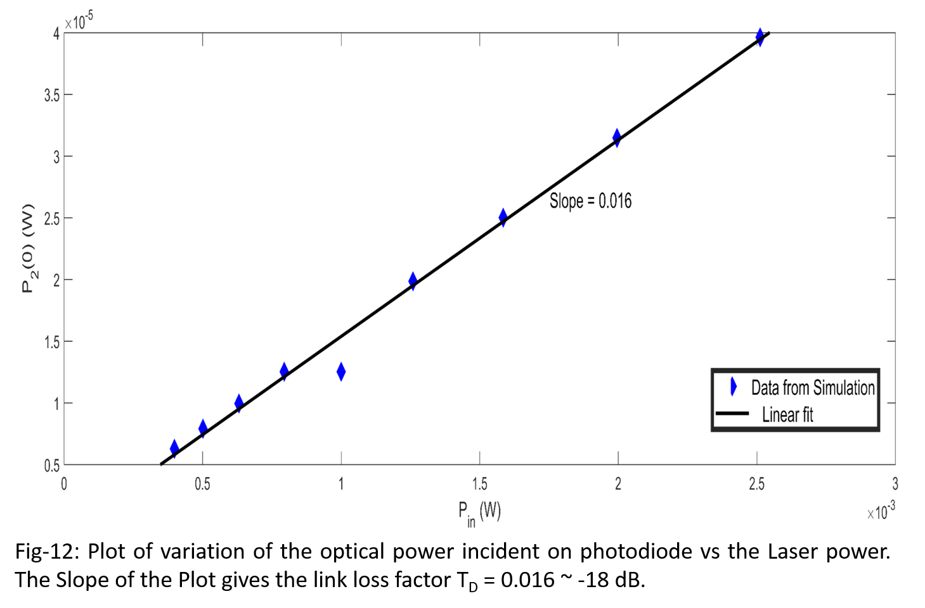

# 2.4.1.2 Determination of Total Optical Link Power Loss (Electrical Domain)

Again consider equation (37):

$P_{DC}= L R^{2}\frac{{P_{in}}^{2}}{16} ×50$

When both LO and RF are switched off, then A = B = 0. And under this condition, the above equation remains unaltered. But sincethe dependence of electrical power with optical power is parabolic in nature, we can use the plot shown in Fig-13, to obtain the DC electrical power for a particular laser power used. Then using the obtained DC power and equation (37), we can easily obtain the value of optical link loss PDC. For example, when 0 dBm or $1 × {10}^{-3}W$ laser source is used, then the corresponding electrical power PDC is $0.25 × {10}^{-9} W$, and from equation (37), the optical Link loss is obtained as $0.08 × {10}^{-6} or-41 dBm$.

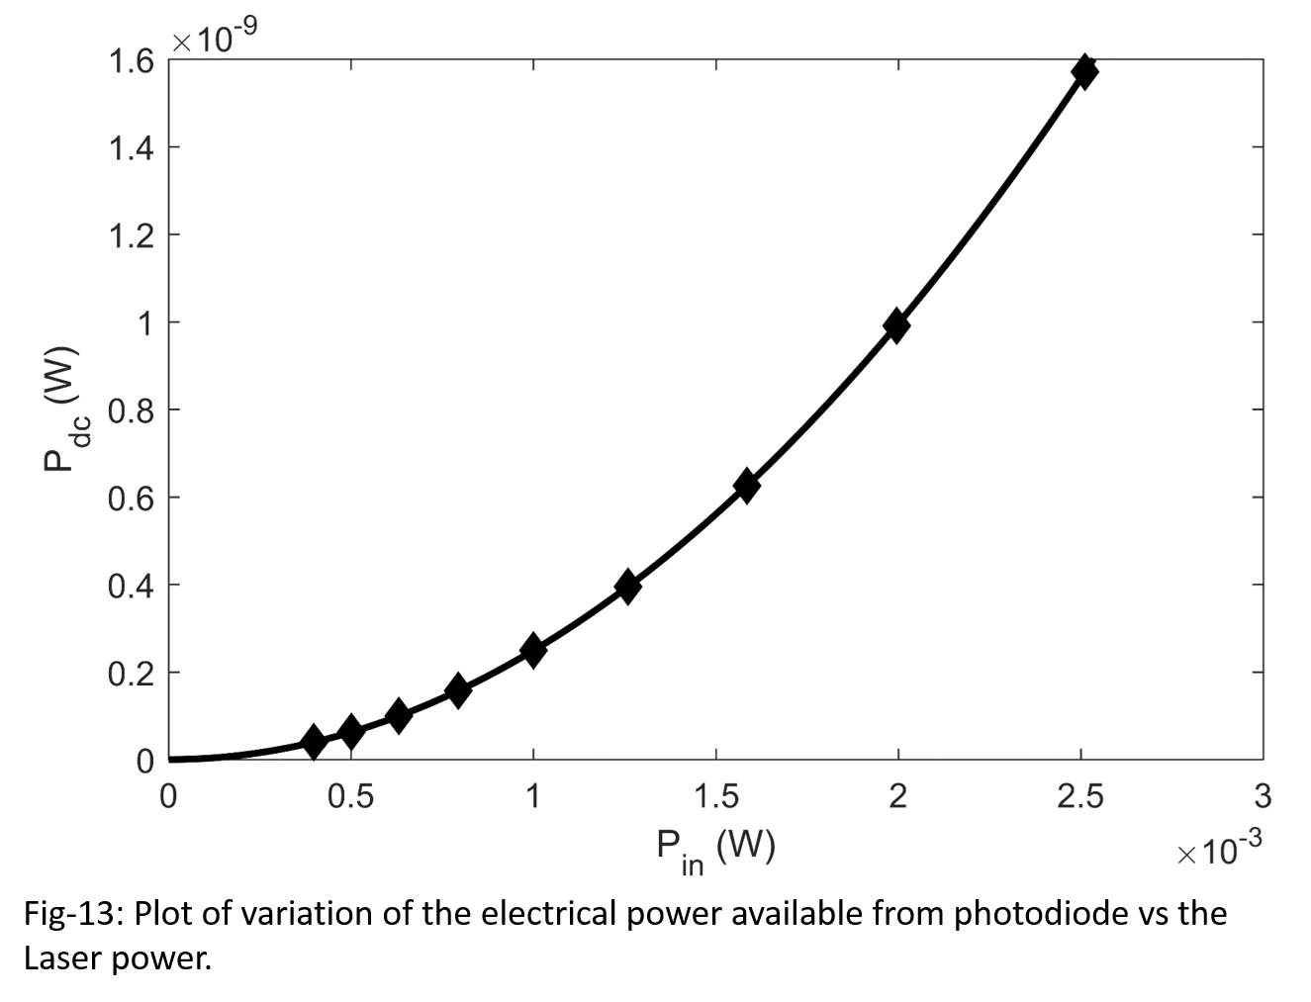

# 2.4.1.3 Theoretical study of the dependence of Output Electrical Power on Modulation Index of RF

Consider the equations (38) through (42):

$P\left(ω_{RF}\right)=L\left(ω_{RF}\right)\frac{P_{DC}}{2}{\{ 2 J_{1} (2 B)\}}^{2}$

$P\left(3 ω_{RF}\right)=L\left({3 ω}_{RF}\right)\frac{P_{DC}}{2}{\{ 2 J_{3} (2 B)\}}^{2}$

$P\left(ω_{LO}\right)=L\left(ω_{LO}\right)\frac{P_{DC}}{2}{\{ 2 J_{1} (2 A)\}}^{2}$

$P\left(ω_{LO} ± ω_{RF}\right)=L\left(ω_{LO} ± ω_{RF}\right)\frac{P_{DC}}{2}{\{ 2 J_{1}\left(2 A\right)J_{1} (2 B)\}}^{2}$

$P\left(ω_{LO} ± {3 ω}_{RF}\right)=L\left(ω_{LO} ± {3 ω}_{RF}\right)\frac{P_{DC}}{2}{\{ 2 J_{1}\left(2 A\right)J_{3} (2 B)\}}^{2}$

First, consider that a Laser source of known power is used. Then the DC electrical power can be readily obtained from Fig-13. Once this is known and also the link losses at various frequencies are known, then the power for respective frequencies can easily be calculated. For the purpose of simulation, the link losses are independent of frequency and therefore, L = 1 as the Fig-13 already incorporates the total optical link loss. Thus, for a given laser power and using the Fig-13, and also setting L=1, equations (38) through (42) become:

$P\left(ω_{RF}\right)=\frac{P_{DC}}{2}{\{ 2 J_{1} (2 B)\}}^{2}$

$P\left(3 ω_{RF}\right)=\frac{P_{DC}}{2}{\{ 2 J_{3} (2 B)\}}^{2}$

$P\left(ω_{LO}\right)=\frac{P_{DC}}{2}{\{ 2 J_{1} (2 A)\}}^{2}$

$P\left(ω_{LO} ± ω_{RF}\right)=\frac{P_{DC}}{2}{\{ 2 J_{1}\left(2 A\right)J_{1} (2 B)\}}^{2}$

$P\left(ω_{LO} ± {3 ω}_{RF}\right)=\frac{P_{DC}}{2}{\{ 2 J_{1}\left(2 A\right)J_{3} (2 B)\}}^{2}$

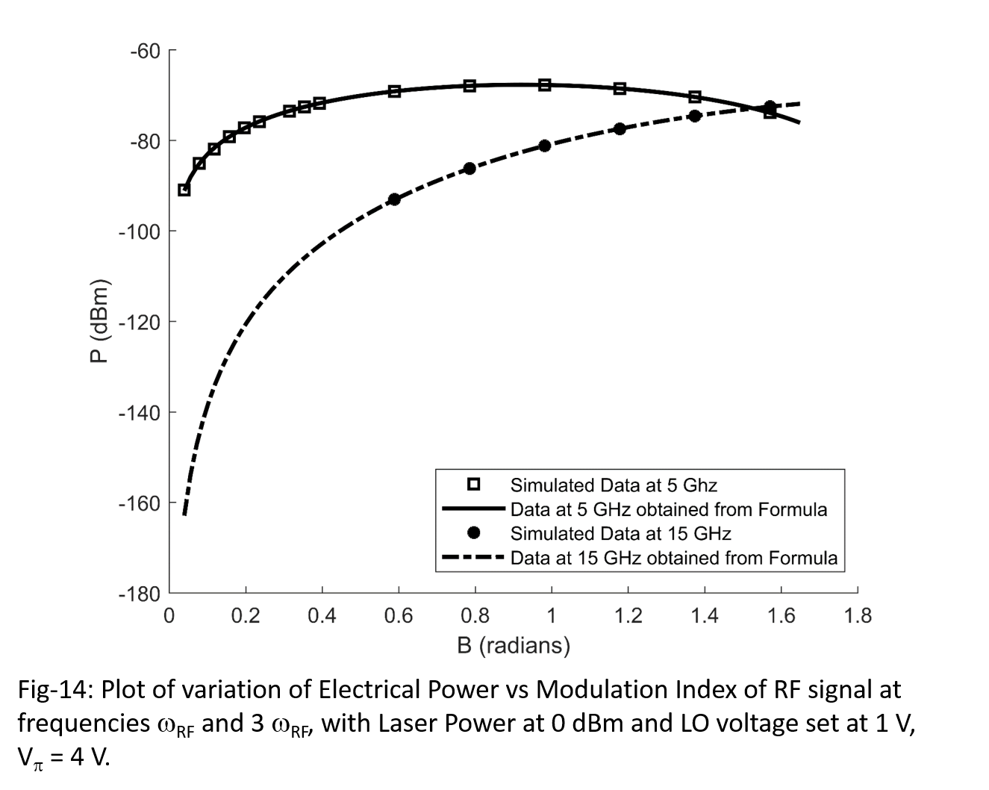 First, set Laser power to $P_{in} = 0 dBm$ and set input LO amplitude to 1 V for an MZM1 with $V_{π}=4 V$ such that $A= 0.3927$. Then from Fig-13, we can readily obtain ${ P}_{DC}=0.25 × {10}^{-9} W$. Then substituting these values in the above equations we can obtain the respective power. Fig-14, 15 and 16 shows the plot of the power measured from the simulation setup in OptiSystem and the values obtained by substituting the values in above formulae. All the figure shows that the predicted by the above formula is in good agreement with that obtained from the simulation data.

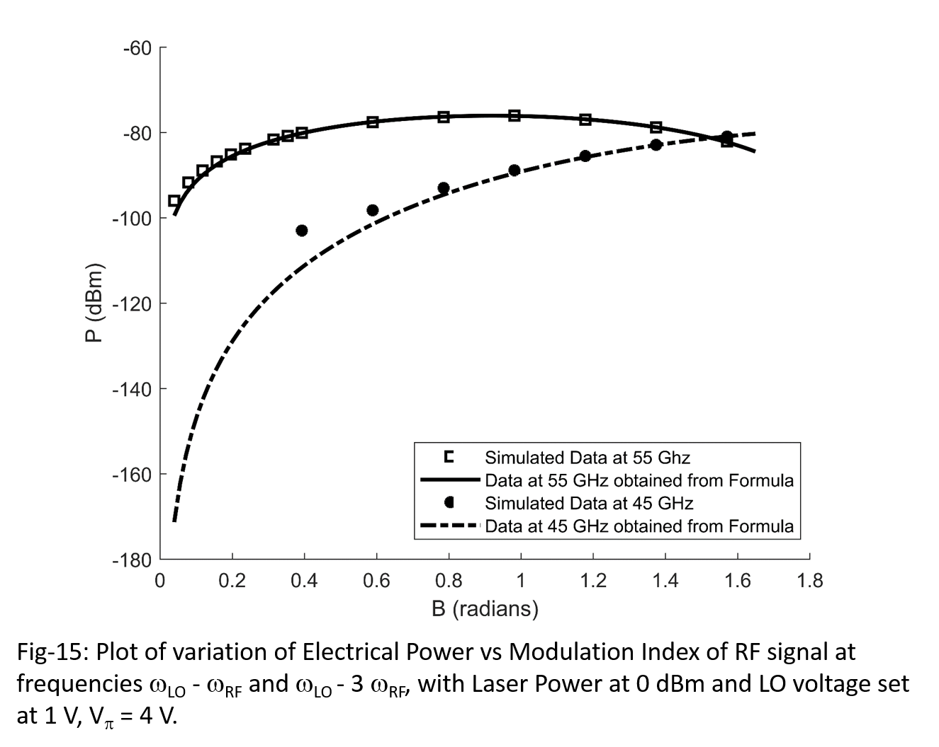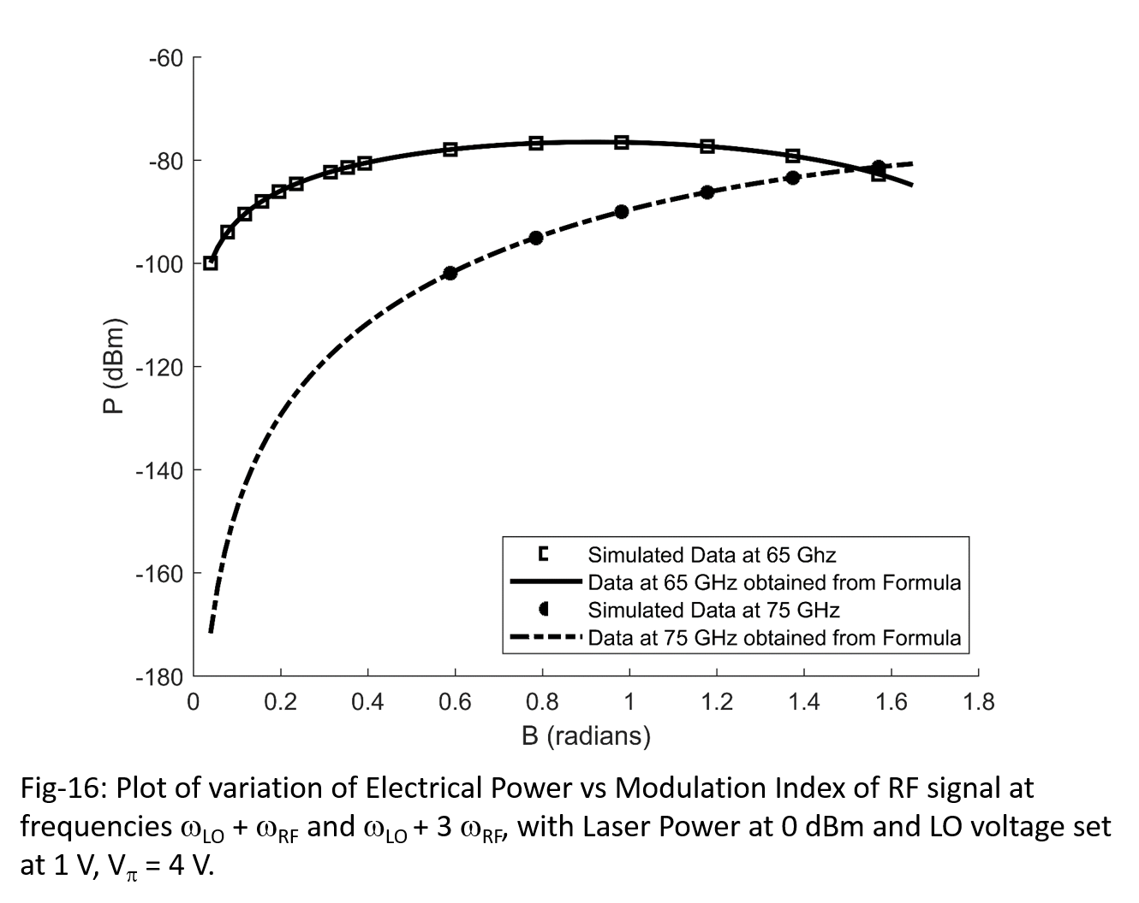

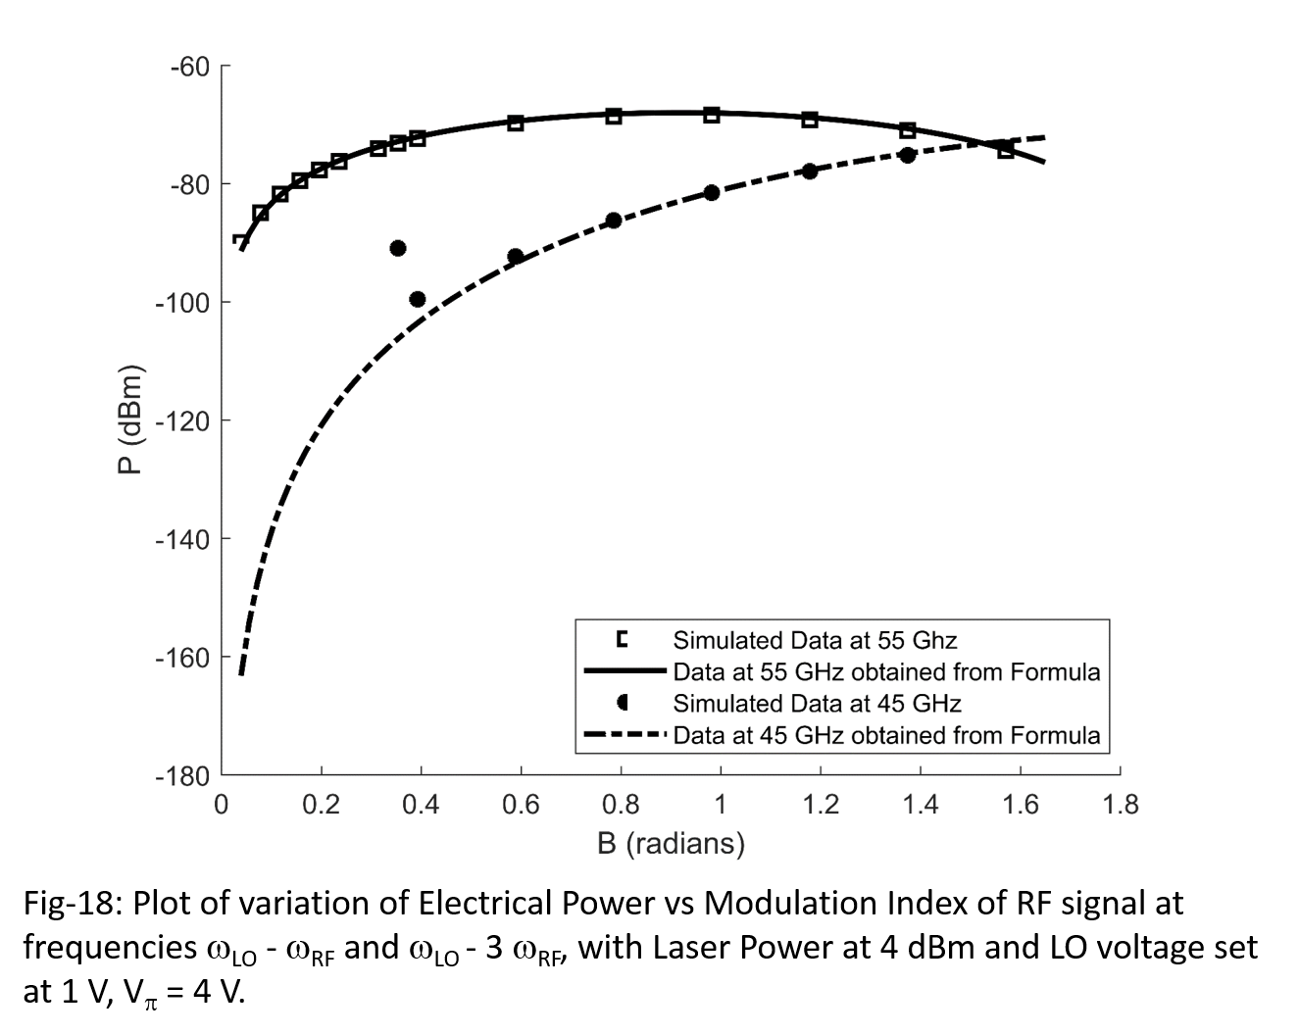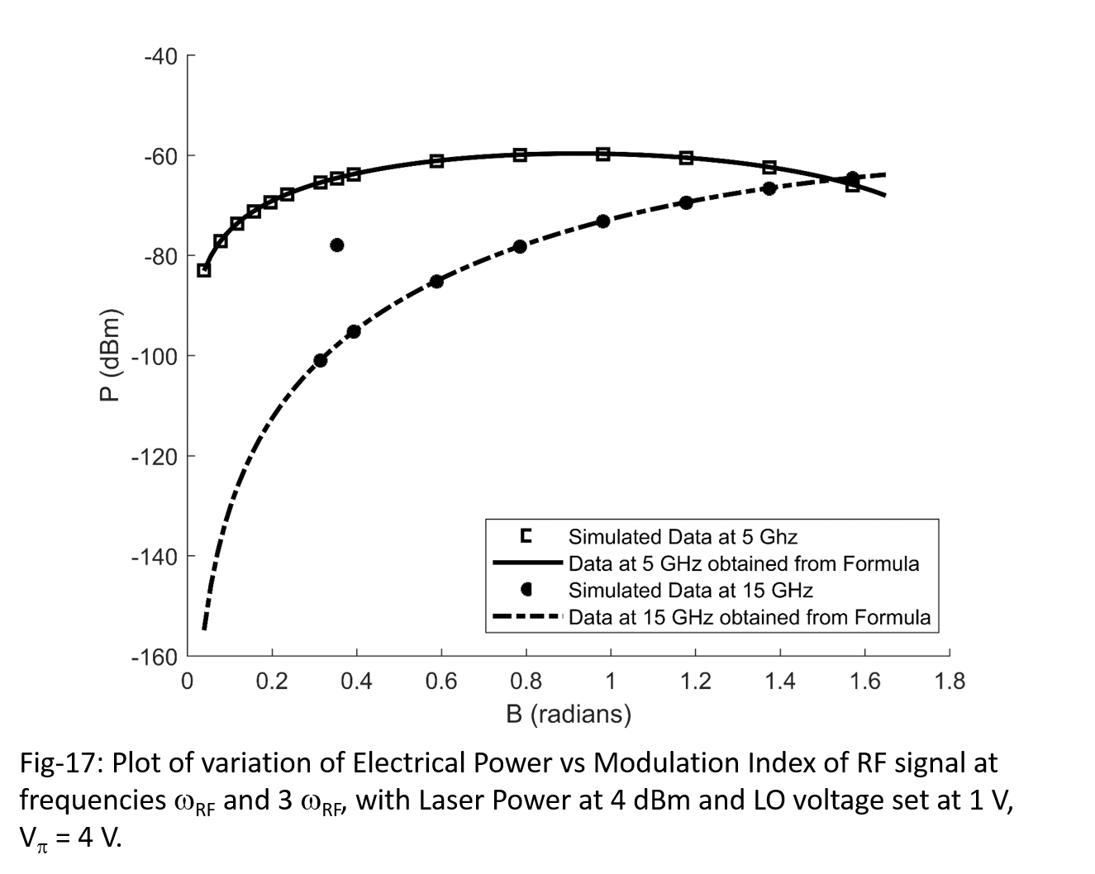Next, set Laser power to $P_{in} = 4 dBm$ and set input LO amplitude to 1 V for an MZM1 with $V_{π}=4 V$ such that $A= 0.3927$. Then from Fig-13, we can readily obtain ${ P}_{DC}=1.6 × {10}^{-9} W$. Then substituting these values in the above equations we can obtain the respective power. Fig-17, 18 and 19 shows the plot of the power measured from the simulation setup in OptiSystem and the values obtained by substituting the values in above formulae. All the figures again shows a strong correlation between the formula and the simulated data.

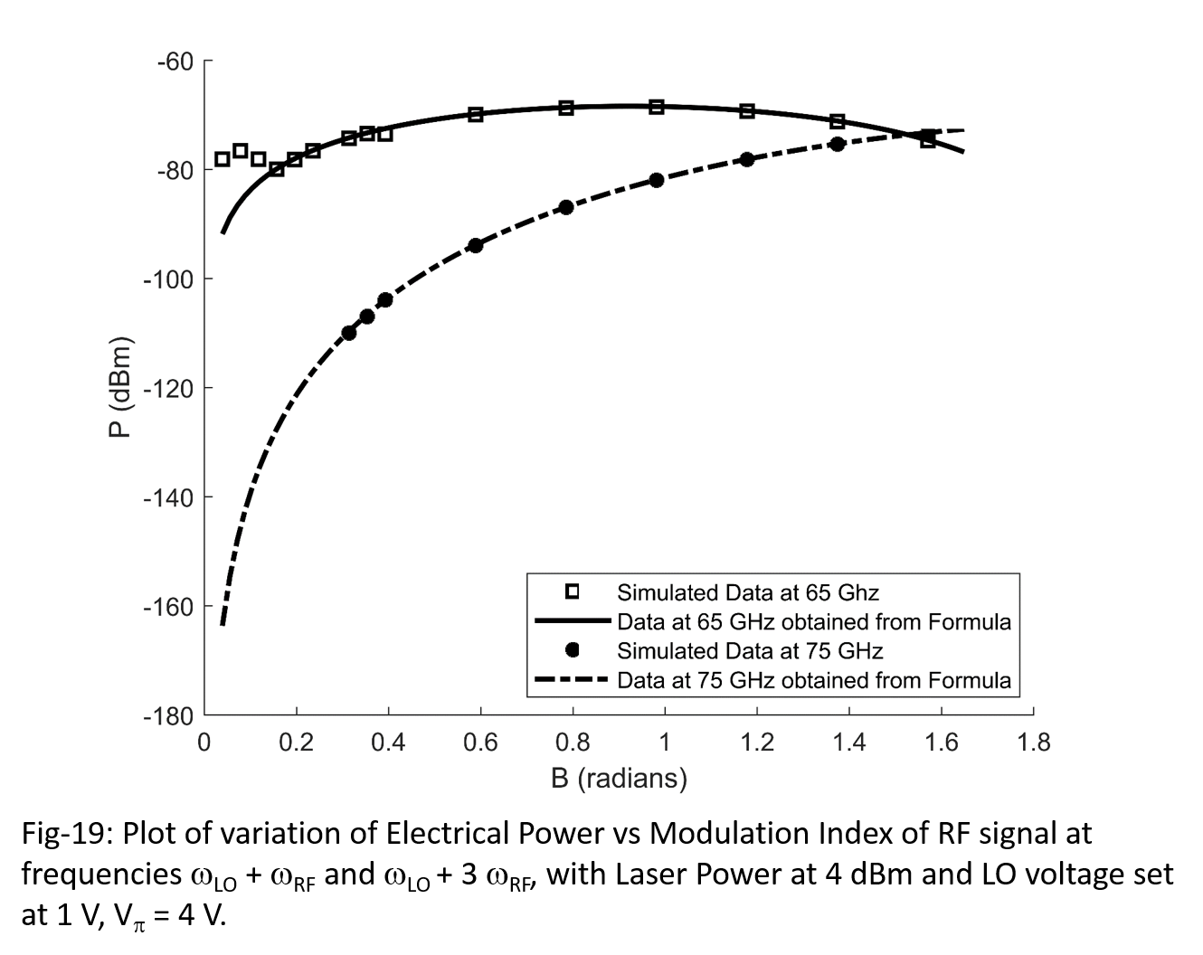

# 2.4.1.4 Third Order Intercept Point (TOI) of the Cascaded MZM based Up-converter

To obtain TOI, for up as well as down-conversion, the LO signal is cutoff by reducing its amplitude to zero. Then the MZM1 just act as an attenuator for the Laser signal. The attenuated laser is directly modulated by MZM2 and the output of Photodiode consists of the DC, ωRF and 3 ωRF. Now, plot the power values of ωRF and 3 ωRF versus the input RF power, all powers are expressed in dBm unit. The plot will initially be linear when the input RF power is low, but the nonlinearity will increase as the input RF power increases.Thus, extrapolating the power plot in its linear region for both the frequencies ωRF and 3 ωRF. These extrapolated lines will intersect at a point called the **Third-Order Intercept (TOI) point**. This intercept point is an important parameter in quantifying the operation of the conversion circuit. In order to design a good up or down-conversion circuit, it is desirable to have a high value of TOI.

Here, we will obtain TOI for the photonic transceiver schematic shown in Fig-11. The laser is first set to 0 dBm, and then LO amplitude is reduced to 0. The MZM2 has ${ V}_{π}=4 V$. Then measurements as described in above paragraph are done and plot as shown in Fig-20 is obtained. Also using Fig-13, we obtain ${ P}_{DC}=0.25 × {10}^{-9} W$. This value of PDC is substituted in equations (38) through (42) to obtain the theoretical plot shown as a darkened line in the figure. As both simulation as well as theoretical plot closely agrees with each other, we directly obtain the TOI from the plot by extrapolating the linear region using the dotted line. The TOI for this circuit is obtained as 47.8 dBm.

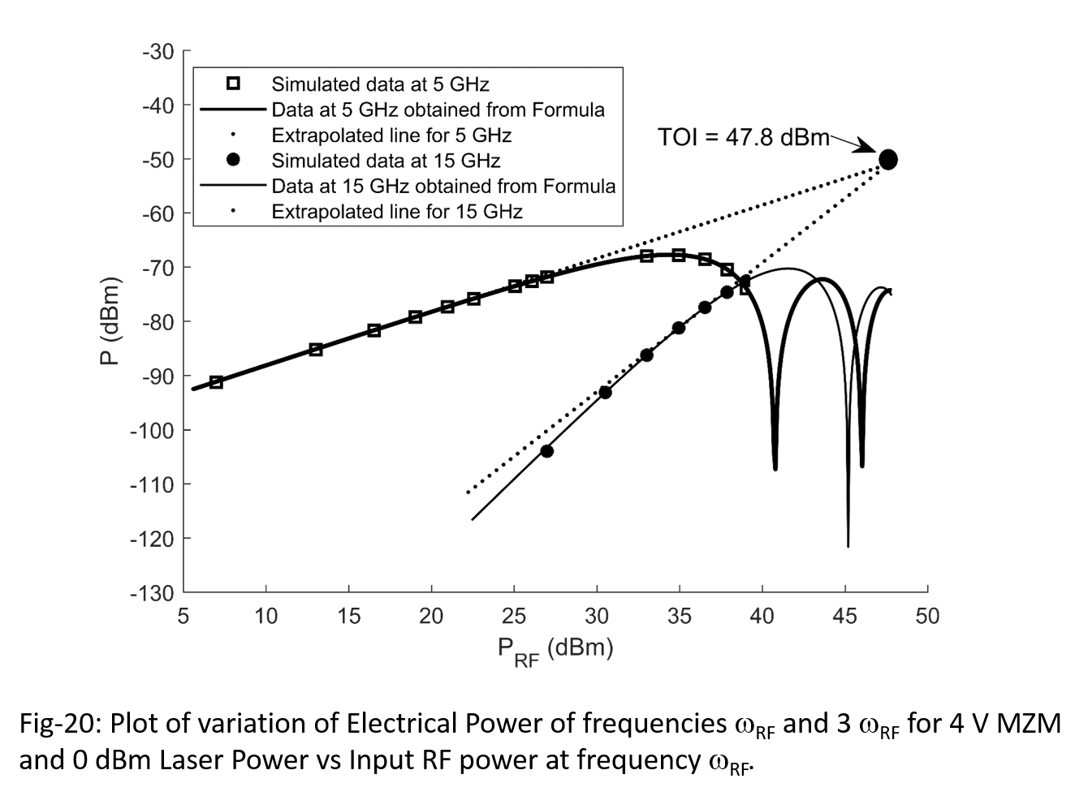

We will again obtain TOI for the photonic transceiver schematic shown in Fig-11. The laser is kept at 0 dBm, and then LO amplitude is reduced to 0. The MZM2 has ${ V}_{π}=8 V$. Then measurements as described in above are done and plot as shown in Fig-21 is obtained. From OptiSystem 7, we obtain ${ P}_{DC}=0.725 × {10}^{-9} W$. This value of PDC is substituted in equations (38) through (42) to obtain the theoretical plot shown as a darkened line in the figure. As both simulation as well as theoretical plot closely agrees with each other, we directly obtain the TOI from the plot by extrapolating the linear region using the dotted line. The TOI for this circuit is obtained as 51.2 dBm.

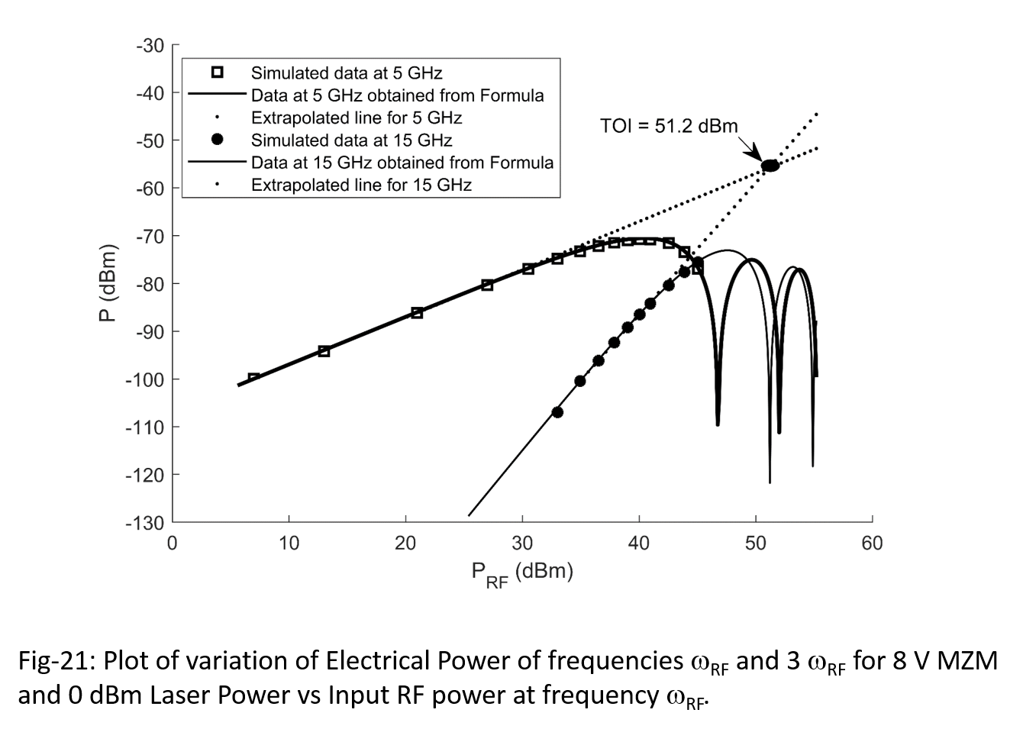

# 2.4.1.5 Theoretical analysis of Photonic Down-conversion

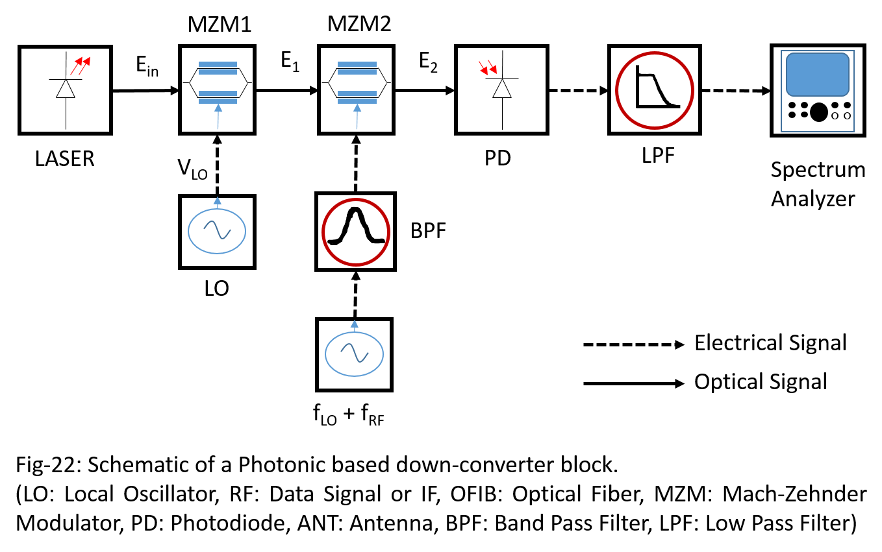

During down-conversion the received RF is centered at ωLo and thus is represented at the frequency of ωRF. Then the output of Photodiode will be passed through a low pass filter to extract the RF. The output spectrum of photodiode will be same as that obtained during up-conversion. Hence, the RF here will correspond to the up-converter output for ${ |ω}_{LO}- ω_{RF}|$. Therefore, the output electrical power the detected RF power corresponds to that in equation (41), which is now written as:

$P\left(ω_{RF}\right)=L\left(ω_{RF}\right) H\left(ω_{RF}\right)\frac{P_{DC}}{2}{\{ 2 J_{1}\left(2 A\right)J_{1} (2 B)\}}^{2}$

In this relation, $L\left(ω_{RF}\right)$ corresponds the optical link loss corresponding to the detected RF frequency and $H\left(ω_{RF}\right)$ represents the filter transfer function. Also, PDC represents the photodiode power received as represented by Fig-13. The spectrum of this detected RF is shown in Fig-10 (M).

Fig-22 is similar to Fig-11, and hence all the above characterization remains valid. A theoretical plot, however, is shown below in Fig-23, which shows the detected power with 0 dBm laser source, and considering various modulation indices B, at different values of A.Further, the corresponding spectrum are shown in Fig-24.

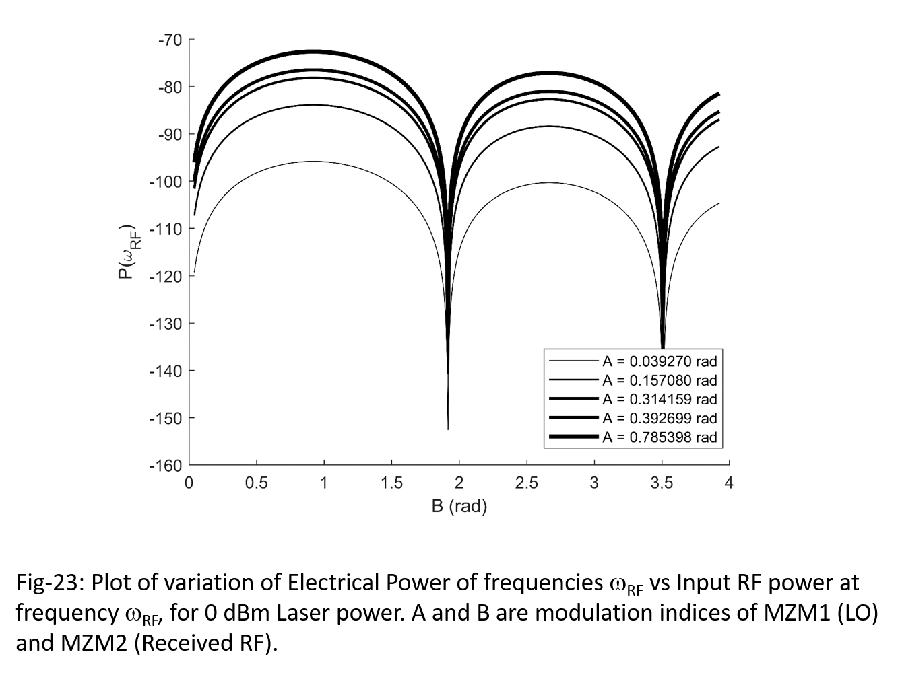

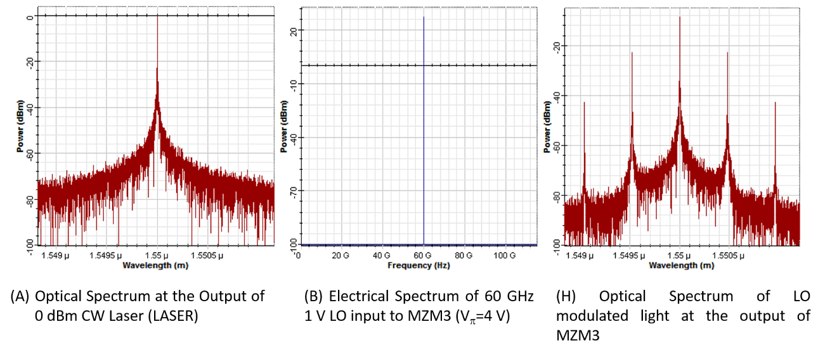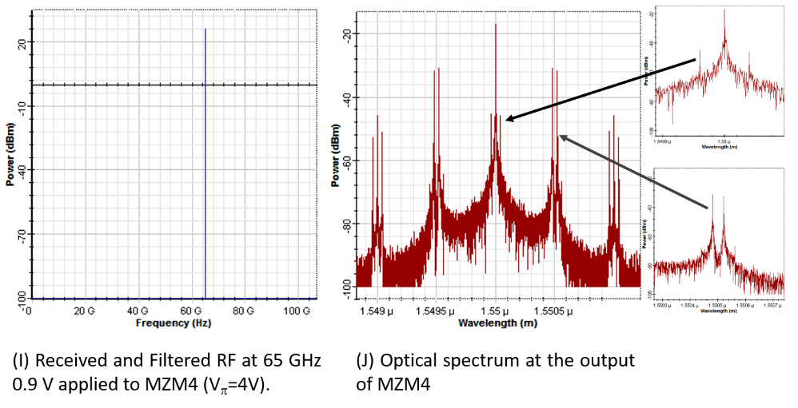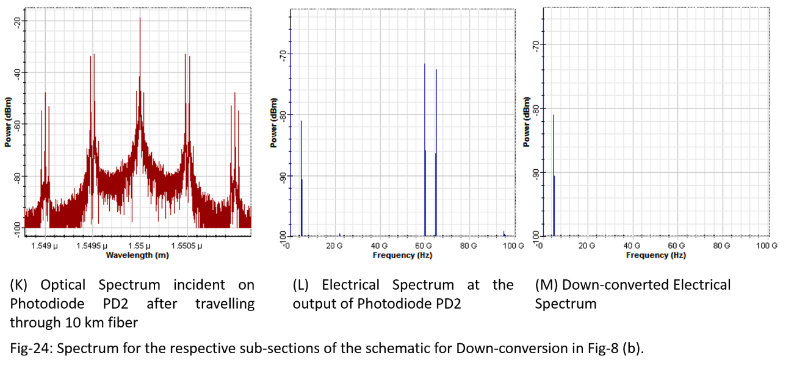

# 2.4.1.6 BER Analysis

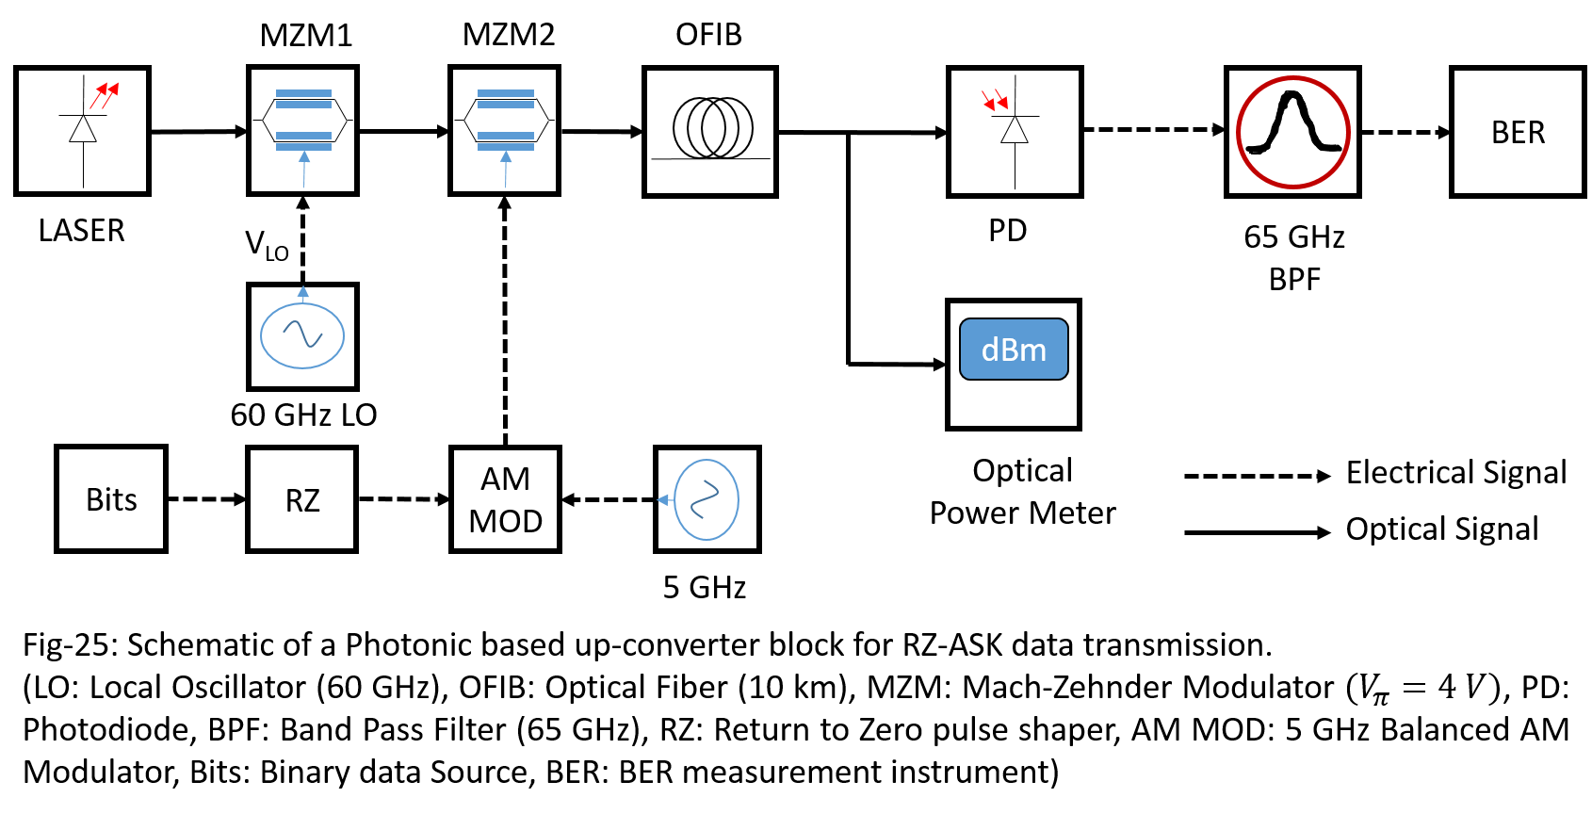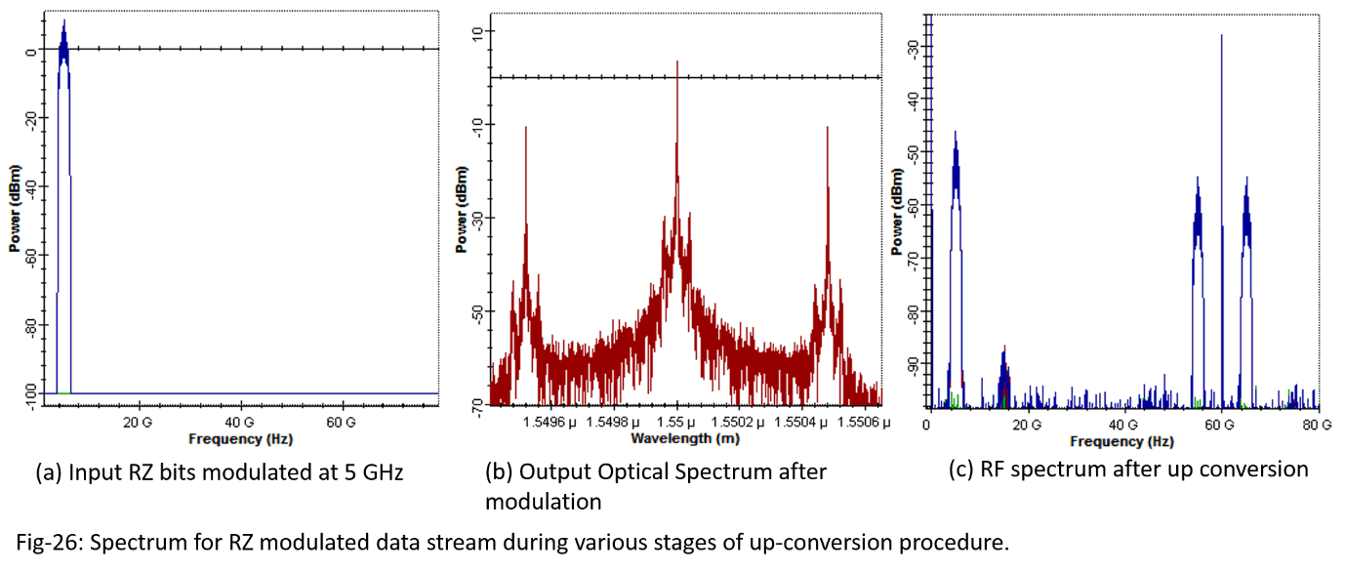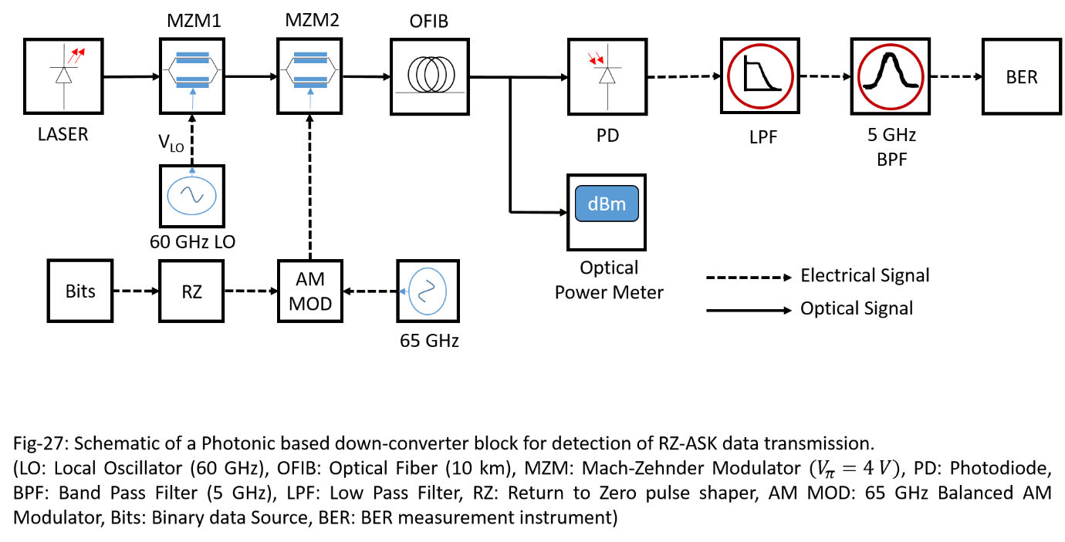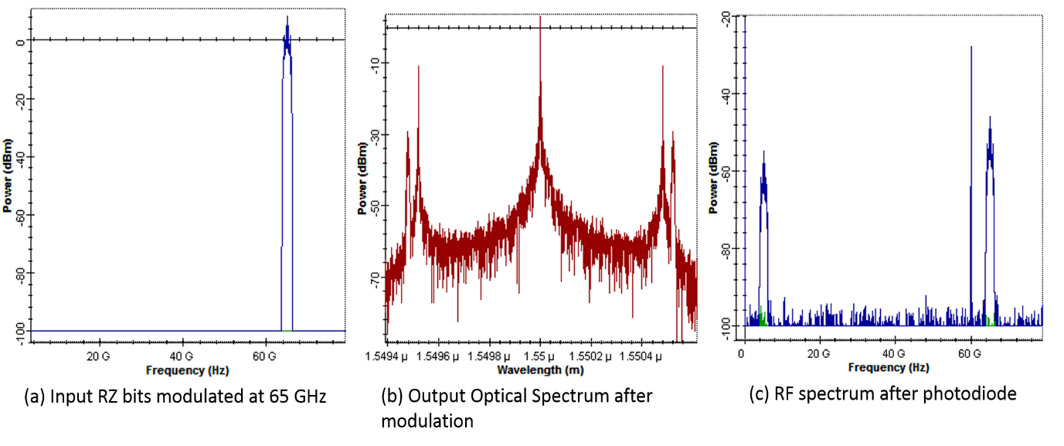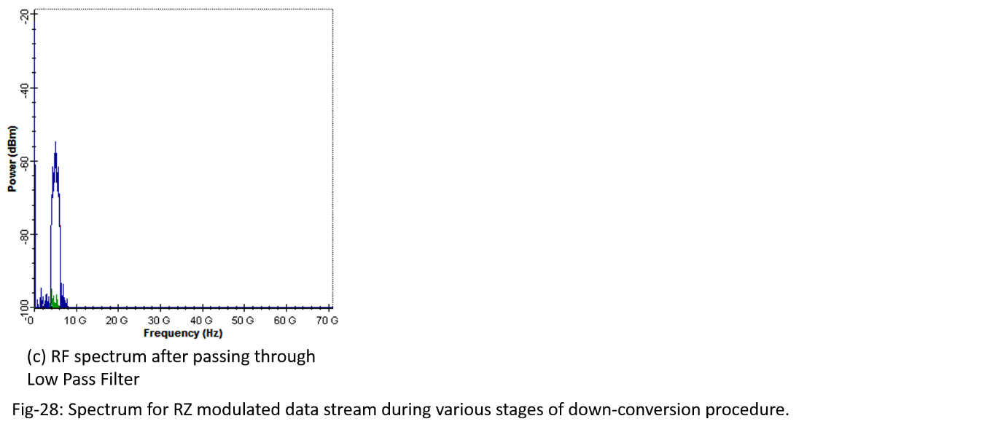

The designed transceiver is used for data transmission as well as for reception. Hence, BER analysis is to be done which will demonstrate the effectiveness of the transceiver for use in a data transmission network. The BER simulation is setup in OptiSystem as shown in Fig-25 above.Here the MZMs used, have $V_{π}=4 V$ and the LO is set to a frequency of 60 GHz. Then a random databit stream, encoded with a suitable FEC correction scheme is generated. The generated bit stream is converted to RZ-pulse with a peak amplitude of 1 V. After the RZ conversion, the resultantpulse is balanced amplitude modulated by a 5 GHz sine wave and up-converted to 65 GHz, using a MZM2.The BER is measured for the signal at 65 GHz, after it is converted from Optical to electrical spectrum by passing it through the photodiode, which is shown in the plot in Fig-29. The corresponding spectrum that shows the modulation is shown in Fig-26.

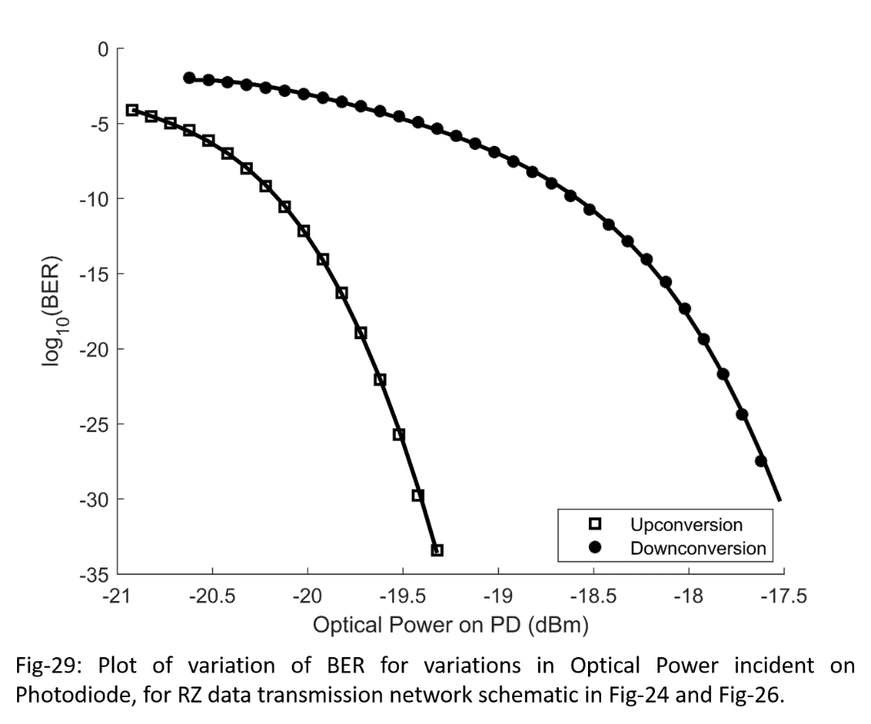 However, during down-conversion, the same pulse is now balanced modulated with a 65 GHz sine wave. This 65 GHz modulated signal simulateda signal received by the down-converter stage due to a wireless transmission. This signal is applied to the MZM2 as shown in Fig-27 and the output of Photodiode is passed through a low pass filter. Then BER at 5 GHz is measured for the RF signal at the output of the low pass filter. The plot of the BER data for the variation in the CW laser power is shown in Fig-29 and the corresponding spectrum at the various stages of the down-conversion procedure is shown in Fig-28.

# REFERENCES

[1] Vincent J. Urick Jr., Jason D. McKinney, Keith J. Williams, “Fundamentals of Microwave Photonics”, Wiley Publishers (2015).

[2] Takahiro Numai, “Fundamentals of Semiconductor Lasers”, Second Edition, Springer (2015).

[3] G. K. Gopalakrishnan, “Microwave-Optical Mixing in LiNbO3 Modulators”, IEEE Transactions on Microwave Theory and Techniques (1993), Vol. 41 (12), Page 2383 – 2391.

[4] J. Yao, “Microwave Photonics”, Journal of Lightwave Technology (2009), Vol. 27(3), Page 314 - 335.

[5] C. Li, Y. Wang, W. Wang, Z. Xu, B. Zhao, H. Wang, D. Tang, “Widely Tunable Optoelectronic Oscillator Using a Dispersion-Induced Single Bandpass MPF”, IEEE Photonics Technology Letters (2017), Vol. 30(1), Page 7 – 10.

[6] G. Tong, T. Jin, H. Chi, X. Zhu, T. Lai, X. Wu, “A Novel Optoelectronic Oscillator Based on Brillouin-Induced Slow Light Effect”, IEEE Photonics Technology Letters(2017), Vol. 29(16), Page 1375 – 2017.

[7] Riu Wu, V R Supradeepa, C M Long, D E Leaird, M. Weiner, “Highly Flat and Stable Optical Frequency Comb Generation Using Intensity and Phase Modulators Employing Quasi-Quadratic Phase Modulation”, IEEE Tropical Meeting on Microwave Photonics (2010).

# Chapter 3

# Photonic Transceiver based on Polarization Modulator

# 3.1 Review of Polarization Optics

MZM based devices exhibit deviation in half-wave voltage with time, which can be attributed to factors like temperature variation, device ageing and package specifications [1].Among these, the most important factors is the temperature induced variation. The change in operating temperature causes development of pyro-electric charges caused by thermal perturbation which manifest as deviation in half-wave voltage of the device, which finally attributes to causing change in device transfer characteristics [2] [3]. Several bias controlling mechanism have been revised in [4] and further improvement based on device fabrication, packaging have been demonstrated in [5], [6]. Thus, a bias controller is the basic requirement to prevent alteration of device characteristics due to environmental operational conditions [4]. But the addition of bias controller imposes more complexity in the design. Hence, an alternative way is required to reduce the design complexity and prevent any bias deviation that may prove futile for the system during its operation.

When looking for an alternate but simpler design option, a classical optics method based on polarization state of light seems to be more suitable for the usage. The method uses wave plates and polarization modulator to fix the bias against any deviation. However, the bias is mechanically fixed to the required operating point, which is adequate for most operations required in the design of photonics circuits. Further, unlike the MZM based system, where theoretical calculations involves generic scalar mathematics; the polarization optics require special matrix based treatment for the system to be designed. This is because, in order to represent polarization state of light wave, it is essential to treat light as a vector quantify having directional characteristics rather than an arbitrary scalar quantity having random polarization state.

Therefore, the transceiver designed in Chapter-2 will be redesigned in this chapter, with the usage of wave plates and a new polarization modulator so that the problem of bias deviation does not deter the applicability of the circuit. Further, a theoretical treatment of the designed system is shown, which uses Jones calculus for representation and also the system is simulated in OptiSystem 7, which will be used to verify the validity of the theory.

# 3.1.1 Jones Calculus

Polarized light can be represented by Jones calculus, discovered by R.C. Jones in 1941. In this representation, the optical elements are represented by Jones matrix whereas the field vectors that represents the polarization state of light is represented by a Jones vector. Therefore, the light emerging from a polarizing element can be represented as a Jones vector which is the result of the matrix multiplication of the Jones matrix representing the optical element and the Jones vector which represent the polarization of the incident light. It is however important to note that, the Jones calculus is only applicable when the light is completely polarized. Therefore, any partially polarized light or existence of random polarization in the light wave cannot be represented using Jones calculus.

# 3.1.2 Jones Vector representation of Polarized Light

Jones vector is used to represent electric field vector of the polarized light. The vector notation is used because the polarized light has directional characteristics, that is, its intensity is dependent on the direction of the orientation of the axis in a 2D elliptical plane. The elliptical plane is a planar section of the more generic Poincare space which can describe each and every polarization state of light.

Among all the available states of light, the states that are of more importance in the design of photonic systems are linear polarized light and circular polarized light. A linear polarized light can further be classified as horizontal linear polarized light, vertical polarized Light and 45o polarized light. A linear horizontal and vertical polarized light are mutually orthogonal, however, the 450 linear polarized light is a linear combination of the mutually orthogonal horizontal and vertical polarized light. The Jones vector to represent these linear state of polarization of light are as follows:

$$\left(1\right) Linear Horizontal Polarized Light: [\begin{matrix}1 \\ 0\end{matrix} ]$$

$$\left(2\right)Linear Vertical Polarized Light:\left[\begin{matrix}0 \\ 1\end{matrix}\right]$$

$$\left(3\right)+45° Linear Polarized Light:\frac{1}{\sqrt{2}}[\begin{matrix}1 \\ 1\end{matrix} ]$$

$$\left(4\right)-45° Linear Polarized Light:\frac{1}{\sqrt{2}}[\begin{matrix}1 \\ -1\end{matrix} ]$$

A circular polarized light is more generic than a linear polarized light. In linear polarization, the field component of light along any direction can be represented by a real number only. But in the case of circular polarization, the field components are no more scalar, as they now become a complex number. The circular polarized light are sub-classed into right and left circular polarized light. Therefore, the circular polarized light can be expressed using Jones vector as follows:

$$\left(1\right) Right Circular Polarized Light:\frac{1}{\sqrt{2}}[\begin{matrix}1 \\ -i\end{matrix} ]$$

$$\left(2\right) Left Circular Polarized Light:\frac{1}{\sqrt{2}}[\begin{matrix}1 \\ i\end{matrix} ]$$

As we have already mentioned that, the circular polarization is more generic, therefore, the linear polarization can be expressed as the sum of the right and circular polarized light.

If a Jones vector of form, $E= \left[\begin{matrix}E_{x} \\ E_{y}\end{matrix}\right]$ is given for a polarized light, then the respective representation of the light in vector notation can be written as $E= E_{x}\vec{x}+ E_{y}\vec{y}$. Hence, the Jones vector representation makes it much clear to represent a polarized light in terms of directional field components only.

## 3.1.3 Jones Matrix representation of Polarization Elements

A Jones matrix is a 2x2 square matrix used to represent the operation exhibit by the polarizing element.The general form of the matrix is of the form $\left[\begin{matrix}A & B \\ C & D\end{matrix}\right]$, where each matrix element may be a real or complex number. The Jones matrix will operate on a Jones vector, using the matrix multiplication operation and produce an output Jones vector which represent the state of the polarized light at the output of the respective polarizing element. An interesting feature of the Jones matrix is that, the sum or product of two Jones matrix is another Jones matrix which will represent that complete system, taken in order from output to input. This property of Jones matrix can be utilized to represent a complete optical system using one matrix instead of several component matrix, which makes the analysis more clean and understandable.

In this section, we will discuss few important basic polarizing elements that will be used in the design of the transceiver viz. linear polarizer, Wave plates, Polarization Controller and Polarization Modulator.

# 3.1.4 Polarized representation of CW Laser

A CW laser forms the source of light for all the photonics based system. Generally laser emits plane polarized light, and is represented throughout the chapter as a horizontal linear polarized light. Thus, a laser with intensity Pin can be written in terms of Jones vector as $E_{in}=\tilde{E_{in}}\left[\begin{matrix}1 \\ 0\end{matrix}\right]$. Here, $\tilde{E_{in}}$ is the peak magnitude of the electric field which is related to laser intensity through the relation $P_{in}= {| \tilde{E_{in}} |}^{2}$. Therefore, if a CW laser light which is horizontal linear polarized falls on a photodiode, which itself is a polarization sensitive device, then the detected photocurrent can be written as $I=Responsivity ×\left(E_{in}{E_{in}}^{*}\right)$, where the terms within the bracket are multiplied according to the rule of matrix multiplication. The conjugation of the complex matrix here should be interpreted as taking Hermitian conjugate of the respective matrix.

# 3.1.5 Polarizer (Linear Polarizer)

A linear polarizer is used to pin the field vector of a light wave to only one orthogonal axis of the polarization plane. Thus, the input light of any input polarization is pinned to a specified axis dictated by the Jones matrix that represent it. The general form of the Jones matrix that represent a Polarizer element is given by $\left[\begin{matrix}A & 0 \\ 0 & B\end{matrix}\right]$, where $A and B$ represents the respective transmittance along specified plane. If the input optical field is of form $E_{in}=E_{x}\vec{x}+ E_{y}\vec{y}$, then the output from the linear polarizer can be written using the equation $E_{out}=A E_{x}\vec{x}+B E_{y}\vec{y}$. Thus, the output field is a sheared andscaled version of the input field depending on the symmetry and type of the polarizer, respectively.

A linear horizontal polarizer is represented by the Jones matrix $\left[\begin{matrix}1 & 0 \\ 0 & 0\end{matrix}\right]$ and therefore the corresponding output electric field is of form $E_{out}=E_{x}\vec{x}$. Similarly, a linear vertical polarizer is represented by $\left[\begin{matrix}0 & 0 \\ 0 & 1\end{matrix}\right]$ and the corresponding output electric field can be represented as $E_{out}=E_{y}\vec{y}$. Commercially, polarizer elements are restricted to either horizontal or vertical linear polarizer. These are obtained as devices which cannot be mechanically rotated.

Fig-1 shows the effect of polarizer when a $45° CCW$ polarized light is incident on horizontal and vertical polarizer. The $45° CCW$ light has the total light intensity equally split along both light axis. The H-POL will allow only the horizontal component to pass through, and thus a light spectrum appears at the output of the horizontal polarizer. As the power is equally split along both light axis, there is an observable 3 dB power loss in the output spectrum. Similar spectrum is observed at the output of vertical polarizer also.

But when the input light is polarized along horizontal direction, then complete light intensity can only be resolved along horizontal axis only. Thus, the output spectrum at the output of horizontal polarizer is identical to the input light spectrum without any optical attenuation. However, as no component of light intensity is resolvable along vertical axis, the vertical polarizer will completely block the light spectrum from passing through. Thus, no optical spectrum is present at the output. Similar observations can be made for vertical linear polarized light.

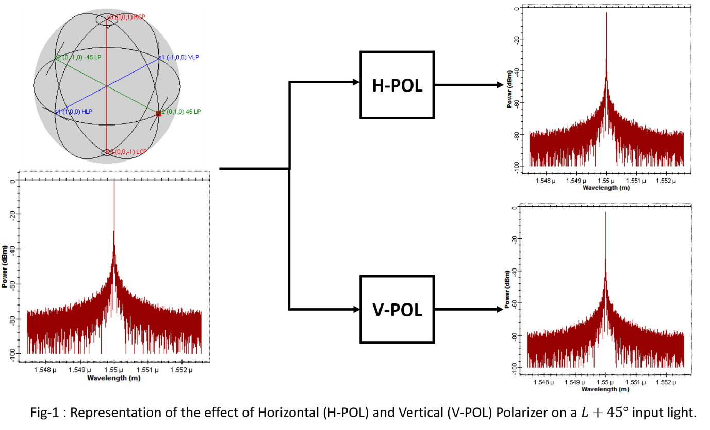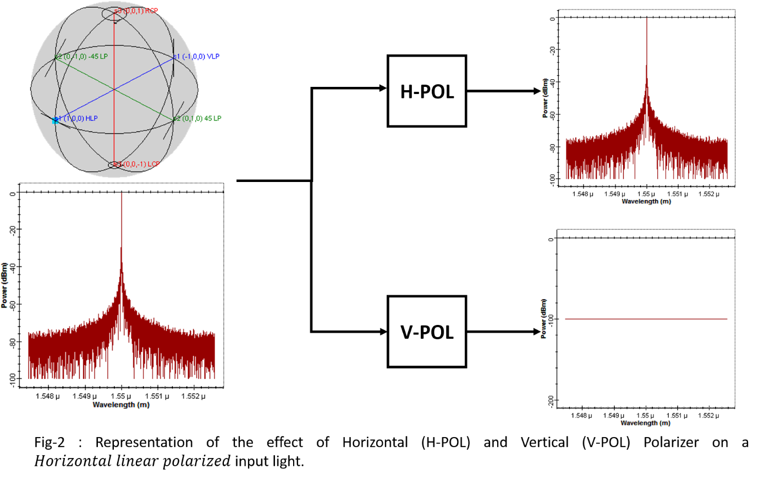

# 3.1.6 Birefringence Fiber as Wave Plates

Wave plates are essential component of polarization optics. They are requires to not only rotate the state of polarization of the incident light but can also change the state of polarization. In order to do so, there are two types of wave plate viz. half wave plate and quarter wave plate. They are named so according to the relation between their thickness and the wavelength of the light they are used for. The half wave plate is used to rotate the plane of polarization of the light that pass through it. But the quarter wave plate is used to convert the polarization state of the incident light from linear to circular polarization, and vice-versa. However, the wave plates used in classical optics are designed using lenses which are not at all suitable for use with photonics system design. An alternative as demonstrated by H.C. Lefevre in 1980, enables us to use the birefringence characteristics exhibit by any optical fiber to design any required wave plate.

A single mode fiber when bent in form of a loop will experience a stress in its axis, which induces birefringence in such a fiber. Due to birefringence the light wave when travelling down the fiber will experience different velocity along the orthogonal axis. This allows us to decompose the light wave into two component called the fast and slow component. The fast component or fast axis is the axis which does not slow down the light passing through it whereas the slow axis will result in slowing the speed of light.Thus, if we consider a Silica based fiber, then the refractive index along the fast and slow axis is given by the relation [7]:

$${∆n}_{x}= n_{e}-n=0.027 {(\frac{r}{R})}^{2}$$

$${∆n}_{y}= n_{o}-n=0.16 {(\frac{r}{R})}^{2}$$

$$where n_{e}=extraordinary stress induced refractive index,$$

$$n_{o}=ordinary stress induced refractive index.$$

Thus, the differential refractive index between the two axes becomes $δn= -0.133 {\left(\frac{r}{R}\right)}^{2}$. If we now define a loop having N turns of this fiber and want to prepare a wave plate of form $mλ$ then the radius of curvature can be defined by the relation:

$$R\left(m, N\right)= \frac{2π ×0.133 × r^{2}}{λ} N m$$

Another factor that should be taken into account is the twist that the loop exhibit during bending from position A to A’ as shown in Fig-3. The twisting of fiber causes the plane of incidence of light to be rotated by a factor $α^{'}=t α$ between A and A’. For a silica doped fiber, the twisting factor have the value $t=0.08$ [8]. Thus, the angle between polarization in A’ and principal axis of the coil varies as $\left(1-t\right)α$ and the effect of the twist is small compared to the direct rotation of principal axis. The same optical activity exist between the twist at B and B’. Therefore, the total rotated angle between A’ and B’ can be written as $α^{''}=2 \left(1-t\right) α$. A freedom of rotation of the coil in the limit of $±48.6°$ will allow the linear polarization to be adjusted through any angle between $± 90°$ [7].

# 3.1.7 Polarization Controller

A variable phase rotatable wave plate can control and generate any arbitrary polarization of light. This device is known as Babinet-Soleil compensator. A single-mode fiber of short length can be used to simulate the behaviour of Babinet-Soleil compensator. Although a Babinet-Soleil compensator is an ideal device, a polarization controller is a more realistic device that can be designed physically and are commercially available.

A Polarization Controller is a practical device that can be used to realize a subset of polarization states that is achievable though the usage of Babinet-Soleil compensator. In practice, all the achievable polarization states can be realized using a polarization controller. An ideal way to design a polarization controller is to use only phase shifting elements rather than attenuating elements. Thus, the polarization controller can be classified into two types according to the way of their design. First type of polarization controllers are those which uses only fiber. The second type of polarization controllers incorporate variable shifting elements.

The polarization controller using optical fiber can behave as fixed phase shifting elements and therefore, can simulate the behaviour of a Babinet-Soleil compensator. This is because of their birefringence which can be used to design a wave plate. Further, by using mechanical rotators the birefringence can be adjusted by controlling the stress on the fiber, which can be used to achieve desired phase shift. However, to properly simulate Babinet-Soleil compensator, the fixed phase optical fibers must be adjusted in tandem, each of the fiber based wave plates being independently rotated around their propagation axis. For non-rotating fixed phase optical elements, the rotations is achieved with different fixed phase shift elements. However, since these polarization controllers uses mechanical parts, they are slow to tune. The examples of commercially available wave plates are PolaRITE, Agilent 8169A, Agilent 11896A, Lefevre 3-loop PC, PolaRITE II, Thorlab Minipaddle PC. Among these the PolaRITE is the fundamental polarization controller which forms the basis for the design of other polarization controller, and Lefevre 3-loop PC, which is the most widely used polarization controller, will be discussed in details. The Lefevre 3-loop PC will be used in all the design throughout the chapter.

A faster alternative to design polarization controller is to replace mechanical parts with non-mechanical parts in order to achieve variable phase shifts. These non-mechanical elements can be lithium niobate, liquid crystals, etc. These types of polarization controllers are generally used for modulating the light polarization based on some electrical signal and are therefore, a good candidate in the design of the polarization modulator.

# 3.1.8 PolaRITE (Rotatable Wave plate) Polarization controller

A stress induced by a looped single-mode fiber will behave as a fixed wave plate, as discussed in the previous section. However, the wave plate will not be able to generate all the polarization states. Hence, a fiber optical device called PolaRITE, was developed by S. Yao, at General Photonics Co., where [9]:

1. Retarder phase shift $∅$ is obtained by squeezing the optical fiber to obtain a fiber loop.
2. Rotation by an angle $θ$ is obtained by physically rotating the loop. As the loop must be tied to a frame for mechanical support, any forward rotation through an angle $+θ$ can be counterbalanced by another reverse angle $-θ$. This is shown in Figure-4 above.

The overall Jones matrix representing the polarization controller shown in figure-4 will be obtained as follows. First, the Jones matrix representing the wave plate is written as:

$$WP\left(∅\right)=\left(\begin{matrix}1 & 0 \\ 1 & e^{-j∅}\end{matrix}\right)$$

Then the Jones matrix of the rotation by an angle $θ° CCW$ is written as:

$$ROT\left(+θ\right)=(\begin{matrix}\cos{θ} & \sin{θ} \\ -\sin{θ} & \cos{θ}\end{matrix})$$

Similarly, the Jones matrix corresponding to rotation by an angle $-θ° CCW$ or $θ° CW$ can be written as:

$$ROT\left(-θ\right)=(\begin{matrix}\cos{θ} & - sin{θ} \\ \sin{θ} & \cos{θ}\end{matrix})$$

Therefore, using the above values, the overall Jones matrix of Fig-4 can now be written as:

$$J\left(θ, ∅\right)=ROT\left(-θ\right).WP\left(∅\right).ROT\left(+θ\right)$$

Simplifying this relation further by substituting all the values, we get,

$$J\left(θ, ∅\right)=\left(\begin{matrix}{Cos\left[θ\right]}^{2}+ⅇ^{-ⅈϕ}{Sin\left[θ\right]}^{2} & \left(1-ⅇ^{-ⅈϕ}\right)Cos\left[θ\right]Sin\left[θ\right] \\ \left(1-ⅇ^{-ⅈϕ}\right)Cos\left[θ\right]Sin\left[θ\right] & ⅇ^{-ⅈϕ}{Cos\left[θ\right]}^{2}+{Sin\left[θ\right]}^{2}\end{matrix}\right)$$

If a rotatable half wave plate is used then the overall Jones matrix become,

$$J\left(θ\right)=\left(\begin{matrix}Cos\left[2θ\right] & Sin\left[2θ\right] \\ Sin\left[2θ\right] & -Cos\left[2θ\right]\end{matrix}\right)$$

This matrix implements a pseudo-rotator where a rotation through an angle $θ$ would resemble an axial rotation of $2θ$ in Poincare space. However, since this rotation does not resemble a true rotation matrix, the device is named as pseudo-rotator.

However, when a rotatable quarter wave-plate is used, then the overall Jones matrix of the Fig-4 can be written as,

$$J\left(θ\right)=\left(\begin{matrix}-ⅈ+Cos\left[2θ\right] & Sin\left[2θ\right] \\ Sin\left[2θ\right] & -ⅈ-Cos\left[2θ\right]\end{matrix}\right)$$

This matrix can be visualized as conversion of a linearly polarized light to a circular polarized light and vice-versa.

Hence, it is noteworthy to study the above matrix, as they form the fundamental matrix to be used in the design of Lefevre 3-loop PC. However, the PolaRITE PC is incapable of producing true rotation or uniform polarization transformation. This limitation will be removed by using Lefevre 3-loop PC.

# 3.1.9 Lefevre 3-Loop Polarization Controller

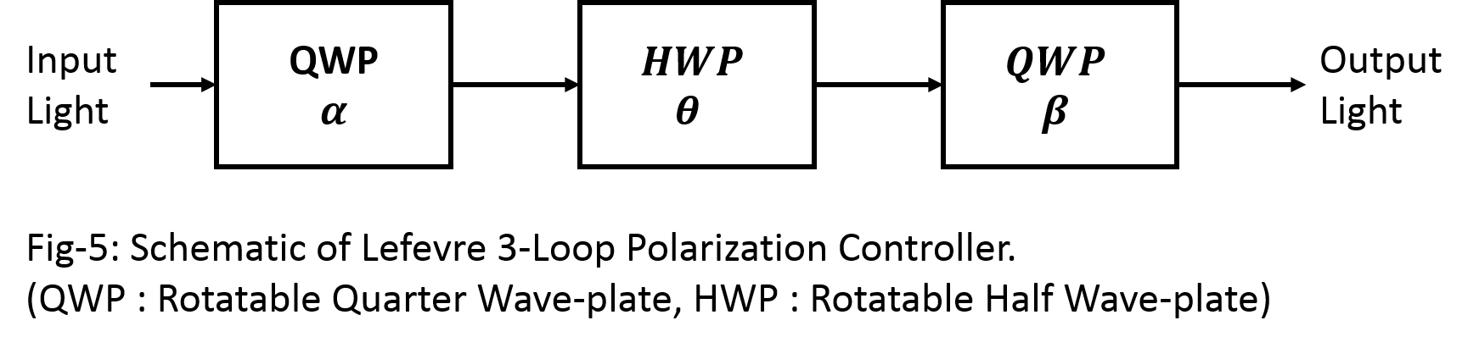

Lefevre in 1980, proposed a 3-fiber loop based polarization controller which is commercially the most used polarization controller. The polarization controller utilizes three wave plates. The first is the quarter wave plate followed by a half wave plate, and finally, the quarter wave plate is used from which the output light is derived. The overall Jones matrix of the figure can be written as the matrix equation:

$$J\left(α, θ, β\right)=QWP\left(β\right).HWP\left(θ\right).QWP\left(α\right)$$

After substituting the required values and simplifying, we get the Jones matrix of the complete system as,

There are two operational modes that are important in the design of the transceiver. First is a rotation matrix and the second is circular rotation, both of which are specialized form of the above matrix.

First, in deriving the rotation matrix which is a matrix of form:

$$J\left(θ\right)=\left[\begin{matrix}\cos{2θ} & \sin{2θ} \\ -\sin{2θ} & \cos{2θ}\end{matrix}\right]$$

This matrix is obtained, when the device in Fig-5 is oriented such that, the first quarter wave plate is adjusted to the angle $α= θ$ and the last quarter wave plate is rotated by the reverse angle $β= -θ$, where $θ$ is the angle of rotation in the counter-clockwise direction. However the half wave-plate must be fixed by rotating it to an angle of $θ= 90°$.

. The circular rotation is not a standard term in optics. It is a simplified coinage for the matrix that has the form:

$$J\left(θ\right)=\left[\begin{matrix}\cos{2θ} & i \sin{2θ} \\ i\sin{2θ} & \cos{2θ}\end{matrix}\right]$$

This matrix can also be obtained from the polarization controller shown in Fig-5 by setting the first quarter wave plate is adjusted to the angle $α= 90°$ and the last quarter wave plate is rotated by the reverse angle $β= -90°$. However at this time, the half wave-plate must be rotatedto an angle of $θ$, which represents the angle of rotation as required.

But it should be noted here that, the matrix can be rewritten in a much simplified form without losing generosity of the above relations:

$$Polarization Rotator :J\left(θ CCW\right)=\left(\begin{matrix}\cos{θ} & \sin{θ} \\ -\sin{θ} & \cos{θ}\end{matrix}\right)$$

$$Circular Rotation:J\left(θ CCW\right)=\left(\begin{matrix}\cos{θ} & i\sin{θ} \\ i\sin{θ} & \cos{θ}\end{matrix}\right)$$

These matrices will be used throughout the chapter.

# 3.1.9 Polarization Modulator

The Polarization Modulator is a class of electro-optic modulator that exhibit opposite refractive index in orthogonal light axis. Hence, the Jones matrix corresponding to the modulation index $β$ which represents the input electrical signal, the Jones matrix for the polarization matrix takes the form:

$$J\left(β\right)=\left(\begin{matrix}e^{i β} & 0 \\ 0 & e^{-i β}\end{matrix}\right)$$

Thus, it can be seen that the polarization modulator is a non-ideal linear horizontal polarizer which shears the signal according to a complex conjugate exponential function of the modulation index corresponding to the input electrical or RF signal.

# 3.2 Photonic Up-converter based on Polarization Optical Components

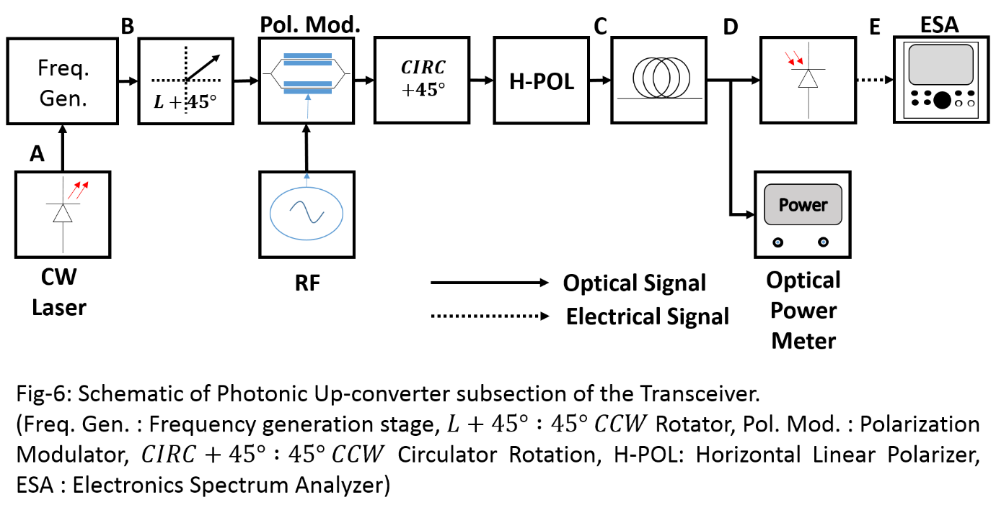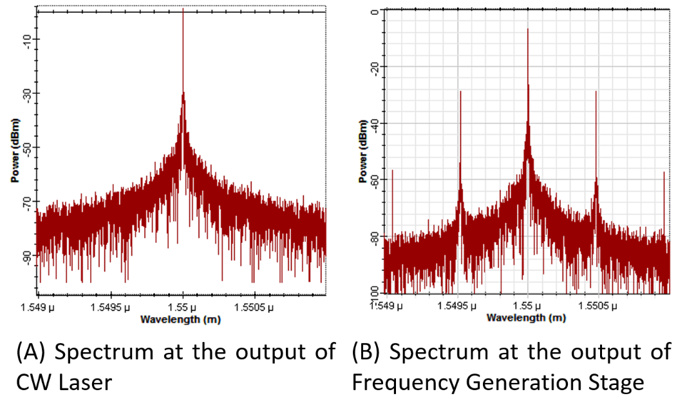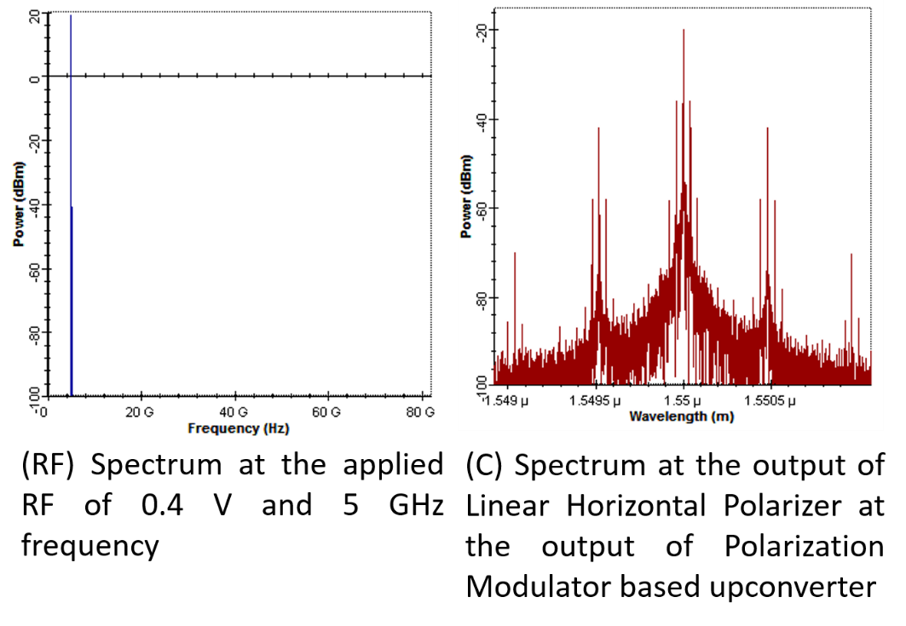

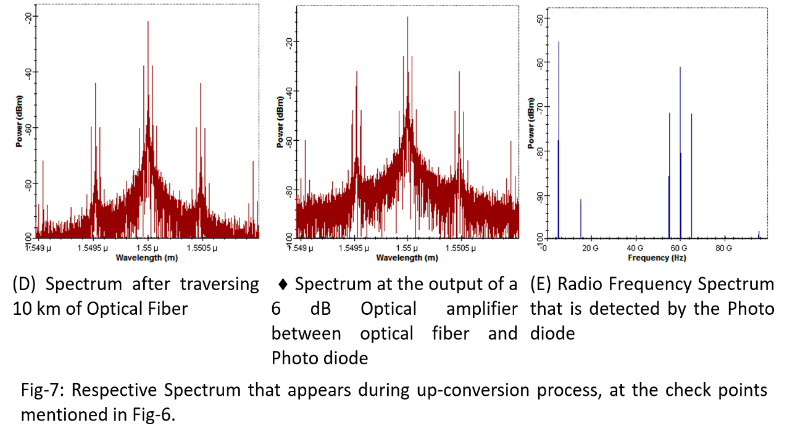

The schematic of a polarization optics based up-converter is shown in the Fig-6 above. In the schematic, it is assumed that the carrier frequency is generated by some mechanism that is not covered in this thesis. Although, a good example of the generation stage for the present thesis, is the MZM based frequency generator discussed in Chapter-2. Therefore, continuing from the discussion in Chapter-2, the frequency generation stage produces the optical carrier along with $±1$ sideband. Therefore, the spectral components that appears at the input of the polarization optics based transceiver are $1550 nm, 1550 nm ±60 GHz$. These frequency components are shown in Fig-7 (B), forms the basis where the modulation will take place.

The up-conversion stage take the horizontally polarized input light. This horizontally polarized light is passed through a linear horizontal polarized light that outputs a $L+45°$ linearly polarized light. This light is such that, the input light intensity is equally distributed onto both light axes. Then this light is applied to the input of a polarization modulator with half-wave voltage of 4 V. The input sinusoidal RF containing a sinusoid of 5 GHz with an input of 1 V is applied to the RF input of the polarization modulator. The polarization modulator can be thought of as a phase modulator, which has mutually opposite sign for phase deviation along both axes. Thus, respective complex sidebands are generated at each axes due to the applied 5 GHz RF. The sidebands are generated for each of the optical carrier that appears across the input of polarization modulator.

The output of the polarization modulator is applied to the input of a circular rotator oriented at $+45°$. This will result in a complex transformation of the polarized signal, such that the signal at X and Y axes are same in magnitude but opposite in sign. This polarized output is applied to a Linear Horizontal Polarizer, which will only select the horizontal component of light that appears at its input. The output consist of the first order sideband of the 5 GHz radio frequency across the optical carrier, as well as its first order sidebands which corresponds to 60 GHz, as shown in Fig-7(C).

The modulated optical spectrum is traversed through a distance of 10 km through an optical fiber, which is selected to act only as an attenuating medium. After traversing the fiber the spectrum remains intact although the fiber causes the overall spectrum to be attenuated. The spectrum at the output of the attenuator is shown in Fig-7(D). The weak signal is amplified by an ideal optical amplifier to a level such that the photo detector can properly detect the optical input and provide the required RF spectrum. The output of the amplifier is applied directly to the photodiode, the corresponding spectrum is shown in the right of Fig-7 (D). The incident optical spectrum will heterodyne at the photodiode and produce a DC current proportional to the optical carrier, a 5 GHz RF corresponding to the amplitude of the respective optical output. Also a 60 GHz output is available along with a 55 and 65 GHz output. The 55 and 65 GHz output are available due to the 5 GHz RF heterodyning with the 60 GHz LO signal, thus, the up-conversion process had taken place which converted the 5 GHz RF to a 55 or 65 GHZ output.

# 3.2.1 Theoretical Analysis of the Up-conversion schematic

The first stage in the photonic up-converter is the MZM based frequency generator, which is depicted in Fig-8. This stage uses a quadrature biased MZM to generate the first order sidebands which have the frequency separation of $ω_{LO}$. Let us consider the peak intensity of the CW laser source be given by $P_{in}$ and the corresponding peak amplitude of the optical field be $E_{in}$. Then the output optical field corresponding to the applied RF sinusoid of form $V_{LO}\cos{ω_{LO}t}$, when applied to MZM1 will produce an output given by,

$E_{1}= α_{1}E_{in}\cos{(\frac{90°}{2}+A\cos\left(ω_{LO}t+ θ_{LO}\right) )}$………………… (1)

$$where α_{1}=a factor contributed by insertion loss of MZM1, \\ A= \frac{V_{LO}}{V_{π}}\frac{π}{2}=modulation index for MZM1 with applied LO voltage, \\ ω_{LO}=frequency of LO signal, \\ θ_{LO}=phase mismatch between LO and optical wave, due to velocity mismatch.$$

Performing mathematical simplification on the above equation, we can write equation (1) as:

$E_{1}= \frac{α_{1}E_{in}}{\sqrt{2}}\left[\cos{(A\cos\left(ω_{LO}t+ θ_{LO}\right) )}-\sin{(A\cos\left(ω_{LO}t+ θ_{LO}\right) )}\right]$…………………. (2)

In the second part, consider the schematic in Fig-9. Here, the input light field $E_{1}$ is applied to a polarization rotator which rotates the input horizontal polarized light to a $L+45°$ linear polarized light. The Jones matrix of this component is:

$J_{1}=\left(\begin{matrix}\cos{45°} & \sin{45°} \\ -\sin{45°} & \cos{45°}\end{matrix}\right)= \frac{1}{\sqrt{2}}\left(\begin{matrix}1 & 1 \\ -1 & 1\end{matrix}\right)$………………….. (3)

The light output from the polarizer is applied to a polarization modulator. The polarization modulator also takes as input RF sinusoid containing the signal to be up-converted. Let us consider the applied RF sinusoid of form $V_{RF}\cos{ω_{RF}t}$, where $V_{RF}$ is the peak amplitude of the applied RF and $ω_{RF}$ is the corresponding frequency. Then the Jones matrix for the polarization modulator is given by,

$J_{2}=\left(\begin{matrix}e^{j β} & 0 \\ 0 & e^{- j β}\end{matrix}\right)$………………….. (4)

$where β= B\cos{{ (ω}_{RF}t}+ θ_{RF})$…………………… (5)

The output of polarization modulator is applied to a circular rotator aligned at $+45°$, the corresponding Jones matrix of this component can be written as,

$J_{3}=\left(\begin{matrix}\cos{45°} & i sin{45°} \\ i \sin{45°} & \cos{45°}\end{matrix}\right)= \frac{1}{\sqrt{2}}\left(\begin{matrix}1 & i \\ i & 1\end{matrix}\right)$………………….. (6)

This complex amplitude based linear polarized signal is passed through a linear horizontal polarizer, the Jones matrix of which is,

$J_{4}=\left(\begin{matrix}1 & 0 \\ 0 & 0\end{matrix}\right)$………………….. (7)

The output of linear horizontal polarized light is now horizontally polarized. This horizontal linear polarized light passes through an optical fiber to reach its destination, where optical to electrical conversion is performed through a photo detector. The optical fiber only attenuates the light travelling through it. Hence, we can write the Jones matrix of the overall system as,

$$J= J_{4}J_{3}J_{2}J_{1}$$

On substituting the required values from (3), (4), (6), (7), we get after simplification,

$J= \left(\begin{matrix}\left(\frac{1}{2}-\frac{ⅈ}{2}\right)\left(cos\left[β\right]-sin\left[β\right]\right) & \left(\frac{1}{2}+\frac{ⅈ}{2}\right)\left(cos\left[β\right]+sin\left[β\right]\right) \\ 0 & 0\end{matrix}\right)$…………………….. (8)

Thus when horizontal linear polarized light have the Jones vector of form $\left\{\begin{matrix}E_{1} \\ 0\end{matrix}\right\}$ is input to the system, then the output Jones vector can be written as,

$E_{5}= J.E_{1}$………………….. (9)

Substituting the values from equation (8) in (9) and simplifying, we get the Jones vector of form,

$E_{5}=E_{1}\left(\begin{aligned}\left(\frac{1}{2}-\frac{ⅈ}{2}\right)\left(cos\left[β\right]-sin\left[β\right]\right) \\ 0\end{aligned}\right)$………………….. (10)

This represents a horizontal linear polarized light of form given by,

$E_{5}= \left(\frac{1}{2}-\frac{ⅈ}{2}\right)E_{1} (cos[β]-sin[β])$………………… (11)

Substituting the values of $β$ from equation (5) in equation (11), we get,

$E_{5}= \left(\frac{1}{2}-\frac{ⅈ}{2}\right)E_{1} (cos[B\cos{ω_{RF}t}]-sin[B\cos{ω_{RF}t}])$………………… (12)

Due to unimodality of the light wave in the single mode fiber, equation (12) can be rewritten in a more generic form as,

$E_{5}= α_{2}E_{1} (cos[B\cos{{ (ω}_{RF}t}+ θ_{RF})]-sin[B\cos{{ (ω}_{RF}t}+ θ_{RF})])$………………… (13)

Here $α_{2}$ accounts for all the losses that would occur during the modulation by the polarization based modulator. After passing through the fiber, an additional attenuation $α_{3}$ occurs which can be incorporated into equation (13), to obtain,

$E_{6}= α_{3}α_{2}E_{1} (cos[B\cos{{ (ω}_{RF}t}+ θ_{RF})]-sin[B\cos{{ (ω}_{RF}t}+ θ_{RF})])$…………… (14)

Now if we substitute the value from equation (2) in equation (14), we get,

$E_{6}= α_{3}α_{2}α_{1}\frac{E_{in}}{\sqrt{2}}\left[\cos{(A\cos\left(ω_{LO}t+ θ_{LO}\right) )}-\sin\left(A\cos\left(ω_{LO}t+ θ_{LO}\right)\right)\right] (cos[B\cos{{ (ω}_{RF}t}+ θ_{RF})]-sin[B\cos{{ (ω}_{RF}t}+ θ_{RF})])$……………… (15)

This can be rewritten in a more generic form as,

$E_{6}= \frac{{\sqrt{T_{D}}E}_{in}}{\sqrt{2}}\left[\cos{(A\cos\left(ω_{LO}t+ θ_{LO}\right) )}-\sin\left(A\cos\left(ω_{LO}t+ θ_{LO}\right)\right)\right] (cos[B\cos{{ (ω}_{RF}t}+ θ_{RF})]-sin[B\cos{{ (ω}_{RF}t}+ θ_{RF})])$………………… (16)

# 3.2.1.1 Optical Spectrum

Expanding the equation (16) using Jacobi-Anger expansion and limiting the expansion to 1st order term, assuming low modulation index, we can write,

$E_{6}= \frac{{\sqrt{T_{D}}E}_{in}}{\sqrt{2}}\left[J_{0}\left(A\right)-2 J_{1}\left(A\right)\cos\left(ω_{LO}t+ θ_{LO}\right)\right] [J_{0}\left(B\right) - 2 J_{1}\left(B\right)\cos\left(ω_{RF}t + θ_{RF}\right)]$…………………. (17)

Simplifying equation (13) we get,

$E_{6}= \frac{{\sqrt{T_{D}}E}_{in}}{\sqrt{2}}\left[J_{0}\left(A\right)J_{0}\left(B\right)-2 J_{0}\left(A\right)J_{1}\left(B\right)\cos\left(ω_{RF}t+ θ_{RF}\right) -2 J_{1}\left(A\right)J_{0}\left(B\right)\cos\left(ω_{LO}t+ θ_{LO}\right) -2 J_{1}\left(A\right)J_{1}\left(B\right)\cos\left\{\left(ω_{LO}+ω_{RF})t+(θ_{LO}+θ_{RF}\right)\right\}-2 J_{1}\left(A\right)J_{1}\left(B\right)\cos\left\{\left(ω_{LO}-ω_{RF})t+(θ_{LO}-θ_{RF}\right)\right\}\right]$…………………. (18)

Therefore, the optical spectrum consists of the optical carrier, as well as the sidebands given by $±ω_{RF}, ±\left(ω_{LO}±ω_{RF}\right),$ which are also observable in Fig-7 (D). The corresponding optical power is obtained from equation (18) as,

$P_{op}\left(optical carrier\right)= \frac{T_{D}{{| E}_{in} |}^{2}}{2}{\{ J_{0}\left(A\right)J_{0} (B) \}}^{2}$

This equation can also be written in a simpler form,

$P_{op}\left(optical carrier\right)= \frac{T_{D}P_{in}}{2}{\{ J_{0}\left(A\right)J_{0} (B) \}}^{2}$………………… (19)

Here, $P_{in}$ is the input laser power or intensity, and $T_{D}$ is the optical path loss from laser source to the photodiode. Therefore, the remaining optical powers can now be written as,

$P_{op}\left(ω_{RF}\right)= \frac{T_{D}P_{in}}{2}{\{ 2 J_{0}\left(A\right)J_{1} (B) \}}^{2}$………………… (20)

$P_{op}\left(ω_{LO}\right)= \frac{T_{D}P_{in}}{2}{\{ 2 J_{1}\left(A\right)J_{0} (B) \}}^{2}$…………………. (21)

$P_{op}\left(ω_{LO}± ω_{RF}\right)= \frac{T_{D}P_{in}}{2}{\{ 2 J_{1}\left(A\right)J_{1} (B) \}}^{2}$…………………. (22)

# 3.2.1.2 Electrical Spectrum

First starting with equation (16),

$E_{6}= \frac{{\sqrt{T_{D}}E}_{in}}{\sqrt{2}}\left[\cos{(A\cos\left(ω_{LO}t+ θ_{LO}\right) )}-\sin\left(A\cos\left(ω_{LO}t+ θ_{LO}\right)\right)\right] (cos[B\cos{{ (ω}_{RF}t}+ θ_{RF})]-sin[B\cos{{ (ω}_{RF}t}+ θ_{RF})])$

This equation can be re-written as,

$$E_{6}= \frac{{\sqrt{T_{D}}E}_{in}}{\sqrt{2}} 2\cos{[45°+A\cos{(ω_{LO}t+ θ_{LO})} ]}cos⁡[45° + B\cos\left(ω_{RF}t+ θ_{RF}\right)]$$

$E_{6}= {\sqrt{2 T_{D}}E}_{in}\cos{[45°+A\cos{(ω_{LO}t+ θ_{LO})} ]}cos⁡[45° + B\cos\left(ω_{RF}t+ θ_{RF}\right)]$

The electrical spectrum is dependent on the incident optical power on the photodiode. The expression for power incident on the photodiode is the square of the magnitude of the expression for optical field, expressed in the above equation. The incident optical power can now be written as,

$${|E_{6} |}^{2}=2 T_{D}{|E_{in} |}^{2}\cos^{2}\left[45°+A\cos\left(ω_{LO}t+ θ_{LO}\right)\right]\cos^{2}[45°+B\cos{(ω_{RF}t+ θ_{RF})}]$$

This can be mathematically simplified to,

${|E_{6} |}^{2}= \frac{T_{D}{|E_{in} |}^{2}}{2}\left\{1-\sin\left[2A\cos\left(ω_{LO}t+ θ_{LO}\right)\right]\right\}\{1-\sin\left[2B\cos\left(ω_{RF}t+ θ_{RF}\right)\right]\}$……. (23)

Using Jacobi-Anger expansion and limiting to second order Bessel-term, we get,

$${|E_{6} |}^{2}= \frac{T_{D}{|E_{in} |}^{2}}{2}\left\{1-2 J_{1}\left(2A\right)\cos\left(ω_{LO}t+ θ_{LO}\right)\right\} \{1-2J_{1}\left(2B\right)\cos\left(ω_{RF}t+ θ_{RF}\right) \}$$

This expression can be mathematically simplified to yield,

${|E_{6} |}^{2}= \frac{T_{D}{|E_{in} |}^{2}}{2} \{1-2J_{1}\left(2B\right)\cos\left(ω_{RF}t+ θ_{RF}\right)-2J_{1}\left(2A\right)\cos\left(ω_{LO}t+ θ_{LO}\right)+2J_{1}\left(2A\right)J_{1}\left(2B\right)\cos\left[\left(ω_{LO}+ω_{RF}\right)t+\left(θ_{LO}+θ_{RF}\right)\right] +2J_{1}\left(2A\right)J_{1}\left(2B\right)\cos\left[\left(ω_{LO}-ω_{RF}\right)t+\left(θ_{LO}-θ_{RF}\right)\right] \}$………………… (24)

The DC photocurrent resulting from the optical carrier incident on photodiode can be written as,

$I_{DC}= \frac{R T_{D}{|E_{in} |}^{2}}{2}= \frac{R T_{D}P_{in}}{2}$………………… (25)

Here, R represents the Resposivity of the photodiode and Pin represents the CW laser intensity. Therefore, if a $50$ resistive load is connected across the photodiode, then the DC power delivered to the load is given by,

$P_{DC}= {I_{DC}}^{2} ×50={\left\{\frac{R T_{D}P_{in}}{2}\right\}}^{2} ×50$………………….. (26)

Apart from the DC component, the RF spectrum is composed of other frequency components. These frequency components are $ω_{RF}, ω_{LO}, ω_{LO}±ω_{RF}$, as shown in Fig-7 (E). Their respective power is obtained from equation (24), and simplifying using equation (26), we can write,

$P\left(ω_{RF}\right)=L\left(ω_{RF}\right)\frac{P_{DC}}{2}{\{ 2 J_{1 }\left(2B\right)\}}^{2}$………………… (27)

$P\left(ω_{LO}\right)=L\left(ω_{LO}\right)\frac{P_{DC}}{2}{\{ 2 J_{1 }\left(2A\right)\}}^{2}$………………… (28)

$P\left(ω_{LO} ± ω_{RF}\right)=L\left(ω_{LO} ± ω_{RF}\right)\frac{P_{DC}}{2}{\{ 2 J_{1 }\left(2A\right)J_{1 }\left(2B\right)\}}^{2}$………………… (27)

In the above expressions, it must be noted that $L\left(ω\right)$ represents the total optical link loss at the radio frequency $ω$.

# 3.2.2 Linearity analysis: Third Order Intercept

In order to obtain TOI, the LO source is turned OFF. Then equation (23) becomes,

${|E_{6} |}^{2}= \frac{T_{D}{|E_{in} |}^{2}}{2} \{1-\sin\left[2B\cos\left(ω_{RF}t+ θ_{RF}\right)\right]\}$………….……. (28)

Then expanding the equation (28) using Jacobi-Anger Expansion, and retaining up to Third-order Bessel function, we get,

${|E_{6} |}^{2}= \frac{T_{D}{|E_{in} |}^{2}}{2} \{1-2J_{1}\left(2B\right)\cos\left(ω_{RF}t+ θ_{RF}\right)+2J_{3}\left(2B\right)\cos\left(3ω_{RF}t+ {3θ}_{RF}\right) \}$……..(29)

The detected DC power can be obtained from equation (29) and is same as obtained in equation (26). The output spectrum would now compose of the frequencies $ω_{RF}, 3ω_{RF}$.Their respective power is given by the following expressions,

$P\left(ω_{RF}\right)=L\left(ω_{RF}\right)\frac{P_{DC}}{2}{\{ 2 J_{1 }\left(2B\right)\}}^{2}$………………… (30)

$P\left(3ω_{RF}\right)=L\left({3ω}_{RF}\right)\frac{P_{DC}}{2}{\{ 2 J_{3 }\left(2B\right)\}}^{2}$………………… (31)

The third order frequency is detrimental to the operation of the up-converter as it would destroy the linearity nature of operation which is required. Thus, for a stable operation to occur the modulation index must be such that the third order frequency component is negligible compared to the first order component. Hence, a judgement of the operational characteristics will be obtained from the value of the TOI (Third order intercept) point. For maintaining linearity during operation, the TOI point must be very high, such that, even a very high modulation index for RF does not produce sufficient non-linear components.

To measure TOI, we will use a simulation as well as equations (30), (31), to obtain a plot of the input RF power versus the output power at fundamental and third-order frequencies respectively. Then extrapolate the linear region of both the points which will intercept at TOI point. The value of input TOI is obtained by taking intercept of the TOI point with the input RF power axis. This RF power is the maximum allowed power for operation of the linear up-converter. The plot is shown in Fig-10 below. It should be noted that, the transceiver is always operated at a much lower input power than the TOI value, so that, it is always linear in its operation. From the figure, it can be seen that the TOI point is obtained for a RF input of 38.25 dBm.

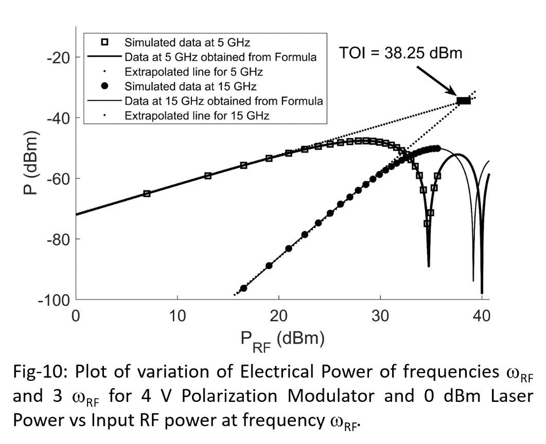

# 3.3 Photonic Down-conversion

The schematic for photonic down-conversion if shown in Fig-11 above.The technique is similar to that used for up-conversion. However, during down-conversion, the received RF spectrum has the frequency value of $ω_{LO}+ ω_{RF}$ (say). Then the output spectrum detected across photodiode would consist of RF frequency components of $ω_{LO}+ω_{RF}, ω_{LO} ±(ω_{LO}+ω_{RF})$, which can be rewritten as $ω_{LO}+ω_{RF}, ω_{RF}, 2 ω_{LO}+ ω_{RF}$. When these frequency components are passed through a low pass filter with $Bandwidth≪ ω_{LO}$, then the output spectrum will only contain the demodulated spectrum at frequency $ω_{RF}$. Thus, the power at the detected or down-converted frequency can be obtained from equation (27) as,

$P\left(ω_{RF}\right)=L\left(ω_{RF}\right)\frac{P_{DC}}{2}{\{ 2 J_{1 }\left(2A\right)J_{1 }\left(2B\right)\}}^{2}$………………… (32)

The corresponding spectrum as obtained during various stages of down-conversion are shown in Fig12.

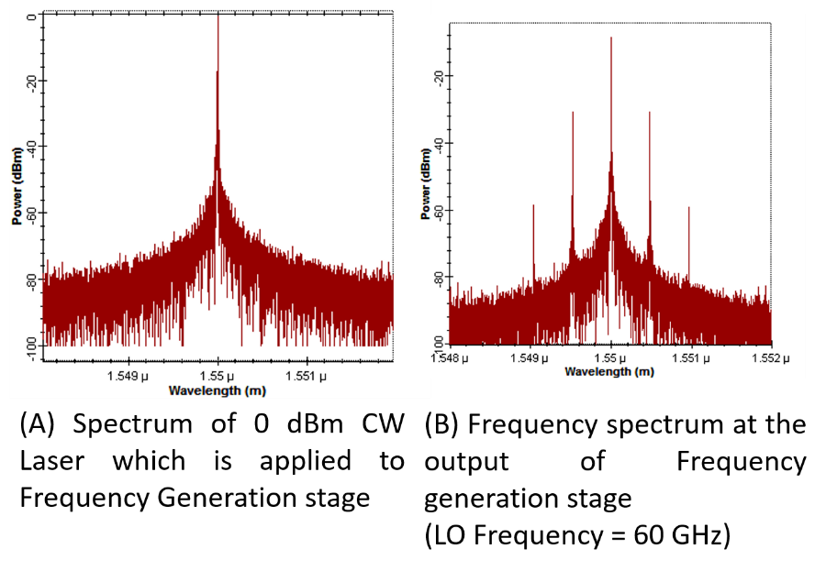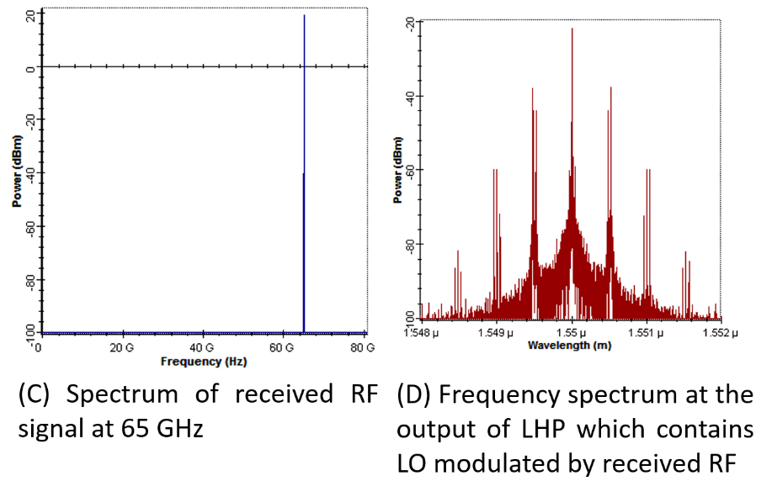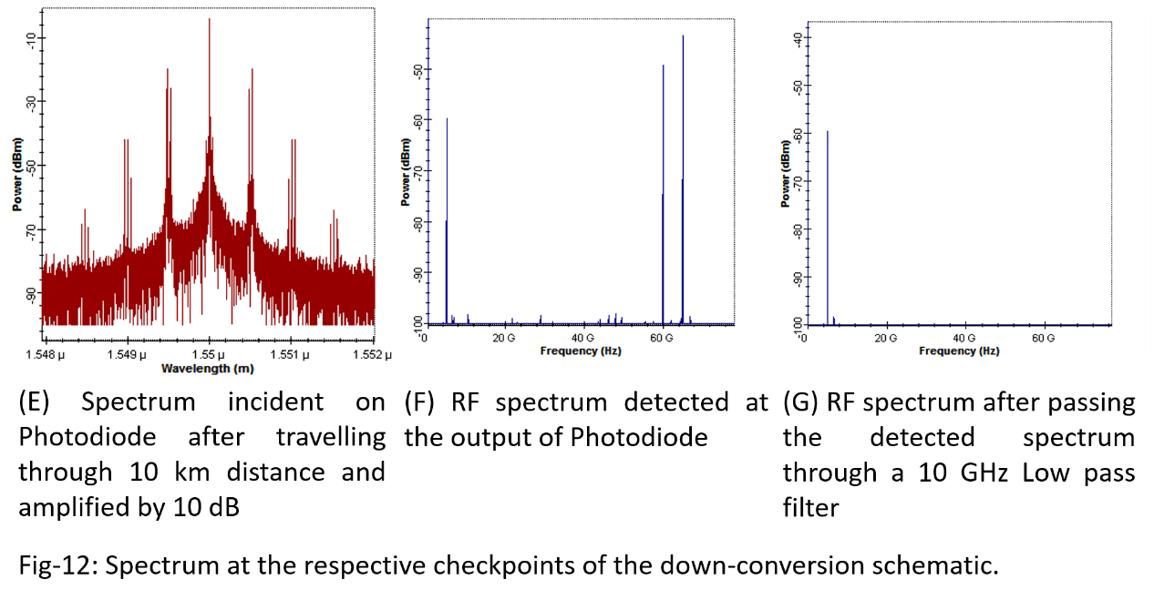

# 3.4 BER simulation for Photonic Up and Down-converter

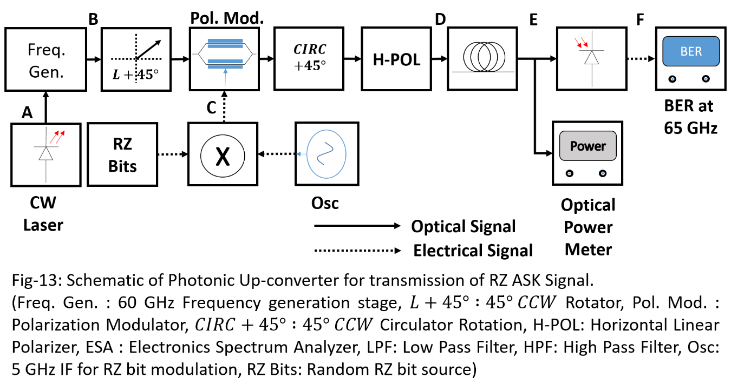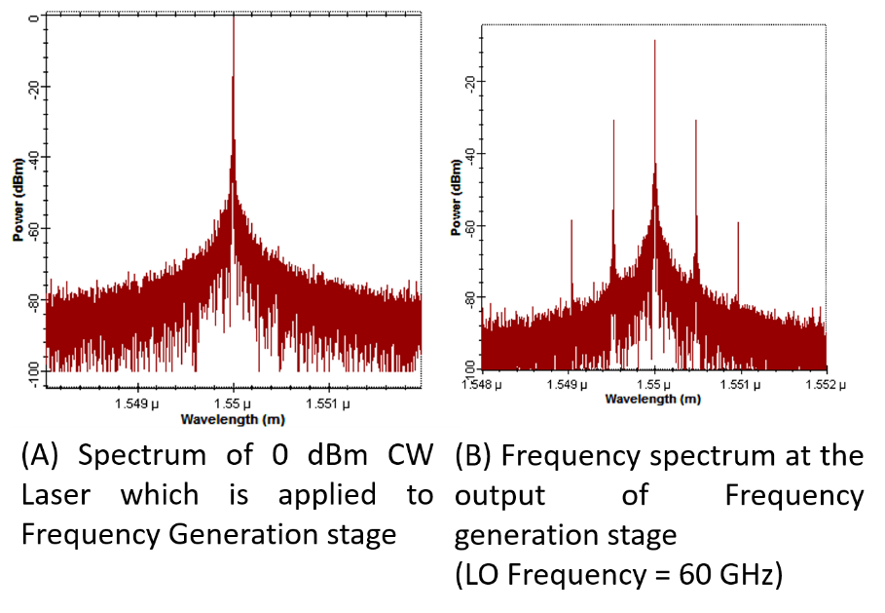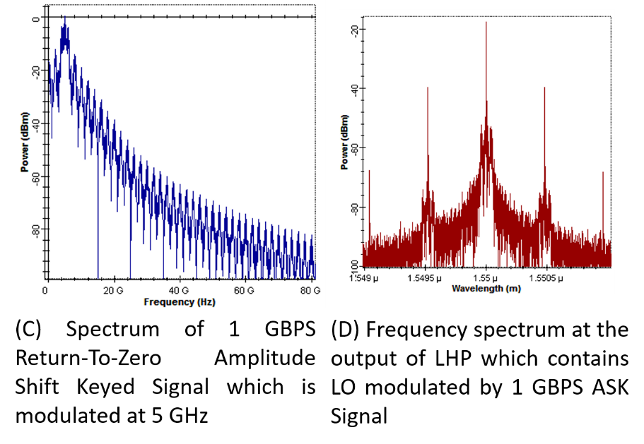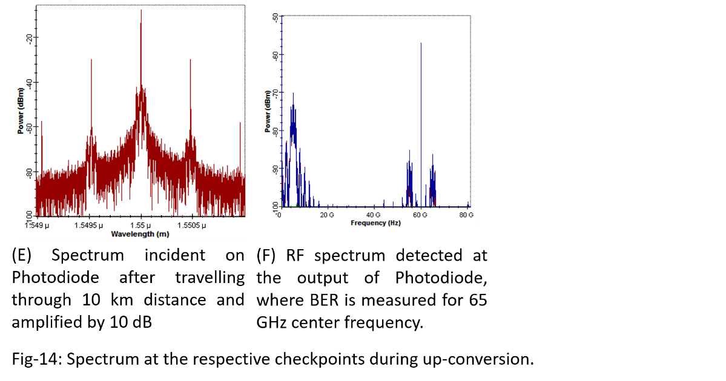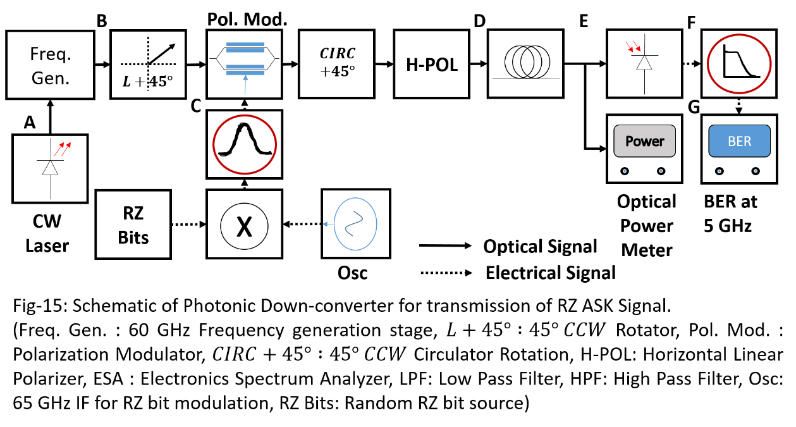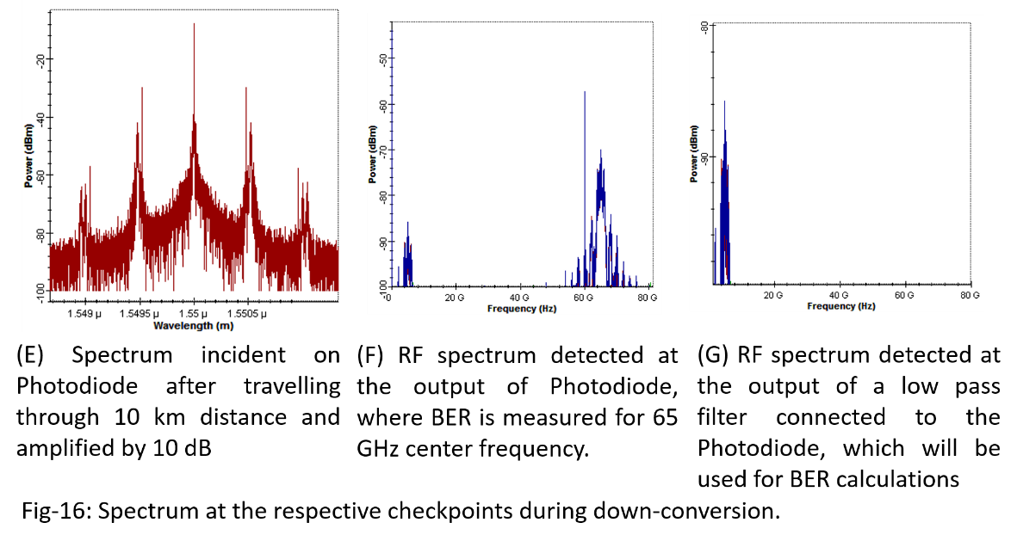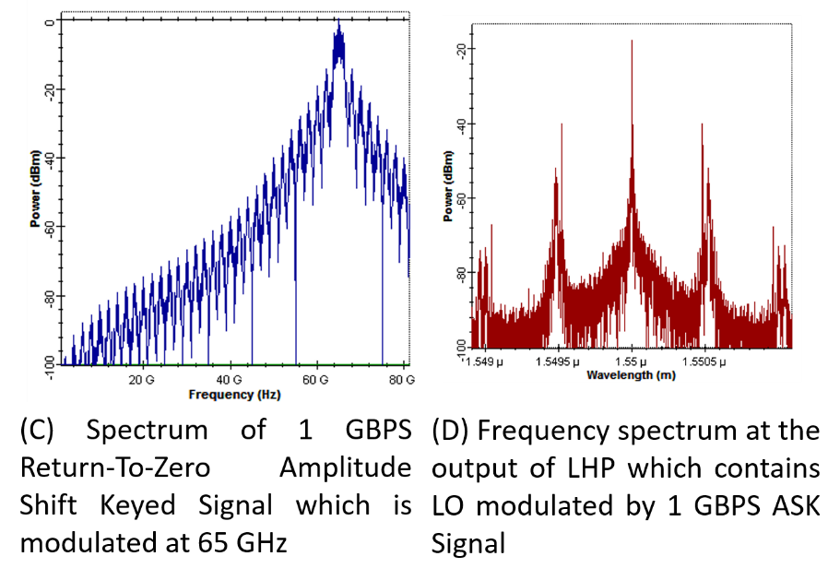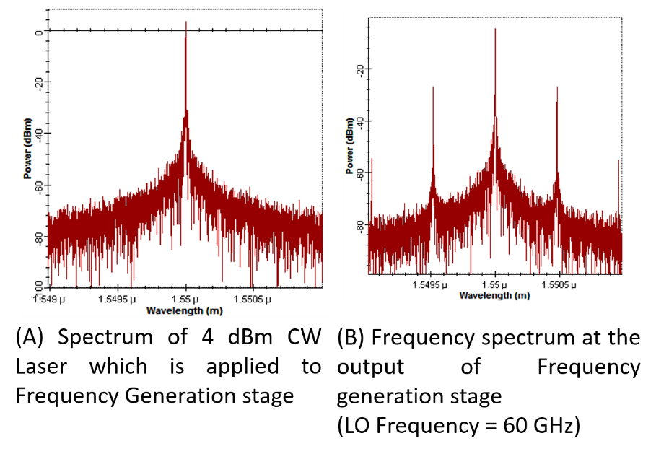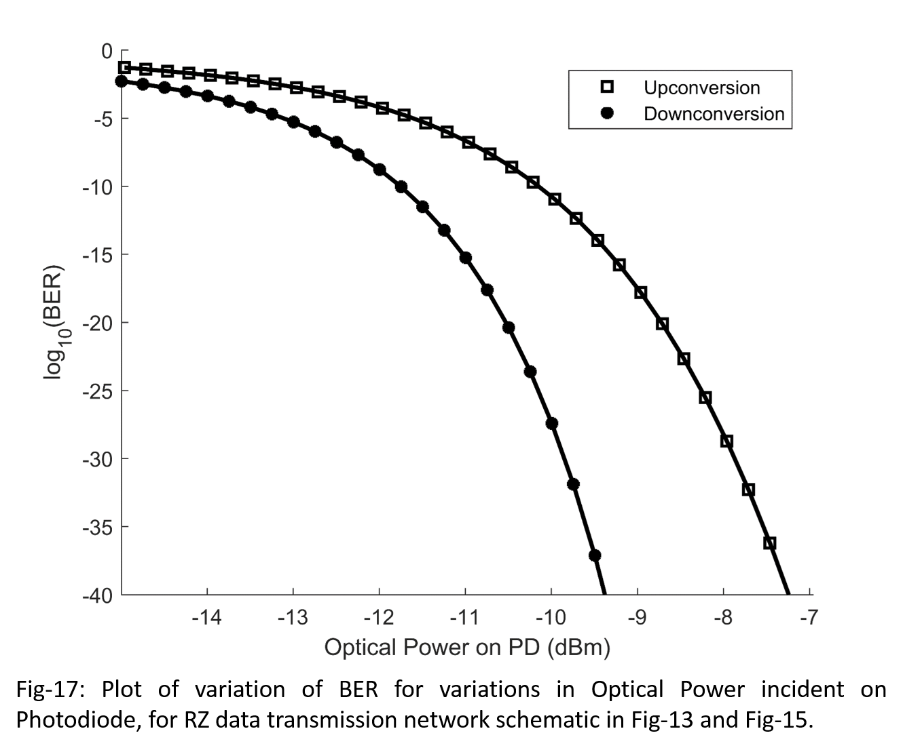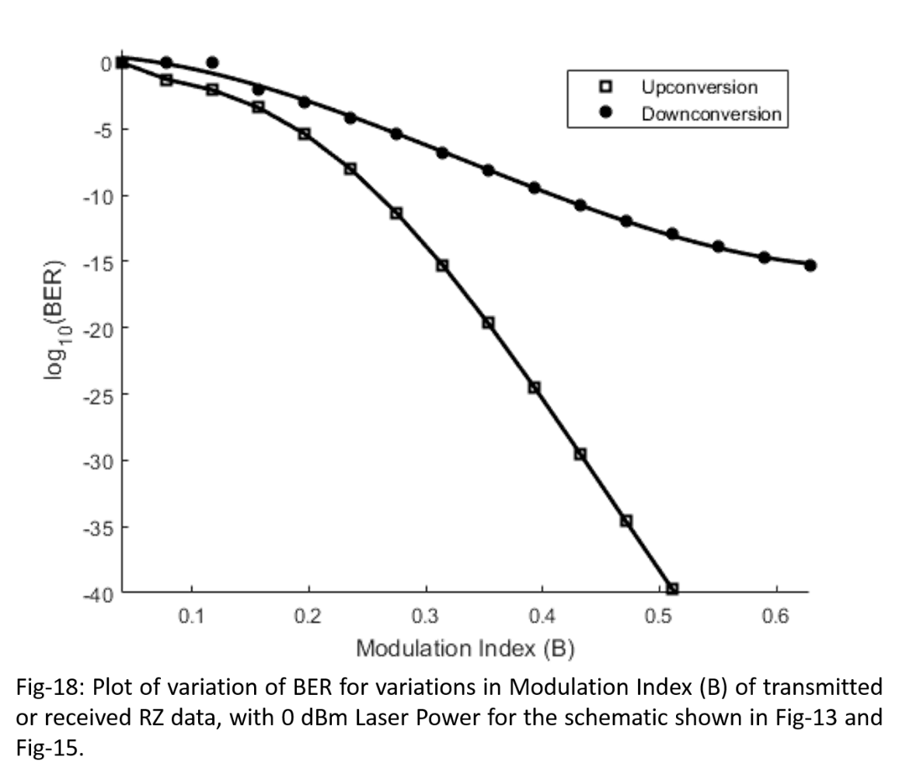

In this section, the polarization optics based transceiver is used to up-convert and down-convert modulated data. The schematic for up-conversion is shown in Fig-13. Here, the up-converter circuit is fed with an optical signal whereby the optical carrier as well as two sideband on either side of the optical carrier. The sidebands are separated from optical carrier by 60 GHz, as shown in Fig-14 (B). The RF input of the polarized up-converter is connected to an amplitude shift keying circuit, which takes return-to-zero random bits. The generated random bits are encoded using forward error coding technique to aid with their recovery after up-conversion. The RF spectrum is shown in Fig-14 (C). Thus, the optical output of the up-converter will result in simultaneous modulation of the optical carrier as well as all its sidebands, as shown in Fig-14 (D). This modulated optical carrier is carried to its destination through a 10 km long optical fiber and then sufficiently amplified so that it can be properly detected during optical to electrical conversion using a photodiode. The photodiode detects the incident waveform and provide an output spectrum containing the data signal at the input frequency of 5 GHz and also at two up-converted frequencies of 55 and 65 GHz, which can be seen in Fig-14 (F). The BER, however, is calculated at 65 GHz for convenience, as can be seen in plots in Fig-17 and Fig-18.

During down-conversion, the schematic shown in Fig-15 is used. The Fig-15 for down-conversion is mostly identical to that of the up-converter shown in Fig-13. However, there lies some subtle differences. The data modulated RF is now at a high frequency of 65 GHz, which is first passed through a band-pass filter before the signal is applied to the down-converter. The RF spectrum is shown in Fig-16 (C). The corresponding optical spectrum obtained at the output of the down-converter is shown in Fig-16 (D). This signal is then carried by a 10 km optical fiber and then properly amplified before applying it to the photo-detector. The output RF spectrum from the photo-detector, shown in Fig-16 (F), is composed of a down-converted signal at 5 GHz as well as the received RF at 65 GHz. Therefore, after passing this signal through a low pass filter, we get the down-converted signal at 5 GHz, as shown in Fig-16 (G). The BER is then measured with this signal is 5 GHz, and plot as shown in Fig-17 and Fig-18 is obtained.

To assess the performance of the transceiver, two characterization processes are undertaken. In the first process, the incident photodiode power is varied by adjusting the input CW laser intensity. Then the BER at the up and down-converted frequencies are respectively measured and the plot in Fig-17 is obtained. This plot shows the BER variation with the incident photodiode power, which can be used to assess the system performance with changes in LO amplitude or laser intensity andmake changes as necessary to obtain a required BER rate.

In the second process, the laser intensity is first fixed at 0 dBm. Then with this fixed laser intensity the input modulation index of the RZ ASK data stream is altered. Then reading of the BER during up and down conversion process are duly noted. A plot as shown in Fig-18 is obtained. This plot can be used to assess the threshold level of the modulation index that must be used to attain a required BER level.

# REFERENCES

[1] E. Sackinger, “Broadband Circuits for Optical Fiber Communications”, Wiley Publishers (2005).

[2] H. Nagata, K. Kiuchi, and S. Kazumasa, “Studies of thermal drift as a source of output instabilities in Ti: LiNbO3 optical modulators,” Journal of Lightwave Technology, vol. 75, no. 9, pp. 4762–4764 (1994).

[3] E. Wooten, K. Kissa, A. Yi-Yan, E. Murphy, D. Lafaw, P. Hallemeier, D. Maack, D. Attanasio, D. Fritz, G. McBrien, and D. Bossi, “A review of lithium niobate modulators for fiber-optic communications systems,” IEEE Journal of Selected Topics Quantum Electron., vol. 6, no. 1, pp. 69–82 (2000).

[4] Yejun Fu, Xiupu Zhang, Bouchaib Hraimel, Taijun Liu, Dongya Shen, “Mach-Zehnder”, IEEE Microwave Magazine, 1527-3342/13 (Nov-Dec 2013).

[5] E. Wooten, K. Kissa, A. Yi-Yan, E. Murphy, D. Lafaw, P. Hallemeier, D. Maack, D. Attanasio, D. Fritz, G. McBrien, and D. Bossi, “A review of lithium niobate modulators for fiber-optic communications systems,” IEEE Journal of Selected Topics Quantum Electron., vol. 6, no. 1, pp. 69–82 (2000).

[6] M. Salvestrini, G. Guilbert, and S. Gille, “Analysis and control of the dc drift in LiNbO3-based Mach-Zehnder modulators,” Journal of Lightwave Technology, vol. 29, no. 10, pp. 1522–1534 (2011).

[7] H.C. Lefevre, “Single-Mode Fibre Fractional Wave Devices and Polarization Controllers”, Electronics Letters, Vol. 16, No. 20 (1980).

[8] R. Ulrich, A. Simon, “Polarization optics of twisted single mode fibers', Applied Optics, Vol.18, pp. 2241-2251 (1979).

[9] E. Colitt, “Polarized light in Fiber Optics”, The PolaWave Group (2003).

# Chapter-4

# Conclusions

The photonic transceiver is designed using MZM and polarization modulator technique. During the study it is found that MZM is a good candidate for design of microwave generation. When a MZM intensity modulator is biased at quadrature, it behaves as a linear device to a wider extent. Further, when an RF field is applied to MZM which is biased at quadrature, the optical spectrum consists of the optical carrier and all the sidebands corresponding to the frequency interval demarcated by the frequency of the impressed RF. Depending on the modulation index of the applied RF, which itself depends on the RF voltage as well as the half-wave voltage of the MZM modulator, the intensity of the sidebands varies. However, under the assumption that the modulation index is low enough, it is seen that the optical spectrum is dominated by the optical carrier and the first order sidebands. This is because the amplitude optical sidebands depends on the respective order of the Bessel function of the RF modulation index. Hence, if the modulation index is small, the higher order Bessel function becomes negligible enough so that the second and higher order sidebands vanishes. Therefore, the optical spectral component has the dominant laser carrier and the first order sidebands, whose amplitude is proportional to the value of first order Bessel function of the RF modulation index. But mathematical researches had already made it evident that the first order Bessel function is proportional to the RF modulation index, when the RF modulation index is small, and it is found to be of amplitude lower than 0.8. Thus, the first order optical sideband proportional to the RF modulation index when the modulation index is lower than 0.8. Therefore, it can be seen that the MZM based optical modulator behaves as a linear device under quadrature bias condition. Similarly, in the detected RF spectrum the fundamental frequency will be present, which is proportional to the applied RF modulation voltage making the complete combination a linear circuit although, the devices are themselves nonlinear.

However as voltage is increased the other sidebands starts to show. This when detected by the photodiode will exhibit in terms of odd order harmonics. Thus, the RF spectrum will consist of the fundamental frequency only if the order of modulation index is low and within the value of 0.8. However, when the modulation index is increased beyond this limit, the third order harmonic will start to grow. But again due to the nonlinear nature of the Bessel function, the amplitude of the fundamental frequency will saturate and will start to decrease with further increase in the RF modulation index. Similar nature is also observable with the third order harmonic. It should also be noted that increasing the RF modulation index will also result in the appearance of fifth and higher harmonic, but with their amplitude much lower than the that of the third order harmonic, they are not considered for analysis.The fundamental frequency at the output of photodiode thus, accounts for the linear nature of the device and the third order term explains the nonlinear third order distortion of the device, with their respective amplitude depending on the modulation index of the applied RF. Hence, a good characterization of the linearity of the device is through the determination of the Third-Order Intercept (TOI) point. The TOI point is a hypothetical input RF power whereby the peak power of detected fundamental and third order harmonic become equal. The device should never be operated close to this point. Therefore, the input RF power or the corresponding modulation index of the device can be easily obtained from the TOI plot. A good judgment will be to keep the RF modulation index well below the TOI intercept point, such that the third order distortion term remains negligibly small compared to the fundamental.

The MZM based transceiver offered a TOI of 47.8 dBm for the MZM having a half-wave voltage of 4 V and 51.2 dBm when the half-wave voltage is 8 V. This shows that the increase in half-wave voltage resulted in the increase in the TOI value. This also means that, high value of half-wave voltage of MZM will allow larger RF voltage swing without causing nonlinearity. But on the other hand, MZM with higher half-wave voltage exhibit more bias deviation with changes in operating temperature, which can cause the further distortion without the knowledge of the designer. Thus, a compromise must be made in the design when considering the TOI and the half-wave voltage value of MZM.

The transceiver was then used to simulate a data transmission system. In this data transmission system, a 1 GBPS Return-to-Zero Amplitude Shift Keying based signal at 5 GHz is up-converted to 65 GHz and the BER measurements are taken at various optical intensity level as detected by photodiode. To demonstrate the down-conversion, the signal is regenerated at 65 GHz and down-converted to 5 GHz, where the BER measurements are taken. The comparative plot which shows the BER variation in BTB and down-conversion process shows a maximum power penalty less than 3 dB. This power penalty is considerable for design of a transceiver.

However, as previously stated, the MZM exhibit bias drift with changes in operating temperature. This can only be compensated by using complicated electrical circuits which compensates for the drift that the circuit exhibit at that moment.An alternative way to fix the bias is to take advantages of the polarization optics to fix the bias variation. The simplest technique, as used in this thesis, it to mechanically fix the wave plates such that the bias is not needed externally. Since the wave plates are insensitive to operating temperature, the bias remain fixed regardless of the operating parameters. This results in a more stable design. The MZM is now replaced with a combination of a series of wave plates forming polarization controller and polarization modulators. The polarization modulator in itself a wave plate, where the polarization angle is varied by using an electrical voltage. However, few limitations are assumed for using polarization based schematic. Here, the assumption is that the non-polarized elements are all horizontally polarized. Thus laser source used and the photodiode are maximally polarized in horizontal direction. Therefore, at the input stage a $45°$ linear polarizer is used to convert the input horizontal polarized light to a vectorial light beam. This light beam is modulated by impressed RF signal and its spectral components are adjusted using mechanical polarization controllers. The emerging vectorial beam is converted back to the horizontal polarized beam using a linear horizontal polarizer, as required by the previous assumption. This light wave is finally detected by the photodiode and spectrum remains similar to that produced by the MZM based transceiver. Hence, the analysis similar to that performed with the MZM based design is performed. The TOI here is found to be 38.25 dB, which although is still lower than the MZM based transceiver, is drift free. The BER is also analyzed and a comparative plot is also obtained. The BER parameter plot shows that the maximum penalty is less than 2.5 dB. This indicates a slight betterment of the system performance and with elimination of the bias drift is therefore, more suitable for application in more sensitive applications.